**ICECAPS Weekly Report**

July 10 – 16, 2017

Marci Beitch

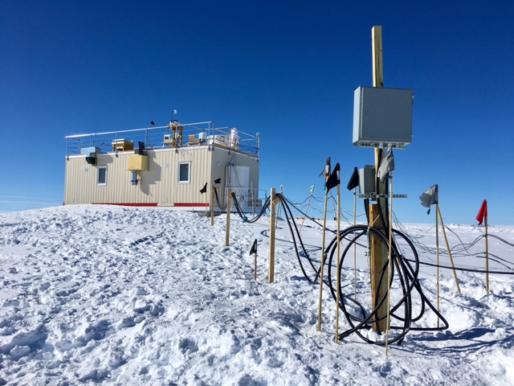

The MSF power boxes and cables were raised above the drift forming on the south side of the MSF.

(Photo taken 07-11 by Marci Beitch)

**General:**

On Tuesday, 07-11, height was added to the MSF power mast and the power boxes were raised to avoid being buried throughout the coming winter. On Sunday, 07-16, Summit Station experienced an unplanned power outage when the Microturbine shut down at 08:27Z. Power was restored within 8 minutes by powering on the Emergency Generator at 08:35Z.

**Significant Weather Observations:**

* 07-10: Few cirrus. Br and Fzfg in early morning hours. -11C, 6 kts.
* 07-11: Few cirrus. Br and Fzfg in early morning hours. -15C, 3 kts.
* 07-12: Few cirrus. Br and Fzfg in early morning hours. -15C, 0 kts.
* 07-13: Few cirrus. Br and Fzfg in early morning hours. -15C, 6 kts.
* 07-14: Few cirrus. Ic. Br and Fzfg in early morning hours. -12C, 11 kts.
* 07-15: Few stratocumulus. Br and Fzfg in early morning hours. -13C, 12 kts.
* 07-16:Bkn to Ovc stratus. -Sn, Drsn. Br and Fzfg in early morning hours. -13C, 15 kts.

**ICECAPS Data Management:**

* 07-10: Data transfer complete 05:54Z.
* 07-11: Data transfer complete 05:48Z.
* 07-12: Data transfer complete 05:44Z.
* 07-13: Data transfer complete 06:00Z.
* 07-14: Data transfer complete 05:40Z.
* 07-15: Data transfer complete 06:22Z.
* 07-16: Data transfer complete 06:12Z.

**MWR:**

* Operating normally.

**SODAR:**

* Operating normally.

**POSS:**

* Operating normally.

**MMCR:**

* Operating normally.
* Pitch 0.00 to -0.10, Roll 0.00 to -0.11 as of 07-16. Continuing to monitor Pitch and Roll readings under varying sunshine conditions.

**CAPABL:**

* Operating normally.

**MPL:**

* Operating normally.

**VCEIL:**

* Operating normally.

**Hotplate:**

* Operating normally.

**IceCAM:**

* Operating normally.
* 07-16: 08:30Z photo not taken due to power outage.

**PAERI:**

* Operating normally.

**TSI:**

* Operating normally.

**IcePIC:**

* No images captured this week.

**Radiosonde:**

* Twice daily soundings.
* *.mwx and *.spf files are not being grabbed by Dataman. Files are manually pushed every 1-2 days by changing permissions in the Sounding Archive folder.
* 07-10: Performed weekly power cycle of SPS and radiosonde computer prior to morning sonde. When sonde preparation began MW41 indicated, “SPS Status: Power test failure,” and sonde, placed in Vaisala cradle, was not registering in MW41 software. SPS and computer were power cycled and the USB connection of the Vaisala sonde preparation cradle was reseated. Problem was not solved. Twice more the SPS and computer were power cycled and a second sonde was tested but the problem persisted. The problem was solved by powering off the computer and SPS, unplugging the SPS power cable, plugging it back in, then powering on the computer and SPS. The SPS status indicated “Connected” and the preparation and launch proceeded normally.

**MASC:**

* Operating normally.