**ICECAPS Weekly Report**

July 17 – 23, 2017

Marci Beitch

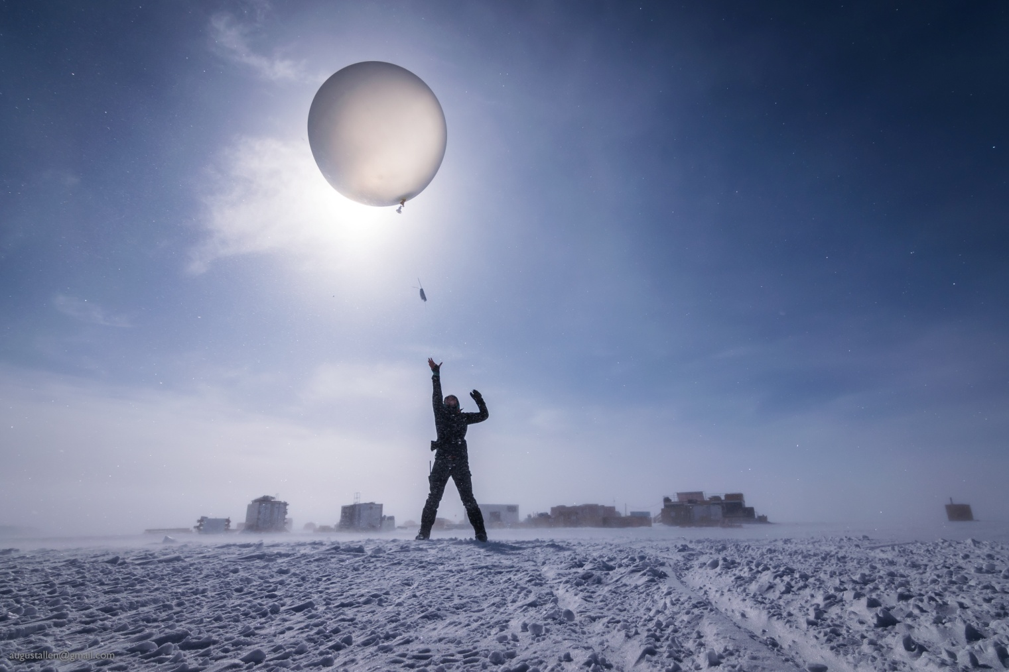

Marci launches the morning radiosonde balloon in 25-knot winds. (Photo taken 07-19 by August Allen)

**General:**

On Monday, 07-17, Station power, which had been on the Emergency Generator since the Microturbine shut down the day before, was transferred to the Primary generators that had recently been moved to the new Summit Mobile Garage (SMG). All instruments were supported by UPS during the brief power outage between 17:46 and 17:48Z when the transfer was made. On Tuesday, Marci gave a tour of the ICECAPS instruments to the very interested summer construction crew. Flight Period 5 began on Saturday after one day of flight delays. 25 Greenlandic, Danish, and American students and teachers arrived at Summit and toured the ICECAPS instruments. The students are also helping to launch the radiosonde balloons.

**Significant Weather Observations:**

* 07-17: Bkn to Ovc stratus. -Sn. -13C, 12 kts.
* 07-18: Bkn stratocumulus. -Sn, Drsn. -11C, 15 kts. Faint solar halo observed in afternoon.
* 07-19: Sct to Bkn cirrostratus. Blsn. -10C, 29 kts. Faint solar halo observed in late morning.
* 07-20: Bkn to Ovc stratus, stratocumulus, and altocumulus. -Sn. Periods of Br and Fzfg in morning. -9C, 6 kts becoming 14 kts.
* 07-21: Bkn to Ovc stratus, stratocumulus, and altocumulus. Ic, Sn, Drsn, and Blsn. -14C, 4 kts becoming 30 kts. Solar halo, parhelic circle, parhelia, and solar pillar observed in evening.
* 07-22: Sct to Few altostratus. Br and Fzfg in early morning hours. -19C, 5 kts.
* 07-23:Ovc to Sct stratus and stratocumulus. -Sn, Drsn, and Blsn. -9C, 15 kts.

**ICECAPS Data Management:**

* 07-17: Data transfer complete 05:36Z.
* 07-18: Data transfer complete 06:32Z.
* 07-19: Data transfer complete 06:09Z.
* 07-20: Data transfer complete 06:09Z.
* 07-21: Data transfer complete 06:48Z.
* 07-22: Data transfer complete 06:31Z.
* 07-23: Data transfer complete 05:49Z.

**MWR:**

* Operating normally.

**SODAR:**

* Operating normally.

**POSS:**

* Operating normally.

**MMCR:**

* Operating normally.
* 07-22: Received four new pairs of clay and silica gel desiccant packets.
* Pitch 0.00 to -0.10, Roll 0.00 to -0.11 as of 07-23. Continuing to monitor Pitch and Roll readings under varying sunshine conditions.

**CAPABL:**

* Operating normally.

**MPL:**

* Operating normally.
* 07-20: 16:10-16:32Z MPL data collection stopped for Monthly Afterpulse Calibration. Calibration results: 30 m, 30 s 16:13-16:21Z CoPolBkdAvg 0.000205, CoPolStdDev 0.000180. 15 m, 30 s 16:22-16:30Z CoPolBkdAvg 0.000208, CoPolStdDev 0.000231.

**VCEIL:**

* Operating normally.

**Hotplate:**

* Operating normally.

**IceCAM:**

* Operating normally.

**PAERI:**

* Operating normally.

**TSI:**

* Operating normally.

**IcePIC:**

* 07-17: Images captured.
* 07-18: Images captured.
* 07-20: Images captured in two separate sessions.

**Radiosonde:**

* Twice daily soundings.
* *.mwx and *.spf files are not being grabbed by Dataman. Files are manually pushed every 1-2 days by changing permissions in the Sounding Archive folder.

**MASC:**

* Operating normally.