**ICECAPS Weekly Report**

July 3 – 9, 2017

Marci Beitch

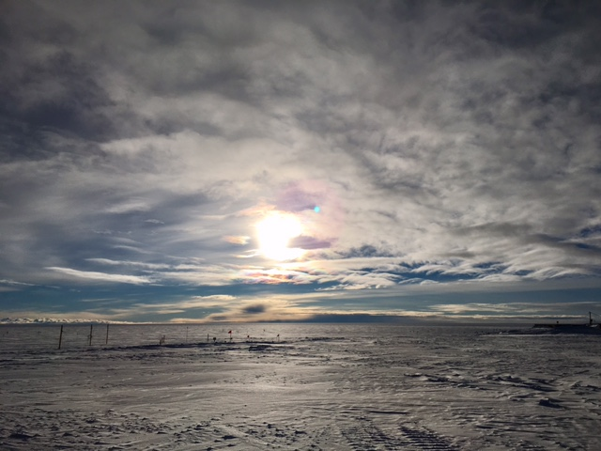Multiple cloud layers make a dynamic landscape in the sky. Photo taken 07-03 00:06Z. (Marci Beitch)

**General:**

Outdoor projects including unburying and raising the power lines from the MSF to the exterior power box, raising flag lines, and rebuilding the ICECAPS winter berm pallet were completed.

**Significant Weather Observations:**

* 07-03: Ovc stratus. -Sn, Drsn, Blsn. -14C 17 to 24 kts. Solar halo observed 07:30 to 11:20Z.
* 07-04: Sct to Few cirrocumulus. Ic, Br. -22C, 10 kts.
* 07-05: Ovc to Bkn stratus. Sg, Drsn. -14C, 14 kts. Solar halo observed most of the morning.
* 07-06: Bkn cirrostratus and cirrus. -12C, 10 kts. Faint solar halo observed most of the morning.
* 07-07: Sct to Few cirrus. -13C, 9 kts.
* 07-08: Few cirrus. -11C, 2 kts.
* 07-09: Few to Bkn cirrus. -11C, 8 kts. Faint solar halo observed in afternoon to early evening.

**ICECAPS Data Management:**

* 07-03: Data transfer complete 06:24Z.
* 07-04: Data transfer complete 05:48Z.
* 07-05: Data transfer complete 05:57Z.
* 07-06: Data transfer complete 06:25Z.
* 07-07: Data transfer complete 05:49Z.
* 07-08: Data transfer complete 06:09Z.
* 07-09: Data transfer complete 05:50Z.

**MWR:**

* Operating normally.

**SODAR:**

* Operating normally.

**POSS:**

* Operating normally.

**MMCR:**

* Operating normally.
* 07-09: Error in LabView when the daily calibration check initiated at 12:32Z. Error resolved when discovered at 17:33Z. Calibration check not performed but data continued to be collected.
* Pitch 0.00 to -0.10, Roll 0.00 to -0.11 as of 07-09. Continuing to monitor Pitch and Roll readings under varying sunshine conditions.

**CAPABL:**

* Operating normally.
* 07-04: Overnight (04:36Z) CAPABL experienced a backup disk reboot failure. Upon discovery, disconnected LaCie backup disk and attempted to start the computer, but computer would not start. While on Skype with Robert, the computer was hard shut down; the laser was stopped; and the Licel, Meadowlark, and motor controllers were power cycled. The computer was started, shut down properly, and started again. LabView was opened, floating reference Laser 2 configure file was selected, and the program was run at approximately 12:47Z. The laser shots began firing. Checks of the system show that the laser is in good alignment and the program is running normally. LaCie back up disk remains disconnected.

**MPL:**

* Operating normally.

**VCEIL:**

* Operating normally.

**Hotplate:**

* Operating normally.

**IceCAM:**

* Operating normally.

**PAERI:**

* Operating normally.

**TSI:**

* Operating normally.

**IcePIC:**

* 07-05: Images captured.

**Radiosonde:**

* Twice daily soundings.
* *.mwx and *.spf files are not being grabbed by Dataman. Files are manually pushed every 1-2 days by changing permissions in the Sounding Archive folder.

**MASC:**

* Operating normally.