**ICECAPS Weekly Report**

July 31 – August 6, 2017

Sam Dorsi

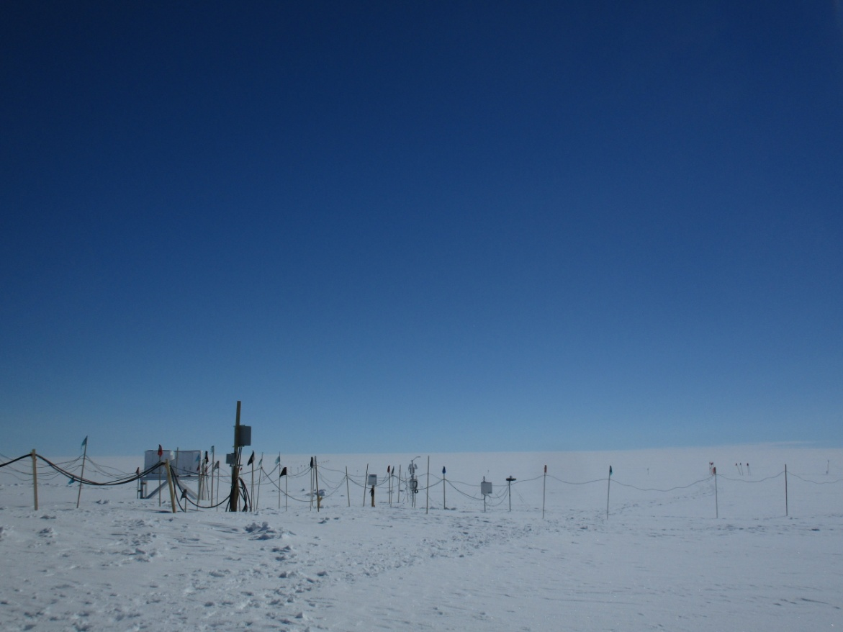

Cables and footpaths radiate from the precipitation suite. SWD

**General:**

* 08-02: The network connection was temporarily switched from summer to winter bandwidth caps from 08-02 to 08-04. The ICECAPS data transfers completed 8 to 13 hours later on these days. We expect summer bandwidth caps to remain in place through the end of FP6.
* 08-03: The D7 bulldozer removed snow drifts from the vicinity of the MSF from 15:48 to 18:15Z.

**Significant Weather Observations:**

* 07-31: Few stratus. Freezing fog in morning. -7C, 8 kts.
* 08-01: Few stratus. -15C, 8 kts.
* 08-02: Few stratus. -14C, 2 kts.
* 08-03: Broken stratocumulus. Freezing fog after 21:00z. Fogbow 23:15z. -16C, 12 kts.
* 08-04: Broken stratocumulus. Freezing fog 10:00z. -13C, 5 kts.
* 08-05: Scattered stratus and broken altostratus. -17C, 2 kts.
* 08-06: Freezing fog. -17C, 2 kts.

**ICECAPS Data Management:**

* 07-31: Data transfer complete 05:40Z.
* 08-01: Data transfer complete 05:55Z.
* 08-02: Data transfer complete 14:15Z.
* 08-03: Data transfer complete 13:59Z.
* 08-04: Data transfer complete 18:57Z.
* 08-05: Data transfer complete 06:07Z.
* 08-06: Data transfer complete 06:19Z.
* 08-06: Currently accessed via borrowed monitor.

**MWR:**

* Operating normally.
* 08-06: Currently accessed via borrowed monitor.

**SODAR:**

* Operating normally.
* 08-06: Currently accessed via borrowed monitor.

**POSS:**

* Operating normally.
* 08-06: Currently accessed via borrowed monitor.

**MMCR:**

* Operating normally.
* Pitch 0.00 to -0.10, Roll 0.00 to -0.11 as of 08-06. Continuing to monitor Pitch and Roll readings under varying sunshine conditions.

**CAPABL:**

* Operating normally.

**MPL:**

* Operating normally.

**VCEIL:**

* Operating normally.

**Hotplate:**

* Operating normally.

**IceCAM:**

* Operating normally.

**PAERI:**

* Operating normally.

**TSI:**

* Operating normally.

**IcePIC:**

* 08-03: Slides placed for collection 18:05Z – 18:40Z. No particles retained on slides. Winds were moderate, so particles are possibly vaporizing. Will try a shaded location closer to the building.

**Radiosonde:**

* Twice daily soundings.
* Issue with *.mwx and *.spf file permissions prevents transfer by data management scripts. File permissions are manually changed every 1-2 days.

**MASC:**

* Operating normally.