**ICECAPS Weekly Report**

June 12 – 18, 2017

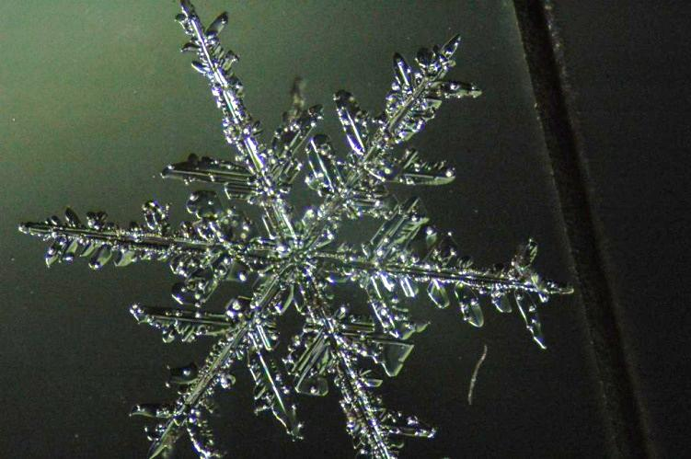Marci Beitch

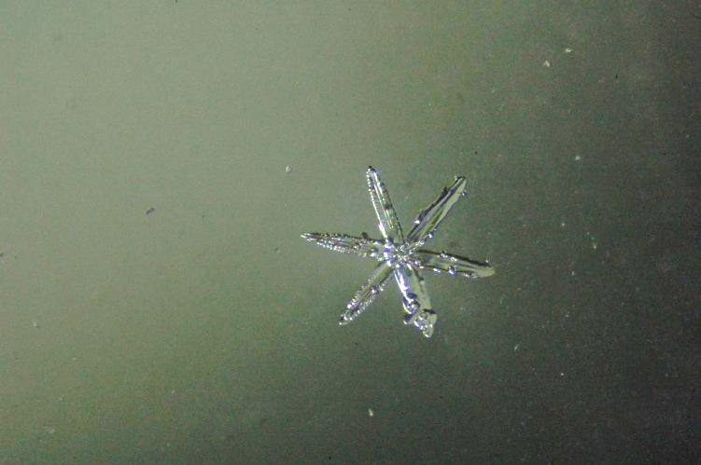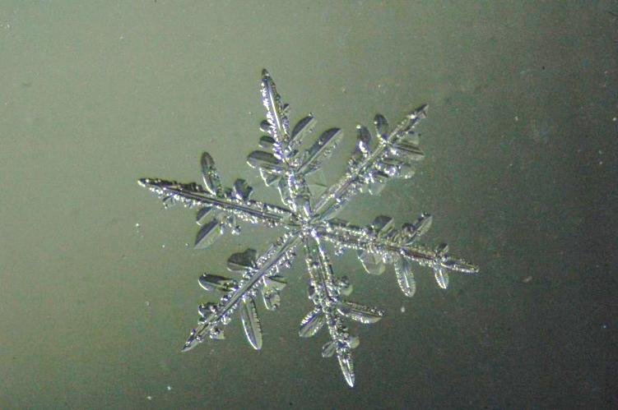Stellar dentrite (upper left), simple star (lower left), and fernlike stellar dendrite (right) captured with IcePIC during Friday’s snowfall. (Photos: Marci Beitch)

**General:**

Summit Station experienced warm temperatures and very light winds in the beginning of the week and the MSF building heated up. Small adjustments were made to the air handling system to decrease the temperature and increase the fan speed of air entering the building. On 06-13 the shelter fan of the PAERI instrument failed and was replaced. Station network trouble shooting continued and we switched back to the primary modem on the afternoon of 06-15.

**Significant Weather Observations:**

* 06-12: Bkn becoming Sct stratocumulus. -10C, 5 kts.
* 06-13: Few altostratus. -10C, 4 kts. Warming up to -4C, 0 kts.
* 06-14: Few altostratus. -13C, 5 kts.
* 06-15: Few altostratus. -12C, 2 kts.
* 06-16: Fzfg and -Sn becoming few altostratus. -11C, 11 kts.
* 06-17: Sct to Bkn stratus, stratocumulus, altocumulus, and cirrus. -Sn and Sg. Patchy Br. -11C, 7 kts.
* 06-18: Bkn stratocumulus. -Sn. -12C, 5 kts.

**ICECAPS Data Management:**

* 06-12: Data transfer complete 10:33Z.
* 06-13: Data transfer complete 13:17Z.
* 06-14: Data transfer complete 11:52Z.
* 06-15: Data transfer complete 11:12Z. Switched from secondary modem to primary modem in afternoon.
* 06-16: Data transfer complete 05:34Z.
* 06-17: Data transfer complete 06:16Z.
* 06-18: Data transfer complete 06:28Z.

**MWR:**

* Operating normally.

**SODAR:**

* Operating normally.
* 06-13: 12:15-13:50Z hand digging to expose base of Sodar.

**POSS:**

* Operating normally.

**MMCR:**

* Operating normally.
* 06-13: Recharged one pair of desiccants, labeled, and sealed for future use.
* Pitch oscillates between 0.00 and -0.10, roll oscillates between 0.00 and 0.11 as of 06-11.

**CAPABL:**

* Operating normally.

**MPL:**

* Operating normally.

**VCEIL:**

* Operating normally.

**Hotplate:**

* Operating normally.

**IceCAM:**

* Operating normally.

**PAERI:**

* Operating normally.
* 06-13: Warm outdoor temperatures caused MSF building temperatures to increase in the afternoon. The PAERI Stirling cooler temperatures also increased. At 18:52Z the MSF air handling system was adjusted to allow cooler air to enter the building at a higher fan speed. The MSF and Stirling cooler temperatures slowly decreased.
* 06-13: Just before 18:00Z the Air Temp Near BBs increased suddenly. The problem was diagnosed as a failure in the shelter fan. At 23:45Z a new fan was installed and the PAERI temperatures that were in alarm began to cool down. All returned to normal by the following morning.

**TSI:**

* Operating normally.
* 06-12: Configured TSI computer clock to sync with server time at 18:36Z. The TSI computer clock had built up a lag of about one and a half minutes over the last week. Image names jump from 183400 to 183629, then 183700 and so on.

**IcePIC:**

* 06-16: Images captured.
* 06-17: Images captured in two separate sessions.

**Radiosonde:**

* Twice daily soundings.
* *.mwx and *.spf files are not being grabbed by Dataman. Files are manually pushed every 1-2 days by changing permissions in the Sounding Archive folder.

**MASC:**

* Operating normally.