**ICECAPS Weekly Report**

June 19 – 25, 2017

Marci Beitch

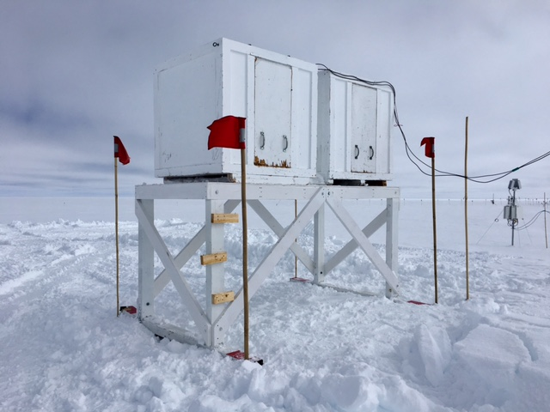

Rasing and leveling of the Sodar was complete on 06-19. (Photo: Marci Beitch)

**General:**

This week included the raising and leveling of the Sodar and preparing for Flight Period 4, which began on 06-23. Duane Hazen arrived on site to work on the MMCR.

**Significant Weather Observations:**

* 06-19: Few to Bkn stratus. On and off -Sn and Sg. Fzfg in early morning. -13C 10 kts.
* 06-20: Sct to Bkn stratocumulus and altocumulus. -12C, 5 kts.
* 06-21: Few to Sct stratus and cirrus. Ic. -13C, 10 kts. 12:00Z faint solar halo observed.
* 06-22: Few to Sct altostratus. -16C, 4 kts.
* 06-23: Few altostratus. -13C, 6 kts.
* 06-24: Sct cirrus. Fzfg and Br in early morning. -15C, 2 kts.
* 06-25: Bkn stratocumulus. -Sn. -10C, 10 kts increasing to 20 kts.

**ICECAPS Data Management:**

* 06-19: Data transfer complete 05:35Z.
* 06-20: Data transfer complete 05:37Z.
* 06-21: Data transfer complete 06:12Z.
* 06-22: Data transfer complete 06:16Z.
* 06-23: Data transfer complete 06:12Z.
* 06-24: Data transfer complete 05:39Z.
* 06-25: Data transfer complete 05:18Z.

**MWR:**

* Operating normally.
* 06-21: Opened MWR crates that are stored on winter berm and did not find a second foam tray used for LN2 calibrations.

**SODAR:**

* Operating normally.
* 06-19: 15:19Z shut down Sodar and disconnected cables. Sodar sled moved, snow backfilled in Sodar location. Sodar sled replaced, leveled, and cables reconnected. 17:43Z restarted Sodar software.

**POSS:**

* Operating normally.

**MMCR:**

* Operating normally.
* 06-21: LabView error noticed at 12:46Z. Receiver/Modulator Range Resolution and Interface Antenna Position performing abnormally. Based on the MMCR error log files, it appeared that the LabView error occurred after the daily 12:30Z calibration began. At 12:50Z when selecting “Continue” in the LabView error prompt to proceed with a system reboot, the instrument regained normal operation. No system reboot performed.
* 06-24: Duane Hazen on site to work on MMCR. 15:00-16:02Z MMCR shut down to perform checks.
  + Checked for water in wave guide and found none.
  + Worked on Pitch and Roll noise and was able to reduce it.
  + Visually checked antenna for problems and found none.
* 06-25: 06-24 MMCR data files not transferred by dataman to Boulder overnight. Checked that instrument was mounted, and also re-mounted the drives. Two day’s worth of files transferred successfully the following night.
* 06-25: Duane and Marci checked level of antenna with precision levels and found values to be similar to Pitch and Roll readings.
* Pitch -0.10, roll 0.00 as of 06-25.

**CAPABL:**

* Operating normally.
* 06-22: Added distilled water to Laser 2.

**MPL:**

* Operating normally.
* 06-20: 12:29-12:51Z MPL data collection stopped for Monthly Afterpulse Calibration. Calibration results: 30 m, 30 s 12:32-12:40Z CoPolBkdAvg 0.000211, CoPolStdDev 0.000158. 15 m, 30 s 12:41-12:49Z CoPolBkdAvg 0.000182, CoPolStdDev 0.000221.

**VCEIL:**

* Operating normally.

**Hotplate:**

* Operating normally.

**IceCAM:**

* Operating normally.

**PAERI:**

* Operating normally.

**TSI:**

* Operating normally.

**IcePIC:**

* 06-25: Images captured.

**Radiosonde:**

* Twice daily soundings.
* *.mwx and *.spf files are not being grabbed by Dataman. Files are manually pushed every 1-2 days by changing permissions in the Sounding Archive folder.

**MASC:**

* Operating normally.