**ICECAPS Weekly Report**

June 26 – July 2, 2017

Marci Beitch

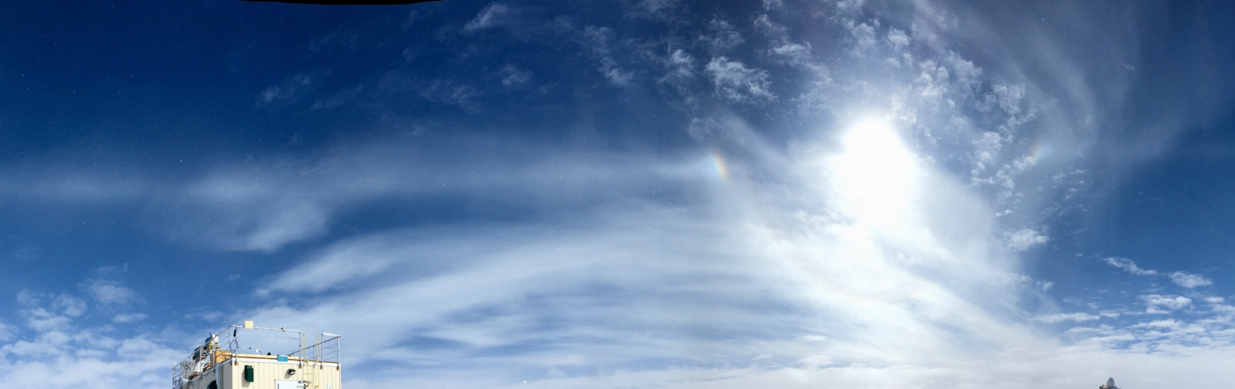

Solar halo, parhelia, and parhelic circle on 06-27. (Photo: Marci Beitch)

**General:**

Tuesday, 06-27, was the end of Flight Period 4 and Duane Hazen left station. On Wednesday, 06-28, from 12:36 to 13:34Z Summit Station experienced a planned power outage to install an 80-amp breaker for the new Summit Mobile Garage. Several MSF instruments were shutdown prior to and during the outage to preserve UPS power.

**Significant Weather Observations:**

* 06-26: Ovc stratus. -Sn. Drsn. -10C, 17 kts. Becoming Few to Sct stratocumulus, altocumulus, and cirrus. Fzfg in late evening. -17C, 3 kts.
* 06-27: Ovc to Bkn stratus becoming Sct stratocumulus. -Sn. Fzfg in morning becoming patchy Br. -13C, 8 kts. Solar halo, parhelia, and parhelic circle observed around 17:37Z.
* 06-28: Bkn stratus becoming Sct to Few stratus, stratocumulus, and cirrus. Ic. Patchy Br. -10C, 11 kts.
* 06-29: Ovc stratus to Sct stratocumulus and altocumulus. -Sn, Sg, Drsn. -10C, 12 kts. Faint solar halo observed around 12:15Z.
* 06-30: Ovc stratus. -Sn, Sg, Drsn. -14C, 13 kts.
* 07-01: Ovc to Bkn stratus and cirrocumulus. Sg, Ic, Drsn. -15C, 14 kts. Faint solar halo observed at 10:55Z.
* 07-02: Ovc to Few stratus, stratocumulus, and altocumulus. Ic, Drsn. -17C, 15 kts becoming 7 kts. Solar halo, parhelia, and parhelic circle observed 10:25-11:00Z and 11:54-12:38Z (times taken from TSI).

**ICECAPS Data Management:**

* 06-26: Data transfer complete 07:07Z.
* 06-27: Data transfer complete 06:14Z.
* 06-28: Data transfer complete 05:51Z.
* 06-29: Data transfer complete 05:36Z. (Fewer data files to send due to 06-28 power outage.)
* 06-30: Data transfer complete 06:57Z.
* 07-01: Data transfer complete 06:10Z.
* 07-02: Data transfer complete 06:08Z.

**MWR:**

* Operating normally.
* 06-28: 12:30-14:18Z MWRs shutdown for power outage lasting longer than 30 minutes.

**SODAR:**

* Operating normally.
* 06-28: 12:31-14:22Z Sodar shutdown for power outage lasting longer than 30 minutes.

**POSS:**

* Operating normally.

**MMCR:**

* Operating normally.
* 06-26: Duane and Marci leveled antenna with precision levels and made adjustments to the Pitch and Roll readings so they read 0.00. Some noise is still present. Average values and standard deviations are being monitored.
* 06-28: 12:13-14:45Z MMCR shutdown for outage lasting longer than 30 minutes. At MMCR restart, Helix Overcurrent Fault was experienced. Fault was resolved after three reboots but cloud data not appearing on LAP-XM displaying. 17:09Z MMCR shutdown and reboot three more times until Helix Overcurrent Fault did not occur and LAP-XM cloud data displayed. Data collection restored 18:00Z.
* Pitch 0.00 to -0.10, Roll 0.00 to -0.11 as of 07-02.

**CAPABL:**

* Operating normally.
* 06-28: 12:26-13:39Z CAPABL shutdown for power outage lasting longer than 30 minutes. LabView was closed but computer was left on. After 15 minutes on UPS power the Powerware NetWatch program shutdown the computer. After outage computer was turned back on and LabView started. LabView program appeared to start normally but after a couple minutes laser shots stuck at 24, number of DAQ cycles stuck at 8, and Polarization Control stuck at 1 even though sounds of laser shots being fired continued. LabView was stopped and run again. Normal data collection restored at 13:48Z.

**MPL:**

* Operating normally.
* 06-28: 12:23-14:04Z MPL shutdown for power outage lasting longer than 30 minutes.

**VCEIL:**

* Operating normally.
* 06-28: 12:21-14:07Z Ceilometer shutdown for power outage lasting longer than 30 minutes.

**Hotplate:**

* Operating normally.
* 06-28: 12:20-14:10Z Hotplate shutdown for power outage lasting longer than 30 minutes.

**IceCAM:**

* Operating normally.
* 06-28: Images from 12:45, 13:00, 13:15, and 13:30 not taken due to power outage.

**PAERI:**

* Operating normally.
* 07-01: 12:32-12:34Z unplugged and removed shelter fan enclosure to check for frost/rime; none found.

**TSI:**

* Operating normally.

**IcePIC:**

* 06-29: Images captured.
* 06-30: Images captured.

**Radiosonde:**

* Twice daily soundings.
* *.mwx and *.spf files are not being grabbed by Dataman. Files are manually pushed every 1-2 days by changing permissions in the Sounding Archive folder.
* Flight Period 4: Received shipments of 760 radiosonde balloons and 72 helium cylinders.

**MASC:**

* Operating normally.