**ICECAPS Weekly Report**

June 5 – 11, 2017

Marci Beitch

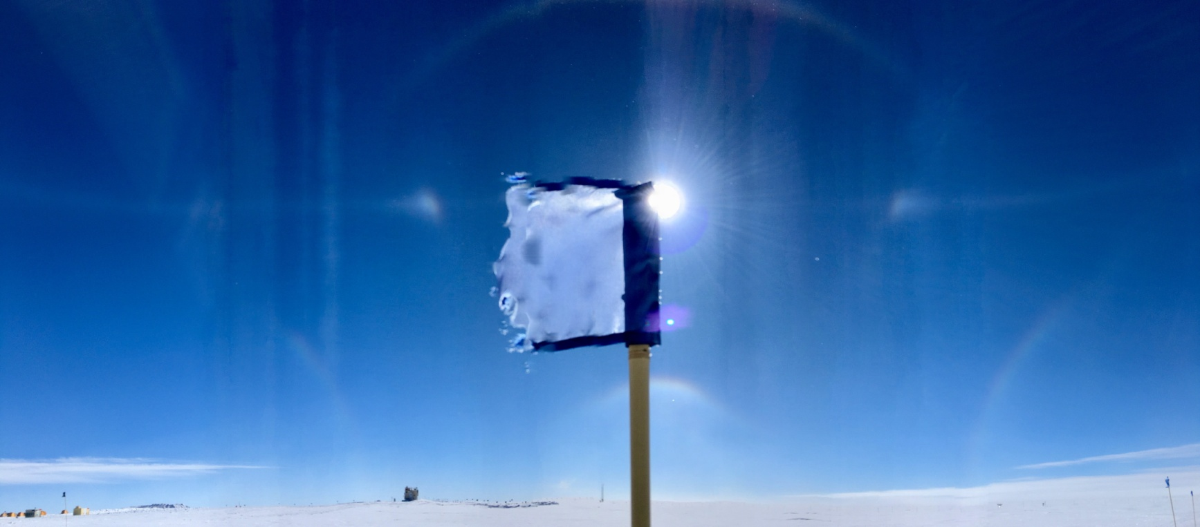

Fantastic sky optics on 06-10 that were hard to capture in one photograph. They included a double solar halo, parhelia, complete parhelic circle, lower tangent arc, upper tangent arc, infralateral arcs, and circumzenithal arc.

(Photo: Marci Beitch)

**General:**

Summit Station experienced a network outage on 06-05 from approximately 11:30 to 17:20Z. Although the outage delayed email communications, the ICECAPS data downloads were not affected. An additional network outage occurred on 06-08 around 17:30Z and lasted 24 hours until around 17:30Z on 06-09. The ICECAPS data downloads did not transfer overnight due to the outage but were manually pushed when communications were restored. On 06-05 the MSF building was leveled to address the pitch and roll of the MMCR. 06-06 began Flight Period 3 in which a large dewar of liquid nitrogen was delivered and MWR calibrations were performed throughout the week. On 06-09 from 12:02-12:03Z Summit Station experienced a planned power outage in order to transfer Station power to the micro-turbine. All ICECAPS instruments remained powered on by the UPS during the outage.

**Significant Weather Observations:**

* 06-05: Bkn stratus, altocumulus, and cirrus. -Sn from approximately 13:00 to 17:00Z. -16C, 2 kts. Halo observed between 11:15 and 12:45Z.
* 06-06: Few stratocirrus. Br in early morning. -16C, 7 kts.
* 06-07: Sct altostratus, altocumulus, and cirrus. -13C, 6 kts.
* 06-08: Few to Bkn stratus, cumulus, altocumulus, and cirrus. Sg in morning. -13C, 10 kts. Parhelia observed at 23:15Z.
* 06-09: Skt to Bkn stratocumulus and cirrus. -Sn. Blsn. -10C, 28 kts.
* 06-10: Skt to Bkn stratocumulus. Ic. -17C, 12 kts. Double solar halo, parhelia, complete parhelic circle, lower tangent arc, upper tangent arc, circumzenithal arc observed on and off from approximately 11:15-13:45Z. Solar corona observed from approximately 17:00-18:00. Photos saved in Significant Wx Pics.
* 06-11: Few altostratus and cirrocumulus. -13C, 9 kts. Halo, parhelic circle, and upper tangent arc observed from approximately 13:15-14:15Z.

**ICECAPS Data Management:**

* 06-05: Data transfer complete 06:12Z. Network outage from approximately 11:30-17:20Z.
* 06-06: Data transfer complete 06:09Z.
* 06-07: Data transfer complete 05:56Z.
* 06-08: Data transfer complete 06:06Z. Network outage beginning at approximately 17:30Z.
* 06-09: Nightly data transfer was unsuccessful due to network outage. Network restored at approximately 17:30Z by switching to a second modem that hosts a slower connection. Data transfer manually initiated at 18:29Z and continued past midnight.
* 06-10: Data transfer of remaining 06-08 data and 06-09 data complete 16:55Z.
* 06-11: Data transfer complete 13:37Z.

**MWR:**

* Operating normally.
* 06-07: Intermittent Rec. 1 and 2 Temp. Stability red alarms.
* 06-07: 13:17Z MWR batches terminated for calibrations. Discovered leaking crack in LN2 foam tray, thus calibration not performed. MWR batches resumed at 14:44Z. Foam tray crack repaired with silicone and left to cure overnight.
* 06-08: 11:38Z MWR batches terminated for calibrations. 12:51-12:56Z successful calibration of the HATPRO. 13:06-13:36Z performed internal-external flop measurement of the HATPRO. 13:44-13:49Z successful calibration of the 150-90. 14:00Z MWR batches resumed.
* 06-10: 12:15Z MWR batches terminated for calibrations. 12:24-12:29Z successful calibration of the HATPRO. 12:34-13:12Z performed internal-external flop2 measurement of the HATPRO. 13:29-13:34Z successful calibration of the 150-90. LN2 dewar ran out. 13:47Z MWR batches resumed.

**SODAR:**

* Operating normally.
* 06-06: 12:42-13:54Z LC-130 on deck may have introduced noise to Sodar. 18:26-19:45Z heavy equipment removing snow buildup near Sodar.
* 06-07: 12:36-12:50Z heavy equipment removing snow buildup near Sodar.
* 06-10: 15:42-16:52Z LC-130 on deck may have introduced noise to Sodar.
* 06-11: 00:04-00:58Z LC-130 on deck may have introduced noise to Sodar.

**POSS:**

* Operating normally.

**MMCR:**

* Operating normally.
* Created Pitch/Roll diagram as a reference for future leveling.
* Pitch 0.00, roll oscillates between 0.00 and 0.11 as of 06-11.

**CAPABL:**

* Operating normally.

**MPL:**

* Operating normally.

**VCEIL:**

* Operating normally.

**Hotplate:**

* Operating normally.

**IceCAM:**

* Operating normally.
* 06-07: 10:00Z photo corrupted. Unknown reason.

**PAERI:**

* Operating normally.

**TSI:**

* Operating normally.
* 06-05: TSI Manager program capturing images each minute but running very slowly (i.e. freezing up when clicking to view earlier images). Unable to view earlier images of the day.
* 06-06: 15:41-16:10Z performed reboot of TSI software and computer to address issues with software. After reboot system is performing better and earlier images of the day are able to be viewed. Cleaned TSI dome with glass cleaner when system was shut down.

**IcePIC:**

* 06-05: Images captured.

**Radiosonde:**

* Twice daily soundings.
* *.mwx and *.spf files are not being grabbed by Dataman. Files are manually pushed every 1-2 days by changing permissions in the Sounding Archive folder.

**MASC:**

* Operating normally.