# ICECAPS Weekly Report

March 6 – March 12, 2017

Hannah James

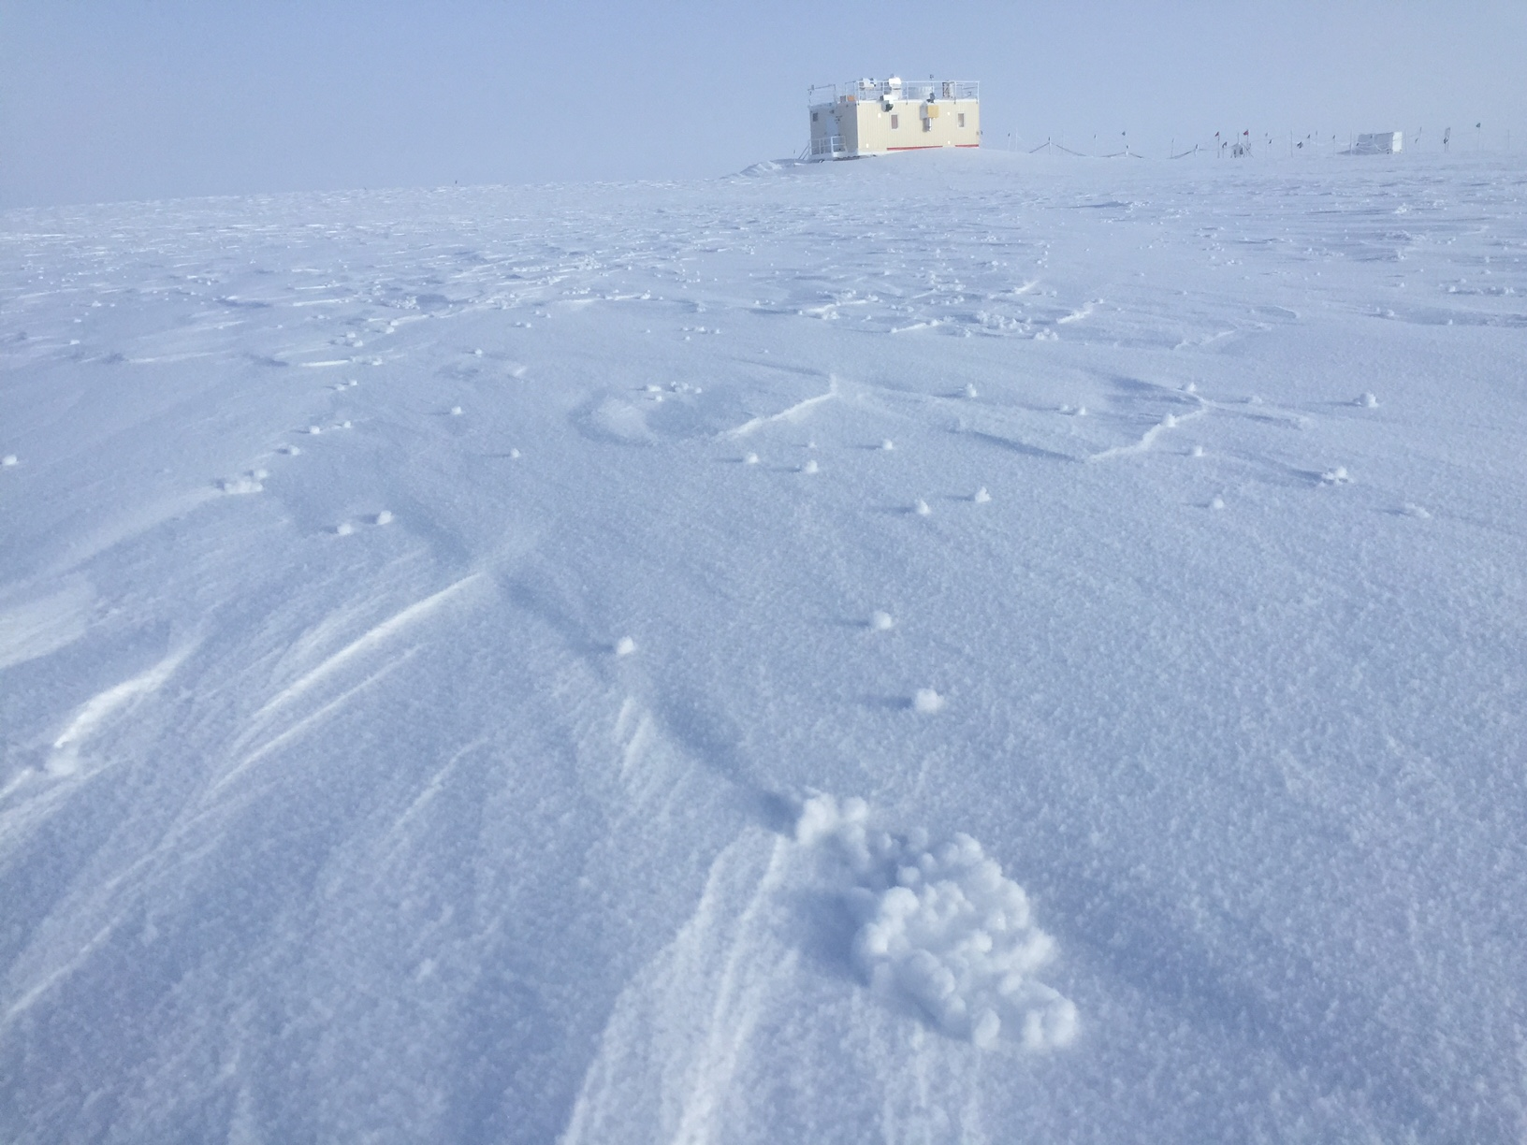

Yukimarimo dotted the landscape on Monday morning. -HJ

**General:**

None to report.

**Significant Weather Observations:**

* 03-06: Br. Sct stratus, stratocumulus. -43C, 10 kts. 1100-1300Z: Yukimarimo measuring 0.5-2cm in diameter, average of 5-10 spheres per square meter away from station. 13:15Z: Fogbow.
* 03-07: Br. Few stratus, sct cirrocumulus. -44C, 11 kts. 11:00Z: halo. Yukimarimo from yesterday remain.
* 03-08: Br. Sct altocumulus, bkn cirrocumulus, bkn cirrus. -46C, 10 kts. 14:30-16:30Z: halo with subhorizon ground halo.
* 03-09: Br, drsn. Few cirrocumulus, few cirrus. -43C, 12 kts.
* 03-10: Fzfg, drsn, IC. Sct altocumulus, bkn cirrus. -35C, 15 kts. 11:00-1200Z: Halo
* 03-11: Fzfg. Sky clear. -33C, 10 kts.
* 03-12: Fzfg. Few stratus. -32C, 4 kts. 12:00-13:00Z: fogbow.

**ICECAPS Data Management:**

* 03-06: Data transfer complete 08:45Z.
* 03-07: Data transfer complete 14:45Z.
* 03-08: Data transfer complete 13:14Z.
* 03-09: Data transfer complete 09:39Z.
* 03-10: Data transfer complete 10:44Z. Remounted due to CAPABL and MMCR mounts down overnight.
* 03-11: Data transfer complete 13:09Z.
* 03-12: Data transfer complete 11:47Z.

**MWR:**

* Operating normally.
* 03-07: Red flags on Rec. 1 Temp stability of Slave and Ambient Target Stability of Master.
* 03-12: Thin frost on the front of both windows, covering approximately half of the 150-90 and one third of the HATPRO.

**SODAR:**

* Operating normally.

**POSS:**

* Operating normally.

**MMCR:**

* Operating normally.
* Pitch 0.00, roll -0.11 as of 03-13.
* 03-06: Mount down overnight, no data transferred. Daily calibrations all failed 12:30Z test.
* 03-07: Daily calibrations failed 12:30Z test, not registering clouds overhead.
* 03-09: Rebooted system per Duane’s request at 13:58Z. Upon restart, TWTA was powered down. Consulting the troubleshooting reference, I manually powered it up and by 14:26Z it was running with daily checks passing.
* 03-10: MMCR mount down overnight.

**CAPABL:**

* Operating normally.
* 03-09: CAPABL mount down overnight, system found with PC logged out and LabView not running. Power cycled the motor controller after LabView continuously force quit, zeroed each motor, and realigned the mirrors.
* 03-10: Mount down overnight.
* 03-11: Heavy frost from the railing covering the window. Lasing turned off 15:27-15:37Z for cleaning.
* 03-12: Light frost from the railing covering the window. Lasing turned off 13:13-13:23Z for cleaning.

**MPL:**

* Operating normally.
* 03-11: Cleared window of frost fallen from railing.
* 03-12: Cleared window of frost fallen from railing.

**VCEIL:**

* Operating normally.
* 03-08: Spare MWR heated blanket (left unplugged) added to improve insulation.

**Hotplate:**

* Offsite for repairs since 2016-6-9.

**IceCAM:**

* Operating normally.

**PAERI:**

* Operating normally.
* 03-12: Time series graphs were not open, but data was being collected and saved to both the computer and FTP. Per the protocol, I left the PAERI as I found it. Monday morning things were running normally.

**TSI:**

* Stored in MSF for winter.

**IcePIC:**

* 03-08: Slides placed for collection 15:00-15:15Z. Particles photographed include isolated bullets, hollow columns, hexagonal plates, triangular crystals, bullet rosettes, simple prisms, capped bullets, radiating plates, and irregulars.

**Radiosonde:**

* Twice daily soundings.
* Ongoing troubleshooting dealing with *.mwx and *.spf files not being grabbed by Dataman. For now, every other day I will manually change the permissions.
* 03-10: Evening sonde not launched due to humidity failure- sonde was reading over 100% humidity while placed outside.
* 03-12: Morning and evening sondes not launched due to same humidity failure.

**MASC:**

* Offsite for repairs since 2016-05-03.