# ICECAPS Weekly Report

March 20 – March 26, 2017

Hannah James

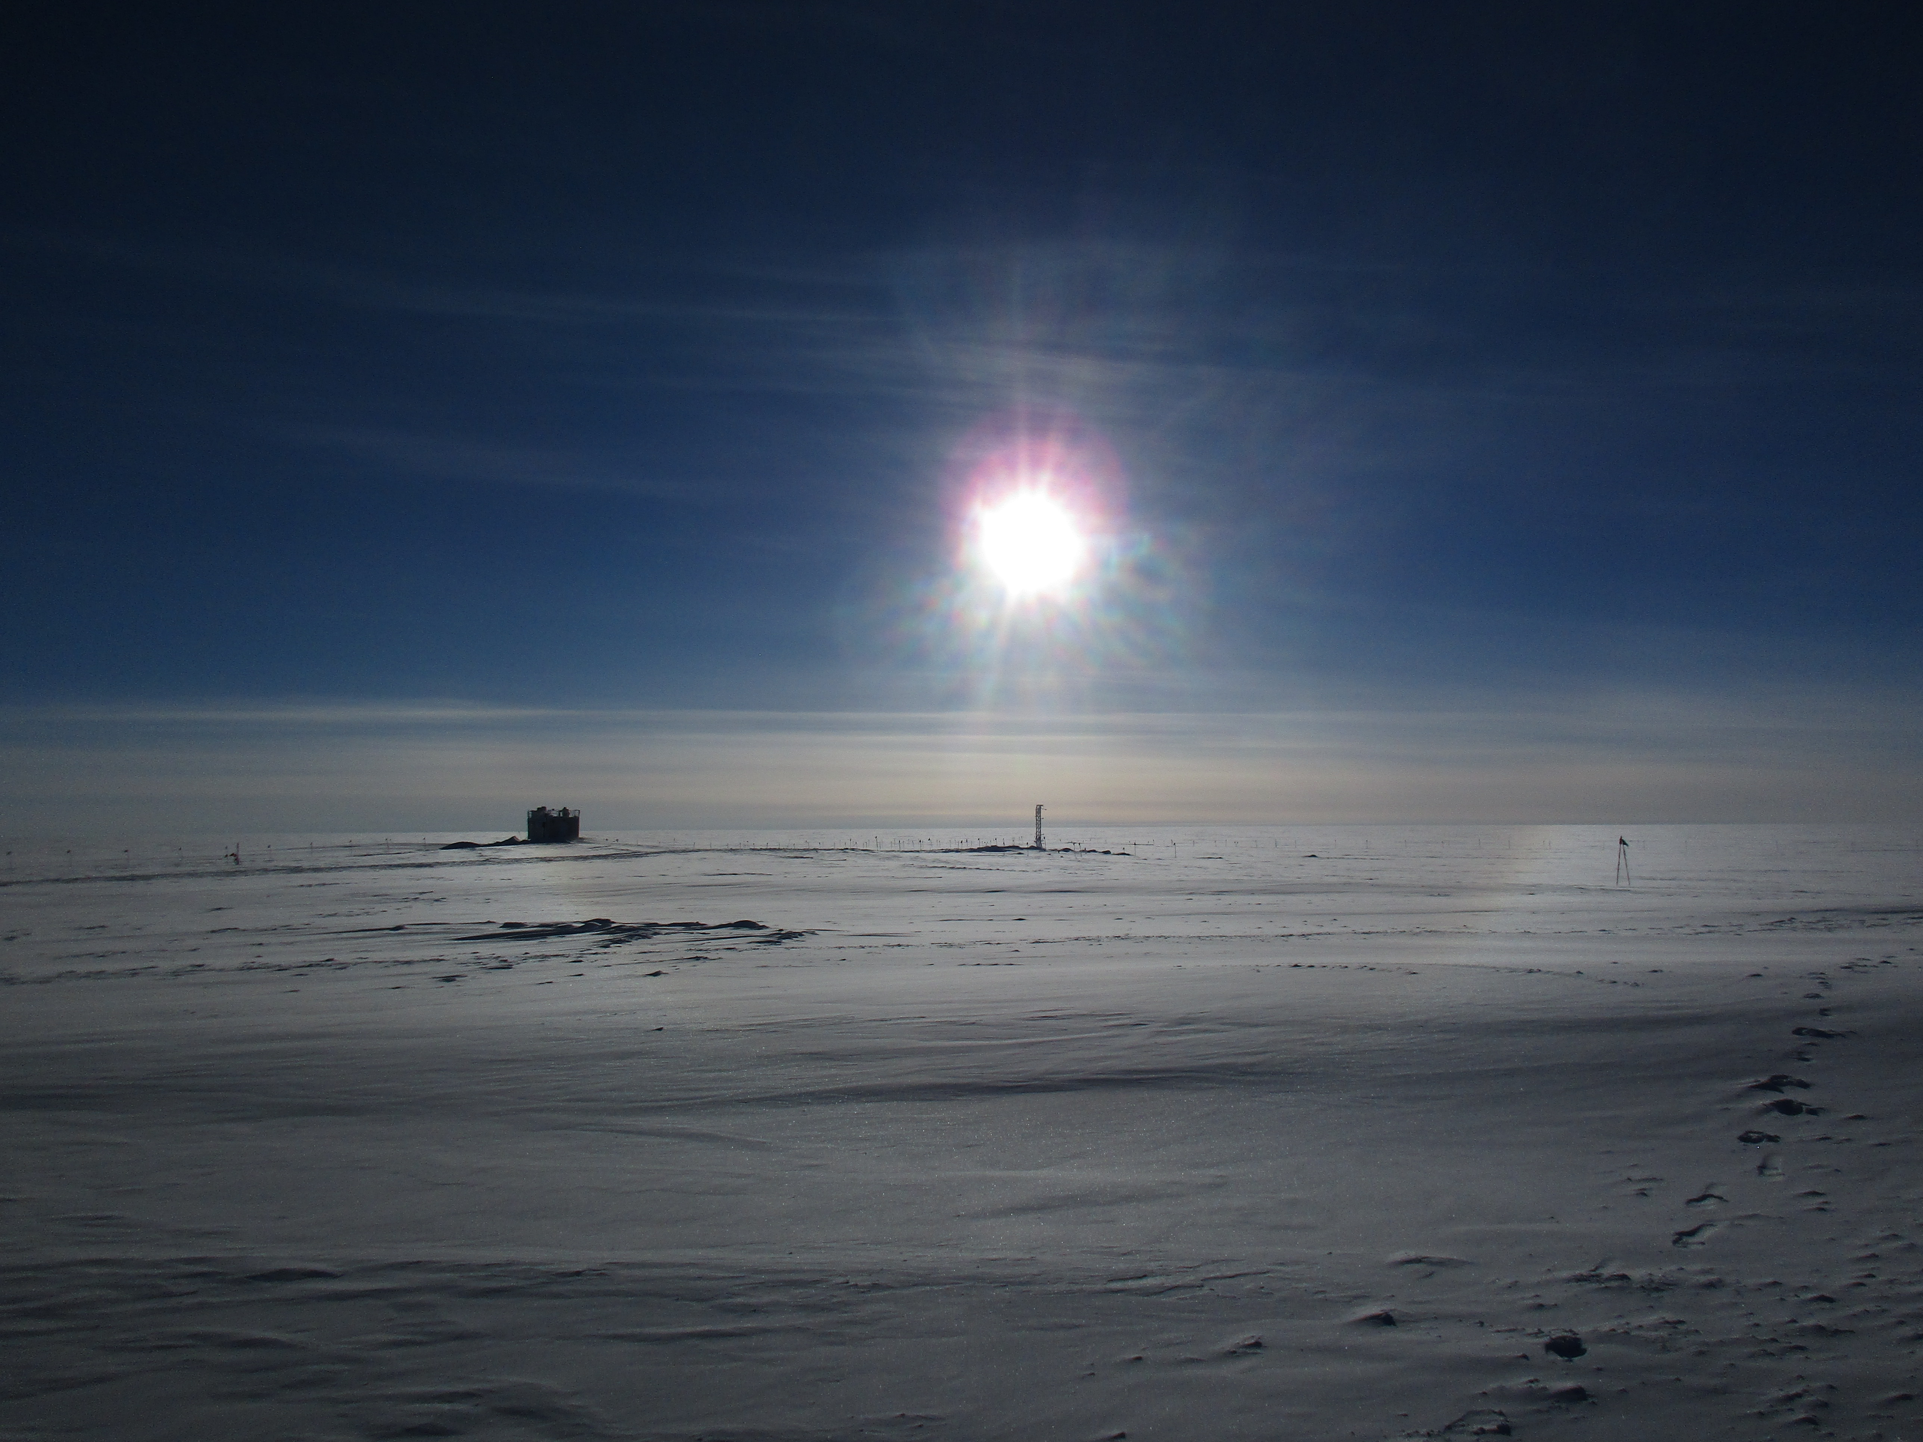

A sub-horizon halo surrounds the MSF and Swiss Tower remains. -HJ

**General:**

Daylight savings time was observed on the evening of 03-25. Summit Station’s time zone is now GMT -2.

**Significant Weather Observations:**

* 03-20: Few cirrus. -47C, 5 kts. 11:30-18:00Z: Sub horizon halo, faint fata morgana.
* 03-21: Bkn stratus. -48C, 11 kts. 12:30-14:00Z: Halo, parhelia, start of parhelic circle.
* 03-22: Blsn, IC. Ovc altostratus. -32C, 17kts. 11:00Z: Halo.
* 03-23: Drsn, IC. Bkn altocumulus. -24C, 15 kts. 11:00-12:50Z: Halo 11:20Z- 22 degree halo, 46 degree halo, upper tangent arc, circumzenithal arc, and column.
* 03-24: -SG, IC, drsn. Bkn altostratus, ovc cirrocumulus. -26C, 13kts. 11:00-13:00Z: Halo. 18:00Z: Halo
* 03-25: Few altostratus. -33C, 10kts. Very small (<0.5cm in diameter) yukimarimo forming downwind of frosted instruments and buildings.
* 03-26: Skc. -42C, 0kts. 11:00-1800: Fata morgana.

**ICECAPS Data Management:**

* 03-20: Data transfer complete 12:05Z.
* 03-21: Data transfer complete 10:57Z.
* 03-22: Data transfer complete 11:53Z.
* 03-23: Data transfer complete 13:14Z.
* 03-24: Data transfer complete 15:11Z.
* 03-25: Data transfer complete 11:30Z.
* 03-26: Data transfer complete 10:25Z.

**MWR:**

* Operating normally.

**SODAR:**

* Operating normally.

**POSS:**

* Operating normally.

**MMCR:**

* Operating normally.
* Pitch 0.00, roll -0.11 as of 03-26.

**CAPABL:**

* Operating normally.
* 03-23: Computer clock off by 1+ minute. Reset at 13:41Z.

**MPL:**

* Operating normally.

**VCEIL:**

* Operating normally.

**Hotplate:**

* Offsite for repairs since 2016-06-09.

**IceCAM:**

* Operating normally.
* 03-23: Reset time- drifted by 1 minute.

**PAERI:**

* Operating normally.

**TSI:**

* Stored in MSF for winter.

**IcePIC:**

* 03-23: Slides placed for collection 17:57-18:19Z. Particles photographed include isolated bullets, bullet rosettes, hollow columns, hexagonal plates, simple prisms, radiating plates, and one trigonal ice.
* 03-25: Yukimarimos and hoar frost photographed 13:55-14:20Z. Particles photographed include surface hoar (feather like and irregulars), needles, hollow columns, isolated bullets, and bullet rosettes.

**Radiosonde:**

* Twice daily soundings.
* Ongoing troubleshooting dealing with *.mwx and *.spf files not being grabbed by Dataman. For now, every other day I will manually change the permissions.

**MASC:**

* Offsite for repairs since 2016-05-03.