# ICECAPS Weekly Report

March 27 – April 2, 2017

Hannah James

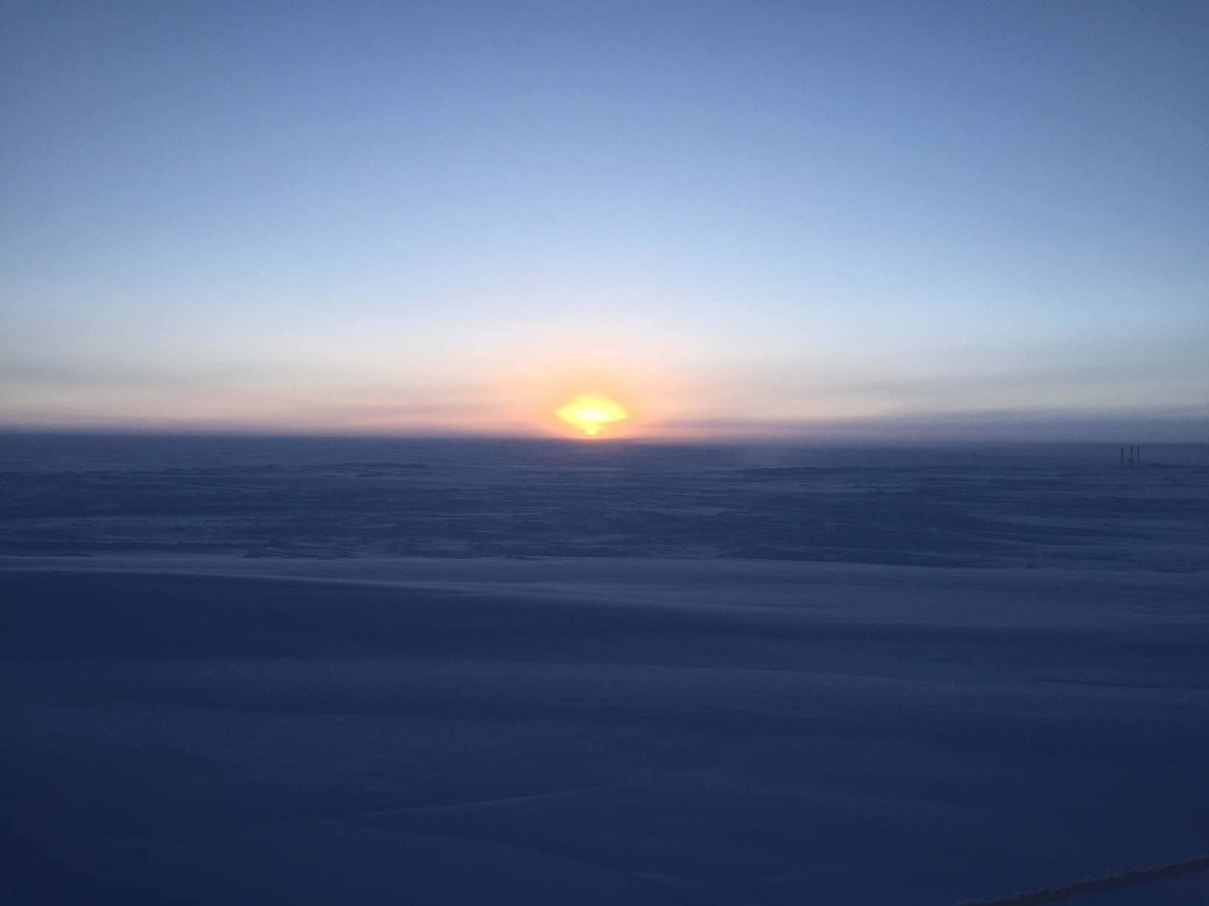Calm weather this week provided some excellent sunsets. -HJ

**General:**

On Friday, 03-31, SRI switched Summit Station to summer bandwidth speeds.

**Significant Weather Observations:**

* 03-27: Br. Few stratus, few altostratus, sct cirrus. -43C, 10 kts.
* 03-28: Br, -Sg. Ovc stratus. -35C, 12kts.
* 03-29: Br, clearing mid-morning. Bkn stratocumulus. -39C, 8kts. 14:00-14:30Z: bright halo, IC (IcePICs captured during this event).
* 03-30: Br in far distance. Skc. -46C, 5 kts. 10:00Z- Fata morgana.
* 03-31: Br, IC. Few altostratus. -44C, 10 kts.
* 04-01: Few stratus, few cirrus. -47C, 10kts. 15:00Z- halo.
* 04-02: Br. Few stratus. -43C, 10 kts.

**ICECAPS Data Management:**

* 03-27: Data transfer complete 14:37Z.
* 03-28: Data transfer complete 11:49Z.
* 03-29: Data transfer complete 11:29Z.
* 03-30: Data transfer complete 15:19Z.
* 03-31: Data transfer complete 11:13Z.
* 04-01: Data transfer complete 05:54Z.
* 04-02: Data transfer complete 05:33Z. CAPABL mount down overnight.

**MWR:**

* Operating normally.

**SODAR:**

* Operating normally.

**POSS:**

* Operating normally.

**MMCR:**

* Operating normally.
* Pitch 0.00, roll -0.11 as of 04-02.

**CAPABL:**

* Operating normally.
* 04-02: Computer found logged out, LabView not running. An error message stated that Windows experienced an unexpected shutdown. Restarted computer, Licel, Meadowlark, and motor controllers. Homed the motors via APT User, motor 2 needed to be enabled and homed twice. After a communications error, Robert remotely logged in and force quit LabView. LabView was able to start, and realignment occurred. At 14:37Z CAPABL’s alignment was complete and data collection resumed.

**MPL:**

* Operating normally.
* 03-28: Monthly afterpulse calibration performed 12:21-12:39Z. 30m, 30sec results: Copol BkdAvg- 0.000268, Copol BkdStd: 0.000200. 15m, 30sec results: Copol BkdAvg- 0.000232, Copol BkdStd: 0.000261.

**VCEIL:**

* Operating normally.

**Hotplate:**

* Offsite for repairs since 2016-06-09.

**IceCAM:**

* Operating normally.

**PAERI:**

* Operating normally.

**TSI:**

* Stored in MSF for winter.

**IcePIC:**

* 03-28: Slides placed for collection 13:10-13:35Z. Particles photographed include isolated bullets, bullet rosettes, simple prisms, hollow columns, radiating disks, hexagonal plates, solid columns, one broken stellar dendrite, and some very small simple trigonal plates.
* 03-29: Slides placed for collection 14:05-14:20Z. Particles photographed include isolated bullets, bullet rosettes, radiating plates growing off bullet rosettes, hexagonal plates, some riming, and one capped bullet.

**Radiosonde:**

* Twice daily soundings.
* Ongoing troubleshooting dealing with *.mwx and *.spf files not being grabbed by Dataman. For now, every other day I will manually change the permissions.

**MASC:**

* Offsite for repairs since 2016-05-03.