**ICECAPS Weekly Report**

May 1 – May 7, 2017

Hannah James

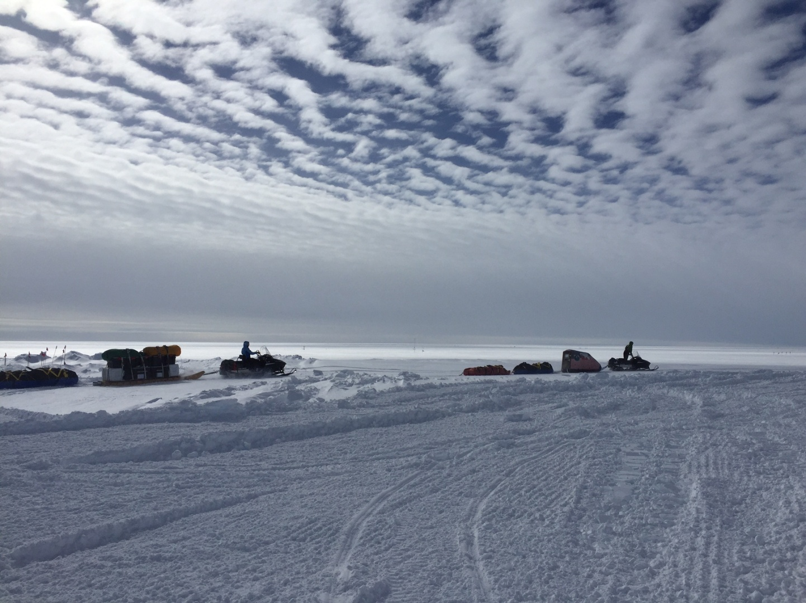Beautiful altocumulus clouds covered the sky as the GreenTRaCs team departed station. -HJ

**General:**

None to report

**Significant Weather Observations:**

* 05-01: Br, drsn. Ovc stratus. -27C, 16 kts.
* 05-02: Blsn, sn. Bkn stratus, ovc altostratus. -18C, 20 kts.
* 05-03: Blsn, sn. Ovc stratus. -10C, 26 kts.
* 05-04: Drsn, sn, br. Sct stratus, sct cumulus, bkn cirrostratus. Snow squall lasting only a few minutes at 11:45Z, heavy large dendritic flakes. -10C, wind varying from 10-20 kts throughout the day.
* 05-05: Drsn, sn, br. Ovc stratus. -12C, 17 kts. 10:00Z- large dendrites falling.
* 05-06: Few cirrus, becoming ovc altostratus to ovc stratus in the afternoon. -15C, 9 kts.
* 05-07: Sct cirrus. -15C, 10 kts.

**ICECAPS Data Management:**

* 05-01: Data transfer complete 06:49Z.
* 05-02: Data transfer complete 05:25Z.
* 05-03: Data transfer complete 06:12Z.
* 05-04: No data transfer due to internet issues at the MSF. Resolved at 13:00Z. Manual push of data to Boulder started in the afternoon.
* 05-05: Data transfer complete 05:52Z.
* 05-06: Data transfer complete 07:29Z. Ceilometer mount down overnight.
* 05-07: Data transfer complete 07:43Z.

**MWR:**

* 150-90 operating normally, HATPRO running inside for diagnostics and repairs throughout the week. Data being saved in /data_2/ directory, so no data transfer all week by Dataman.
* 05-01: Deeper diagnostic work on the HATPRO began. 17:00Z- stopped measurements, shut down software, unplugged HATPRO. Comms cable from outside brought in for testing. 17:13Z- comms cable connected, power back on, MBF sent to both radiometers. Sky tip recorded via screenshots on connected monitor. Motor was loud as mirror was rotating. Measurements continue to run inside, monitoring for error messages.
* 05-02: Diagnostic testing of the HATPRO continued, and resulted in techs replacing the entire mirror motor assembly. Metal-on-metal whining was heard as the old assembly rotated, so the old motor assembly will be sent back to RPG, along with the faulty spare comms cable. 18:05Z- measurements stopped. 18:51Z- 150-90 put back online while HATPRO mirror assembly was replaced. 20:34Z-150-90 stopped, 20:37Z- both MWRs connected. 21:08Z- regular MBF running, data saving in \data_2\ directory. The HATPRO will continue to run inside the MSF until we hear from RPG and/or the winds allow the instrument to return to the roof.
* 05-04: 15:45Z- measurements stopped to open up HATPRO for photos of mirror alignment procedure. 16:01Z- measurements resumed.
* 05-07: Reinstalled dowel on new motor placement (only one, as second one got bent in attempt to remove from original motor assembly). Measurements stopped 15:00-15:44Z.

**SODAR:**

* Operating normally.
* 05-06: Sodar home screen left with .jpeg image up overnight, no screenshots until 12:30Z.

**POSS:**

* Operating normally.

**MMCR:**

* Pitch -0.20, roll -0.22 as of 05-07.

**CAPABL:**

* Operating normally.

**MPL:**

* Operating normally.

**VCEIL:**

* Operating normally.
* 05-05: 16:57-17:00Z: power cycled computer for Hotplate troubleshooting.
* 05-06: Mount down overnight, no data transferred.

**Hotplate:**

* 05-05: Attempted to connect inside, but ran into communications issues reading “Error 8 occurred at open/create/replace file… File permissions error; you do not have permissions for the file.” Not able to ping Hotplate, no IP address found labeled Hotplate.

**IceCAM:**

* Operating normally.

**PAERI:**

* Operating normally.

**TSI:**

* Stored in MSF for winter.

**IcePIC:**

* 05-04: Slides placed for collection 11:45-14:15Z. Particles photographed include broken stellar dendrite arms, simple stars, stellar plates, hexagonal plates, isolated bullets, a few instances of rimed crystals, and irregulars.
* 05-05: Slides placed for collection 13:00-13:20Z. Particles photographed include stellar plates, stellar dendrites, sectored plates, hexagonal plates, split plates, some rimed crystals, simple stars, double plates, and lots of broken arms of dendrites.

**Radiosonde:**

* Twice daily soundings.
* 05-03: Evening balloon experienced a failed humidity sensor. Due to 35 knot winds, a second balloon was not attempted.
* Ongoing troubleshooting dealing with *.mwx and *.spf files not being grabbed by Dataman. For now, every other day I will manually change the permissions.

**MASC:**

* Offsite for repairs since 2016-05-03.