**ICECAPS Weekly Report**

May 15 – May 21, 2017

Hannah James & Marci Beitch

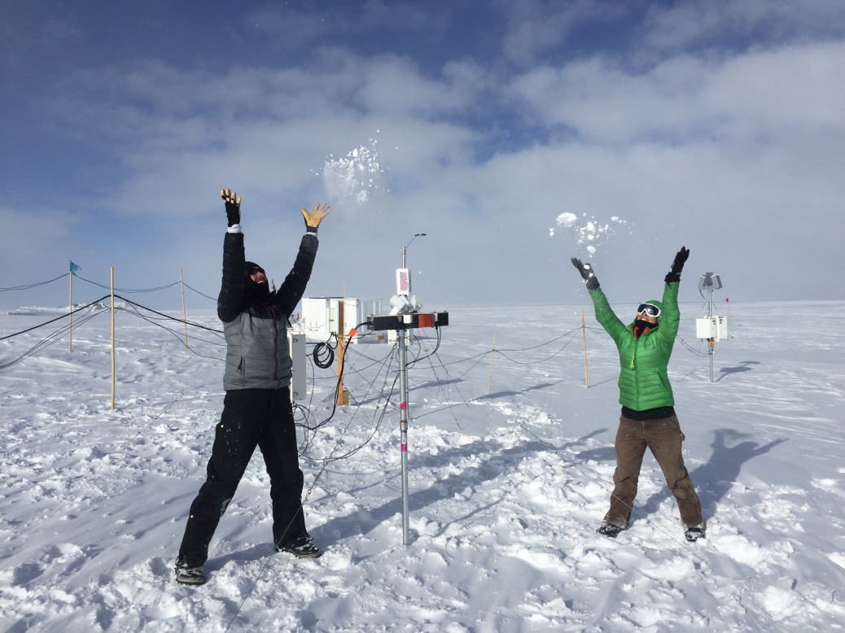

Marty and Marci celebrate the success of the MASC installation, while at the same

time test the precipitation sensors. – HJ

**General:**

A busy and successful week with the start of Flight Period 2 and tech turnover week! Marty Martinez arrived with the MASC on Wednesday, but due to high winds installation was delayed until Sunday afternoon. The ICECAPS precipitation suite is now complete! Marci Beitch also arrived on Wednesday to replace Hannah for the next few months. A number of planned power outages occurred this week in order to get our micro-turbine generator online. The first was 2017-05-19 from 11:05-11:16Z, the second on 2017-05-20 from 11:08-11:16Z. All instruments fared well, specific shutdowns are noted below.

**Significant Weather Observations:**

* 05-15: Few cirrus, few cirrostratus. Becoming ovc and –sn at 20:00Z. -18 C, 7 kts. 12:00Z- fata morgana. 17:35Z- halo.
* 05-16: Bkn altocumulus, bkn cirrus. -18C, 5 kts. –Sn 10:00Z.
* 05-17: Few stratus in far distance. Skc overhead. -20C, 6 kts. 10:00Z- fata morgana.
* 05-18: Drsn. Few stratocumulus, altostratus, cirrostratus, cirrus. -14C, 16 kts. Winds picking up to 20 kts at 14:00Z, increasing to 25 kts 18:00Z.
* 05-19: Drsn, -sn. Ovc stratus. -8C, 20 kts.
* 05-20: Blsn, Ic, Few to Bkn altocumulus. -7C, 28 kts. 20:00Z- solar halo, parhelia, circumzenithal arc.
* 05-21: Drsn, -sn. Bkn stratocumulus, changing to sct cumulus in afternoon. -10C, 16 kts. 00:00Z solar halo.

**ICECAPS Data Management:**

* 05-15: Data transfer complete 05:22Z.
* 05-16: Data transfer complete 05:33Z.
* 05-17: Data transfer complete 05:22Z.
* 05-18: Data transfer complete 07:17Z.
* 05-19: Data transfer complete 07:22Z.
* 05-20: Data transfer complete 06:27Z.
* 05-21: Data transfer complete 07:32Z.

**MWR:**

* Operating normally.
* 05-15: HATPRO taken down to fix mirror alignment. 11:26Z- MBF stopped, HATPRO powered down and disconnected. 11:38Z- scan_11_hf.mbf started on 150-90. Once the HATPRO was inside, the lid was removed and the mirror was rotated by 90 degrees and re-affixed to the shaft. The HATPRO was placed back on the roof, reconnected, and collecting data with the regular scan_11.mbf running at 17:04Z.
* 05-17: R2CH program found not running. Last saved data started yesterday at 16:19Z. Restarted program and loaded MBF at 12:08Z.
* 05-19: Communication error found upon daily rounds, 150-90 not connected since 04:21Z. While trying to re-establish connections, “Baudrate programming failed! Connection not established.” message appears, and R2CH software freezes. Restarted computer at 13:34Z, but connections not established. Power cycled the MWRs at the power switch, successful data connection established at 15:22Z.
* 05-20: Same communication error as yesterday discovered upon daily rounds, last connection recorded was previous day at 23:20Z. 11:00-12:10Z- MWRs shut down for power outage lasting more than 15 minutes.
* 05-21: Same communication error found, no connection to radiometers as of yesterday at 15:13Z. 18:26Z- Clicked “go offline,” but software froze up. Ended program, power cycled radiometers, started R2CH software. MBF loaded, data collection resumed 18:31Z.

**SODAR:**

* Operating normally.
* Flights throughout the week introduced noise picked up by the sodar.
* 05-19: 16:00-16:32Z: Sodar shut down for power outage lasting more than 15 minutes.
* 05-20: 10:46-11:53Z: Sodar shut down for power outage lasting more than 15 minutes.

**POSS:**

* Operating normally.

**MMCR:**

* Pitch -0.21, roll -0.22 as of 05-21.
* 05-20: 18:45-19:11Z: System reboot performed for turnover. Two reboots required due to faults. Desiccant changed.

**CAPABL:**

* Operating normally.
* 05-20: 13:31Z: LabView program accidentally shut off while trying to configure new settings for auto-shutdown with UPS support. Took the time with the Laser off to clean the window, CAPABL back up and running at13:43Z.

**MPL:**

* Operating normally.
* 05-19: 15:27Z: Updated time, computer clock 20 seconds ahead. 16:03-16:05Z: MPL shut down for power outage lasting more than 15 minutes.
* 05-20: 10:40-11:28Z- MPL shut down for power outage lasting more than 15 minutes. 18:19-18:38Z- MPL Afterpulse calibration performed. 30 m, 30 s 18:19-18:27Z CoPolBkdAvg 0.000227, CoPolStdDev 0.000178. 15 m, 30 s 18:28-18:36Z CoPolBkdAvg 0.000227, CoPolStdDev 0.000240.

**VCEIL:**

* Operating normally.
* 05-20: 10:58-11:40Z- Shut down for power outage lasting more than 15 minutes.

**Hotplate:**

* Hotplate potentially not registering precipitation.
* 05-20: Hotplate error discovered. 10:57-11:42Z- shut down for power outage lasting more than 15 minutes, error was gone and data collection resumed.

**IceCAM:**

* Operating normally.
* 05-19: Image not taken during 11:15Z power outage.
* 05-20: Image not taken during 11:15Z power outage.

**PAERI:**

* Operating normally.

**TSI:**

* Operating normally.
* 05-17: Installed on the MSF roof. Collecting data at 15:58Z.
* 05-18: TSI not mounted (Matt Shupe added it to the Dataman grab later in the afternoon).

**IcePIC:**

* No images captured this week.

**Radiosonde:**

* Twice daily soundings.
* Ongoing troubleshooting dealing with *.mwx and *.spf files not being grabbed by Dataman. For now, every other day I will manually change the permissions.

**MASC:**

* 05-17: Returned to station with Marty Martinez!
* 05-21: Installed, powered on, and collecting data by 18:00Z.