**ICECAPS Weekly Report**

May 22 – May 28, 2017

Hannah James & Marci Beitch

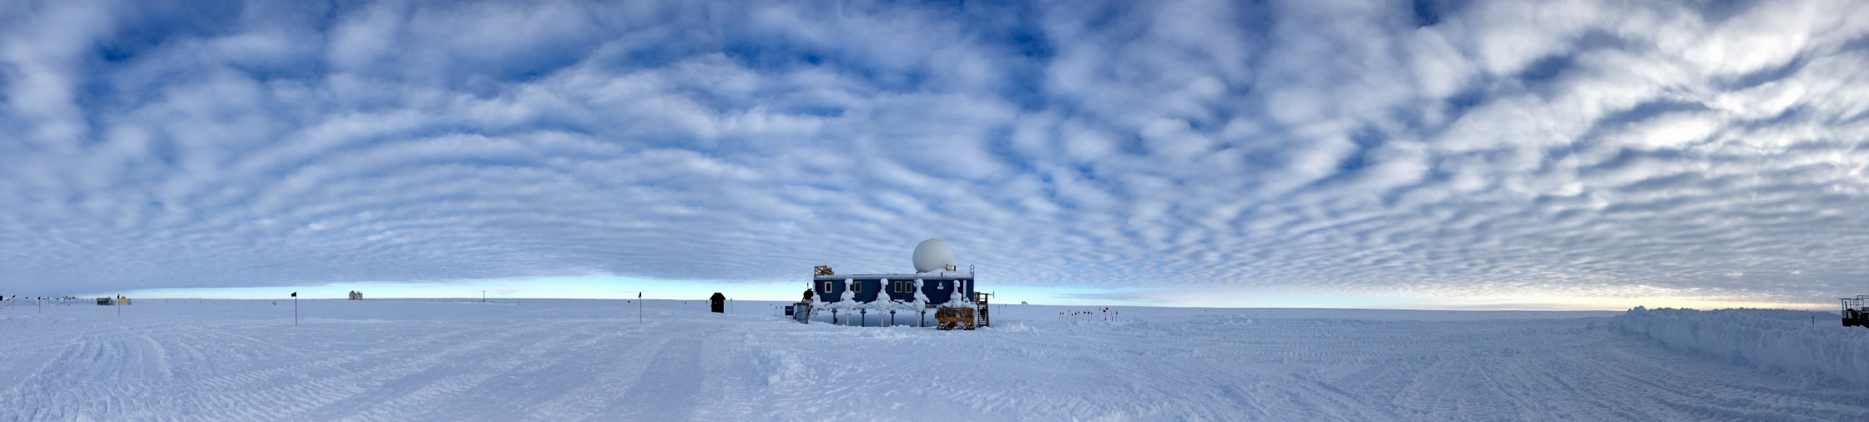

Altocumulus clouds approximately 2 km above Summit Station, 05-26 23:50Z. (Photo: Marci Beitch)

**General:**

This week Hanna and Marci completed turnover and Hannah departed Summit Station on 05-23. Marty Martinez completed testing with the MASC and also departed Station on 05-23. The Station experienced an unplanned power outage on 05-22 from 18:31-18:39Z. All ICECAPS instruments were powered by UPS during the outage.

**Significant Weather Observations:**

* 05-22: Sct to Bkn altocumulus and cirrus. Drsn, Blsn at times. Sg and -Sn. Some Fzfg and patchy Br. -10C, 22 kts decreasing to 12 kts.
* 05-23: Few to Bkn altocumulus and cirrus. Becoming Few altostatus. Drsn. Ic. Fu from LC-130 on deck. -16C, 15 kts.
* 05-24: Few altostratus. Br. -16C, 2-3 kts.
* 05-25: Few to Sct cirrocumulus. Ic. -13C, 7 kts. 1200Z solar halo.
* 05-26: Sct to Bkn altostratus and altocumulus. -14C, 2-4 kts.
* 05-27: Few cirrocumulus. -16C, 7 kts.
* 05-28: Few becoming Ovc altocumulus. -Sn. -12C. 10 kts becoming 16 kts.

**ICECAPS Data Management:**

* 05-22: Data transfer complete 06:16Z. Swapped out USB Disk #3 with #1.
* 05-23: Data transfer complete 07:02Z.
* 05-24: Data transfer complete 06:19Z.
* 05-25: Data transfer complete 06:27Z.
* 05-26: Data transfer complete 05:59Z.
* 05-27: Data transfer complete 05:59Z.
* 05-28: Data transfer complete 05:58Z.

**MWR:**

* Operating normally.

**SODAR:**

* Operating normally.
* Monday, Tuesday, and Thursday flights introduced noise picked up by the sodar.

**POSS:**

* Operating normally.

**MMCR:**

* Operating normally.
* Pitch -0.21, roll -0.22 as of 05-28.

**CAPABL:**

* Operating normally.
* 05-21: Removed head of Laser One for shipment back to the US. As of 2017-05-20, CAPABL only has Laser Two installed.

**MPL:**

* Operating normally.

**VCEIL:**

* Operating normally.

**Hotplate:**

* Operating normally.

**IceCAM:**

* Operating normally.

**PAERI:**

* Operating normally.

**TSI:**

* Operating normally.

**IcePIC:**

* 05-22: Images captured.

**Radiosonde:**

* Twice daily soundings.
* Ongoing troubleshooting dealing with *.mwx and *.spf files not being grabbed by Dataman. For now, every other day I will manually change the permissions.
* 05-22: 1200Z initial sounding (launch time 11:14Z) terminated early due to PTU sensor failure. Second sounding was performed (launch time 12:03Z) and was successful.

**MASC:**

* Operating normally.
* 05-22: Marty Martinez continued testing with rice to create a set of calibration images.