**ICECAPS Weekly Report**

May 29 – June 4, 2017

Marci Beitch

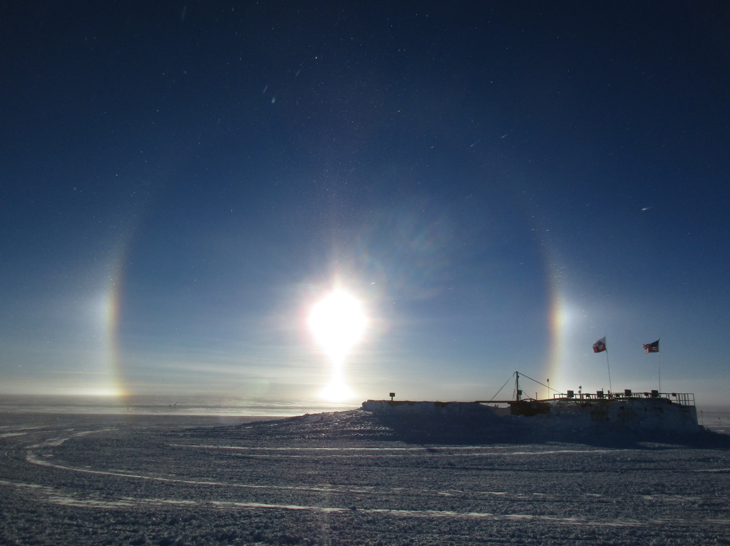

Ice crystals in the air and a strong solar halo and parhelia seen behind the fuel pits, 05-31 00:03Z.

(Photo: Marci Beitch)

**General:**

It was a quiet week in between flight periods. Pleasant outdoor conditions signaled that Summit Station is settling into summertime.

**Significant Weather Observations:**

* 05-29: Few altocumulus. Ic. Br. -15C, 12 kts. Halo and parhelia observed at 09:45Z.
* 05-30: Few cirrus. Drsn. Ic. Br. -17C, 17 kts. Halo and parhelia observed most of the day. *201705310003Z.halo_parhelia* photo saved into Significant Wx Pics on Dataman.
* 05-31: Few cirrus. Ic. -15C, 11 kts.
* 06-01: Sct altocumulus becoming Bkn stratocumulus. Ic then Sg. -15C, 10 kts.
* 06-02: Sct cirrocumulus and cirrus. Fzfg in early morning. -17C, 5 kts.
* 06-03: Few cirrus. Heavy Fzfg in evening. -15C, 4 kts.
* 06-04: Few cirrus. -13C, 6 kts.

**ICECAPS Data Management:**

* 05-29: Data transfer complete 06:06Z.
* 05-30: Data transfer complete 06:15Z.
* 05-31: Data transfer complete 05:52Z.
* 06-01: Data transfer complete 05:34Z.
* 06-02: Data transfer complete 06:09Z.
* 06-03: Data transfer complete 06:08Z.
* 06-04: Data transfer complete 05:52Z.

**MWR:**

* Operating normally.

**SODAR:**

* Operating normally.
* 05-29 16:45-16:51Z: Cleaned snow out of receiver dish only (transmitter dish was clear of snow).

**POSS:**

* Operating normally.

**MMCR:**

* Operating normally.
* Pitch -0.21, roll -0.22 as of 06-04.

**CAPABL:**

* Operating normally.

**MPL:**

* Operating normally.

**VCEIL:**

* Operating normally.

**Hotplate:**

* Operating normally.

**IceCAM:**

* Operating normally.

**PAERI:**

* Operating normally.
* 06-02: 13:37-13:40Z removed PAERI fan enclosure and cleaned rime from fan blades.

**TSI:**

* Operating normally.
* 06-01: Noticed computer clock running 18 minutes behind server time. Computer clock reset at 18:25:55Z from 18:07Z. Image names jump from 180700 to 182557, then 182600 and so on.
* 06-03: Computer clock running 3 minutes behind server time. Computer clock reset at 12:49:30Z from 12:46Z. Image names jump from 124600 to 124935, then 125000 and so on.
* 06-03 and 06-04: TSI Manager program capturing images each minute but running very slowly (i.e. freezing up when clicking to view earlier images). Unable to view earlier images of the day.
* 06-04: Computer clock running 4 minutes behind server time. Computer clock reset at 16:09:00Z from 16:05Z. Image names jump from 160500 to 160915, then 161000 and so on.

**IcePIC:**

* No images captured this week.

**Radiosonde:**

* Twice daily soundings.
* *.mwx and *.spf files are not being grabbed by Dataman. Files are manually pushed every 1-2 days by changing permissions in the Sounding Archive folder.
* 06-03: Evening radiosonde experienced humidity sensor failures. The problems arose when the conditioned sondes were placed outside. RH values bounced between 50 and 100% for one sonde and exceeded 100% for two other sondes. Four attempts at reconditioning were made with three sondes. The sounding software, computer, and SPS were rebooted in between reconditioning attempts. No 06-04 0Z launch was made. Outdoor conditions were heavy freezing fog and light winds.

**MASC:**

* Operating normally.