**ICECAPS Weekly Report**

May 8 – May 14, 2017

Hannah James

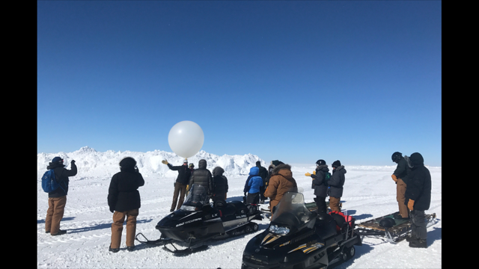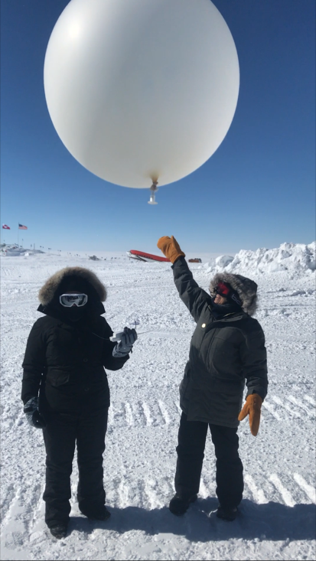 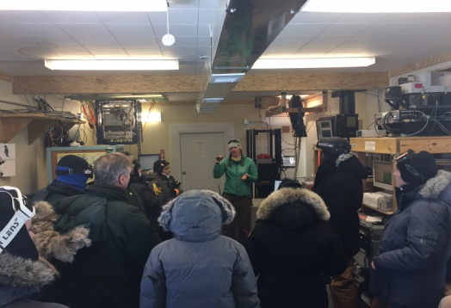

Minster Jakobsen and Dr. Cordova launch a radiosonde during the CODEL visit, Hannah and Auroroa explaining our radiosonde campaign, and the tour of the MSF and ICECAPS project. – KH, GD photos

**General:**

Another busy week here at Summit, with the highlight being the Congressional Delegation visit led by Dr. France Cordova (Director of the National Science Foundation) and Jen Mercer (Arctic Support and Logistics Manager).

**Significant Weather Observations:**

* 05-08: Drsn, br, -sn. Ovc altostratus. -14C, 20 kts.
* 05-09: Blsn, sn. VV. -18C, 30 kts. 18:00Z- 46 and 22 degree halo, lower tangent arc, start of parhelic circle.
* 05-10: Few cirrostratus. -28C, 6 kts.
* 05-11: Few altostratus, bkn cirrus. -26C, 10 kts.
* 05-12: Br, IC. Sct altostratus, sct cirrostratus. -28C, 14 kts.
* 05-13: Vcfzfg. Few stratus, far in the distance. -32C, 8 kts.
* 05-14: Vcfzfg. Few stratus far in the distance. -24C, 10 kts.

**ICECAPS Data Management:**

* 05-08: Data transfer complete 05:46Z.
* 05-09: Data transfer complete 05:18Z.
* 05-10: Data transfer complete 05:47Z.
* 05-11: Data transfer complete 05:42Z.
* 05-12: Data transfer complete 07:48Z.
* 05-13: Data did not transfer overnight. Started manual push at 10:25Z. Data still did not transfer, rebooted system at 18:11Z.
* 05-14: Data transfer from previous two days complete late in afternoon.

**MWR:**

* 150-90 operating normally, HATPRO running inside for diagnostics and repairs throughout the week. Data being saved in /data_2/ directory, so no data transfer all week by Dataman.
* 05-09: 17:05-17:06Z- Measurements stopped to switch to V11_SCAN_HF.mbf. 17:24-17:27Z- Measurements stopped to disconnect HATPRO, data redirected back into \data\ folder so Dataman will transfer 150-90 data. HATPRO powered down, communication cable disconnected in preparation for move to roof.
* 05-10: HATPRO placed back on MSF roof. Measurements were stopped on the 150-90 at 20:18Z, the regular measurement batch file was sent and data was being collected by both radiometers at 20:19Z.
* 05-11: Liquid nitrogen calibration attempted on HATPRO. 15:54Z- stopped measurements. 16:03- started absolute calibration. A few minutes in, “No response to cold load. Calibration terminated!” message was displayed. It was discovered that the HATPRO was the slave, so the comm ports were swapped via serial configuration, and a new calibration was started. This responded with the same message. 16:35-17:08Z- internal_external_flop measurement ran.
* 05-14: News from Dave and Erik that the mirror is not positioning correctly because it is flipped 180 degrees from where it should be. HATPRO will come back down Monday morning.

**SODAR:**

* Operating normally.
* 05-10: Cleaned Sodar dishes, transceiver off 13:13-13:23Z.

**POSS:**

* Operating normally.
* 05-13: Rebooted Dataman computer due to transferring issues. POSS offline 18:11-18:22Z.

**MMCR:**

* Pitch -0.20, roll -0.11 as of 05-14.

**CAPABL:**

* Operating normally.

**MPL:**

* Operating normally.

**VCEIL:**

* Operating normally.
* 05-09: Brief loss of data when computer was accidentally powered down when troubleshooting Hotplate.
* 05-10: Black insulation blanket taken down for summer season.
* 05-12: 12:01Z- Instrument briefly stopped on accident while repositioning monitor/keyboard.

**Hotplate:**

* Operating normally.
* 05-05: Attempted to connect inside, but ran into communications issues reading “Error 8 occurred at open/create/replace file… File permissions error; you do not have permissions for the file.” Not able to ping Hotplate, no IP address found labeled Hotplate.
* 05-09: More troubleshooting with Matt Shupe continued via email and skype call. Connected ceilometer computer and Hotplate to a separate Network switch (found in the black spare ICEAPS crate). Able to reset the IP address to .134 by isolating the Hotplate this way. Changed permissions to allow full access to YESINC folder on computer, letting data be written and saved. Running and collecting data in the MSF at 22:49Z. Ran over night with fan blowing on it.
* 05-10: Installed outside in precipitation suite, running in the evening.
* 05-12: Offline 17:20-17:28 for data cable rearrangement.

**IceCAM:**

* Operating normally.
* 05-11: Leveled at 12:45Z.

**PAERI:**

* Operating normally.

**TSI:**

* Stored in MSF for winter.

**IcePIC:**

* 05-05: No images captured this week.

**Radiosonde:**

* Twice daily soundings.
* 05-13: Extra sonde launched at 15:30Z during Congressional Delegation visit.
* Ongoing troubleshooting dealing with *.mwx and *.spf files not being grabbed by Dataman. For now, every other day I will manually change the permissions.

**MASC:**

* Offsite for repairs since 2016-05-03.