**ICECAPS Weekly Report**

November 13 – November 19, 2017

Hannah James

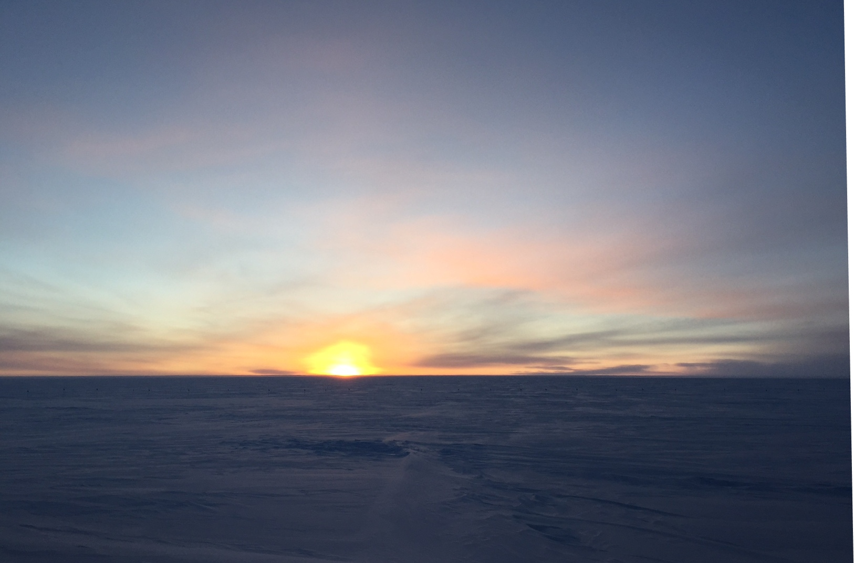

Although the sun offically set the previous day, a strong inversion

on Tuesday provided one last look for 2017. -HJ

**General:**

* The Hotplate and MASC were brought inside for inspection/further troubleshooting. Summit experienced a planned power outage on 2017-11-18 lasting from 13:03-13:05Z and 13:06-13:08Z. The MSF had a very sporadic internet connection on 2017-11-19. On the same day, the KVM switch hosting Dataman/POSS/IceCam, MWR, and SODAR computers stopped working, therefore preventing access to all these instruments.

**Significant Weather Observations:**

* 11-13: Few stratus, sct altostratus, bkn cirrus. -32C, 13 kts. Fzfg, -sn in the afternoon.
* 11-14: Few stratus, sct altostratus, sct cirrus. -45C, 13 kts. Vcfzfg. 13:00Z- fatamorgana.
* 11-15: Sct altostratus, sct cirrus. -41C, 13 kts. Br.
* 11-16: Sct altostratus, sct cirrus. -46C, 14 kts. Vcfzfg.
* 11-17: Bkn stratus, ovc cirrostratus. -37C, 14kts. Br, -sn in morning.
* 11-18: Few cirrostratus. -47C, 14 kts.
* 11-19: Few cirrostratus on far horizon, clear overhead for most of the day. -50C, 16 kts. Br in morning, fzfg in evening.

**ICECAPS Data Management:**

* 11-13: Data transfer complete 10:55Z.
* 11-14: Data transfer complete 12:16Z.
* 11-15: Data transfer complete 12:35Z.
* 11-16: Data transfer complete 12:11Z.
* 11-17: Data transfer complete 12:14Z.
* 11-18: Data transfer complete in late afternoon.
* 11-19: Data transfer not completed due to broken internet connection to MSF throughout the day.

**MWR:**

* As of 10-28, 150-90 operating in V11_SCAN_HF.MBF. HATPRO remains on and heated until weather conditions allow it to come off the MSF roof.
* KVM issues preventing direct access, accessible via LogMeIn.

**SODAR:**

* Operating normally.
* KVM issues preventing access.

**POSS:**

* KVM issues preventing access.
* Old POSS software unable to run due to a “segmentation fault” beginning 11-15. No data collection since.
* Working with Peter at EC to run new software. POSS offline from time to time while troubleshooting.

**MMCR:**

* Operating normally.
* 11-17: 04:00Z- “Could not read calibration table NetCDF file” error appeared. System rebooted multiple times starting 14:10Z, resumed data collection at 17:38Z.
* 11-18: MMCR found with an unexpected shutdown message. Rebooted, running with daily checks passing at 12:51Z.

**CAPABL:**

* Operating normally.
* 11-19: Found with Block Diagram for Polarization Control open and error line flashing. Robert was contacted; he was able to remote in. Per his request, a flashlamp change was performed on Laser 1. CAPABL was off from 18:02-19:09Z during this process.

**MPL:**

* Operating normally.

**VCEIL:**

* Operating normally.

**Hotplate:**

* Currently in the MSF to troubleshoot persistent miscellaneous errors.
* 11-17: 17:11Z- powered down for further troubleshooting in the MSF.

**IceCAM:**

* Operating normally.

**PAERI:**

* Operating normally.

**TSI:**

* In the MSF for winter storage.

**IcePIC:**

* No images collected this week.

**Radiosonde:**

* Twice daily soundings.

**MASC:**

* 11-17: 18:00Z- MASC shut down to bring inside to check for leaks, inspect desiccant etc. Electronics box was raised.