**ICECAPS Weekly Report**

November 27 – December 03, 2017

Hannah James

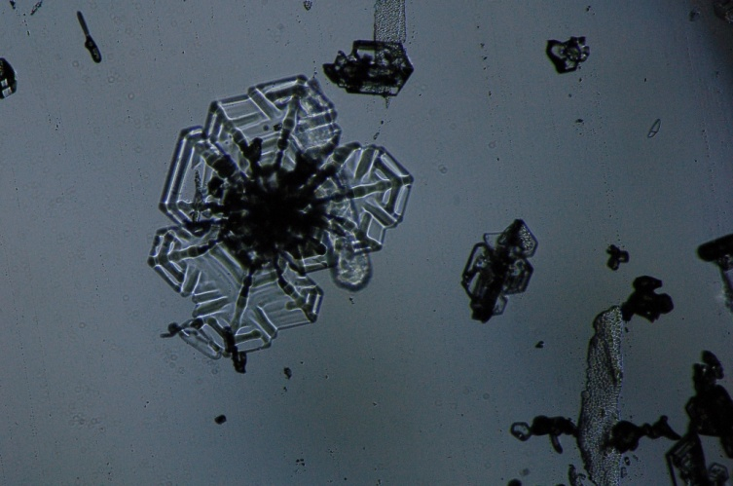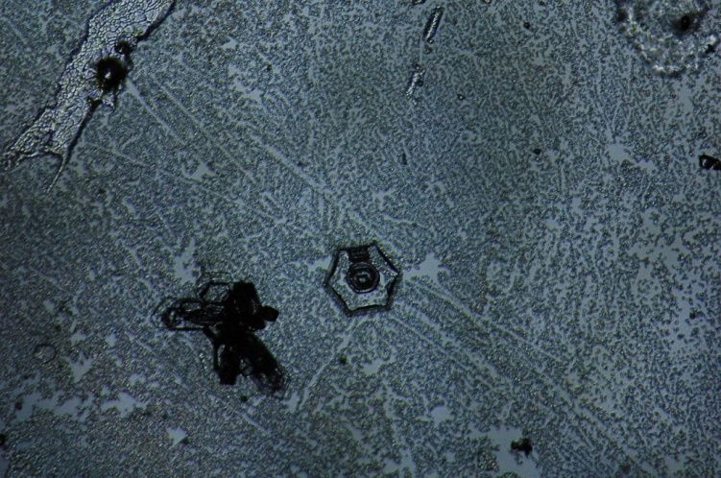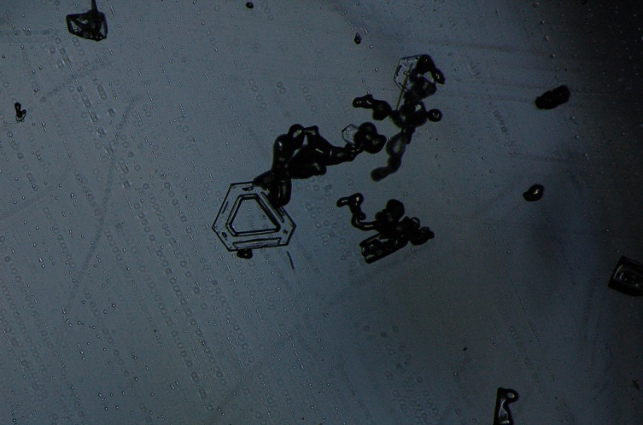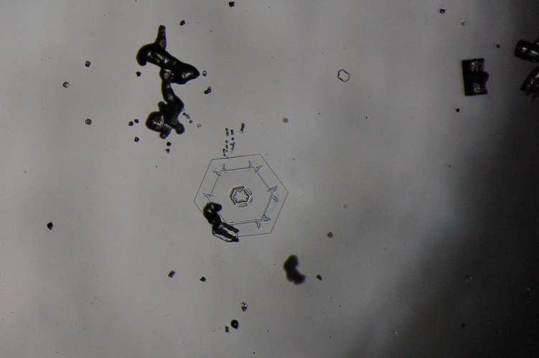

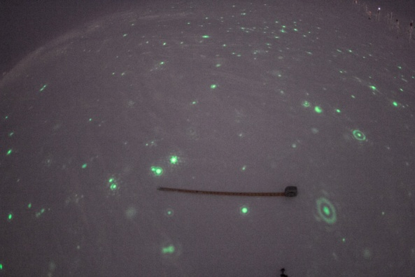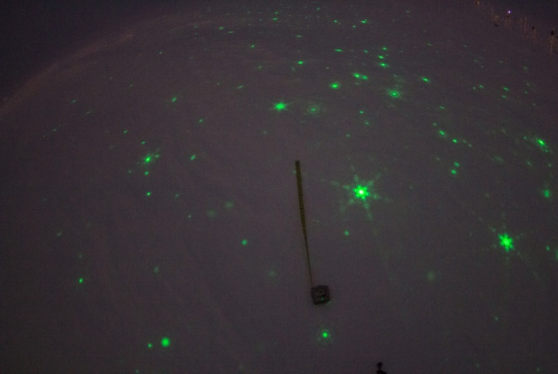

A sample of IcePICs taken during a Rave Ice event. Tape measures 3 feet. -IcePICs HJ, Rave Ice MM

**General:**

* Two planned power outages occurred this week, on 11-27 from 17:01-17:03Z and 12-03 from 17:02-17:03Z.

**Significant Weather Observations:**

* 11-27: Ovc stratus. -23C, 11 kts. -Sn in the evening.
* 11-28: Ovc stratus. -16C, 17 kts. Sn, drsn. Large dendrites 20:00-21:00Z.
* 11-29: Few nimbostratus in distance, bkn stratus, bkn cirrus.-16C, 13 kts. -Sn in morning. 11:00-11:30Z- verga. Clearing to bkn altocumulus ~14:00Z. Winds increased to 20+ kts in the afternoon.
* 11-30: Sct stratus, bkn altostratus. -21C, 13 kts. –Sn. 14:00Z- cumulus clouds.
* 12-01: Few stratus, sct stratocumulus, sct cirrus. -32C, 13 kts. –Sn. Winds increased in the evening.
* 12-02: Bkn stratus, ovc cirrus. -34C, 12 kts. –Sn, drsn, fzfg.
* 12-03: Bkn cirrocumulus, bkn cirrostratus. -43C, 5 kts. Fzfg, -sn.

**ICECAPS Data Management:**

* 11-27: Data transfer complete 12:01Z.
* 11-28: Data transfer complete 11:06Z.
* 11-29: Data transfer complete 16:20Z. Larger files due to IcePICs from previous day.
* 11-30: Data transfer complete 12:05Z.
* 12-01: Data transfer complete 11:56Z.
* 12-02: Data transfer complete 11:13Z.
* 12-03: Data transfer complete 11:48Z.

**MWR:**

* As of 10-28, 150-90 operating in V11_SCAN_HF.MBF. HATPRO remains on and heated until weather conditions allow it to come off the MSF roof.

**SODAR:**

* Operating normally.

**POSS:**

* Operating normally.
* Working with Peter at EC to run new software. POSS offline from time to time while troubleshooting.

**MMCR:**

* Operating normally.
* Error 7, Receiver Cal running. Error cleared, normal operations resumed at 13:12Z.

**CAPABL:**

* Operating normally.
* 11-28: 12:50-13:15Z: CAPABL laser turned off to remove snow and ice from outside window. IcePICs and Rave Ice event captured in photos 17:40-18:30Z.
* 11-30: 12:28-12:42Z: CAPABL laser turned off to remove snow and ice from outside window.
* 12-01: 20:32-20:39Z: CAPABL laser turned off to remove snow from outside window.
* 12-02: 13:12-13:41Z: CAPABL laser turned off for roof work near laser output.

**MPL:**

* Operating normally.
* 11-28: 13:00Z- removed snow and ice from outside window.

**VCEIL:**

* Operating normally.

**Hotplate:**

* 11-27: Reinstalled outside, miscellaneous errors reappeared.
* 11-29: Brought back into the MSF for testing. Direct connection to the network switch proved successful. The Hotplate was set up on the front porch of the MSF, and connected to the network via a new Cat 5E cable. Test ran for 20 minutes with success.
* 11-30: 12:50-16:40Z- testing continued on MSF front porch with new Cat 5E cable. Successfully collected data.
* 12-02: Walked existing outside cable and found a small kink, plus some rusting on the end of the outdoor cable. Replaced female-to-female Cat 5 connector at Hotplate box. Data was collected for 13 minutes, but the “test” precipitation was not registered by the instrument. Errors appeared and persisted shortly thereafter. Hotplate brought back inside.

**IceCAM:**

* Operating normally.

**PAERI:**

* Operating normally.
* 12-01: Shelter fan not running or drawing any power. 12:35Z- unplugged fan, brought enclosure inside. Shelter thawed and dried out. Replaced seized fan #6 with fan #4, replaced blown fuse. Shelter fan replaced at 16:32Z.

**TSI:**

* In the MSF for winter storage.

**IcePIC:**

* 11-28: IcePICs taken during Rave Ice event 17:40-18:30Z. Images include simple prisms, solid columns, sheaths, hexagonal plates, hollow columns, stellar plates (broken and whole), bullet rosettes, split plates, split stars, radiating plates, sectored plates, isolated bullets, 1 radiating dendrite (broken and rimed), 1 simple needle, graupel, irregulars.

**Radiosonde:**

* Twice daily soundings.
* 12/01: Temp A and B messages from 00:00Z balloon failed to transmit to DMI for unknown reason.

**MASC:**

* Operating normally.
* 11-27: Raised MASC stand, reinstalled MASC. Data acquisition started at 17:40Z.
* 12-02: De-Ice cable found disconnected. Reconnected at 12:23Z, daily checks pass.