**ICECAPS Weekly Report**

November 06 – November 12, 2017

Hannah James

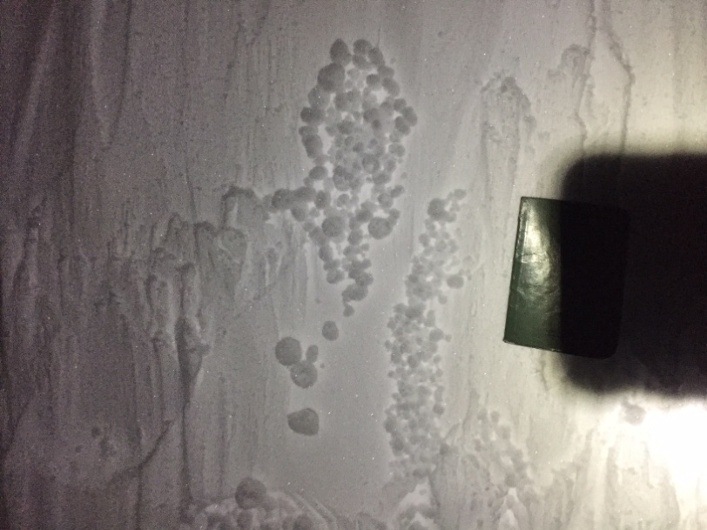 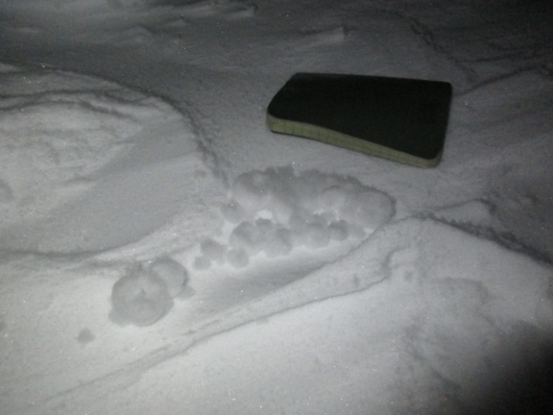

Yukimarimos discovered between the Big House and Greenhouse on 2017-11-06. -HJ

**General:**

* None to report.

**Significant Weather Observations:**

* 11-06: Bkn altocumulus. -31C, 22 kts. Up to 40 kts through the day, calming in the evening. Blsn. 22:38Z- Yukimarimos! Witnessed between Big House and Green House. Small in size (0.5-2.0cm in diameter), clustered in small wallows such as footprints and lee side of drifts.
* 11-07: Few stratus, bkn altocumulus, bkn cirrus. -38C, 22 kts. Drsn.
* 11-08: Ovc stratus. -31C, 8 kts.
* 11-09: Few stratus, sct altostratus, sct cirrus. Clearing later in the day. -40C, 11 kts.
* 11-10: Sct stratus, sct stratocumulus. -37C, 15 kts.
* 11-11: Few stratus, few cirrostratus. -50C, 13 kts.
* 11-12: Few stratus. -34C, 20 kts. Blsn.

**ICECAPS Data Management:**

* 11-06: Data transfer complete 13:04Z.
* 11-07: Data transfer complete 11:14Z.
* 11-08: Data transfer complete 10:55Z.
* 11-09: Data transfer complete 10:44Z.
* 11-10: Data transfer complete 10:08Z.
* 11-11: Data transfer complete 10:55Z. CAPABL mount down, remounted 12:46Z.
* 11-12: Data transfer complete 11:00Z.

**MWR:**

* As of 10-28, 150-90 operating in V11_SCAN_HF.MBF. HATPRO remains on and heated until weather conditions allow it to come off the MSF roof.

**SODAR:**

* Operating normally.
* 11-09: 13:36-13:46Z- SODAR off while removing snow from dishes.

**POSS:**

* Operating normally.
* Working with Peter at EC to run new software.

**MMCR:**

* Operating normally.

**CAPABL:**

* Operating normally.
* 11-10: CAPABL found with Disk Boot Error. With the initial restart, LabView crashed. After Licel, Meadowlark, and the computer were power cycled LabView crashed again. After a power cycle of all the above, plus the lasers and motors while the PC was off, CAPABL resumed data collection around 17:10Z.

**MPL:**

* Operating normally.

**VCEIL:**

* Operating normally.

**Hotplate:**

* Currently offline due to remaining miscellaneous errors. When weather and time allows, it will be brought into the MSF for troubleshooting this week.

**IceCAM:**

* Operating normally.
* 11-08: Removed frost from lens at 12:29Z.

**PAERI:**

* Operating normally.

**TSI:**

* In the MSF for winter storage.

**IcePIC:**

* No images collected this week.

**Radiosonde:**

* Twice daily soundings.

**MASC:**

* Operating normally.