**ICECAPS Weekly Report**

October 16 – October 22, 2017

Hannah James

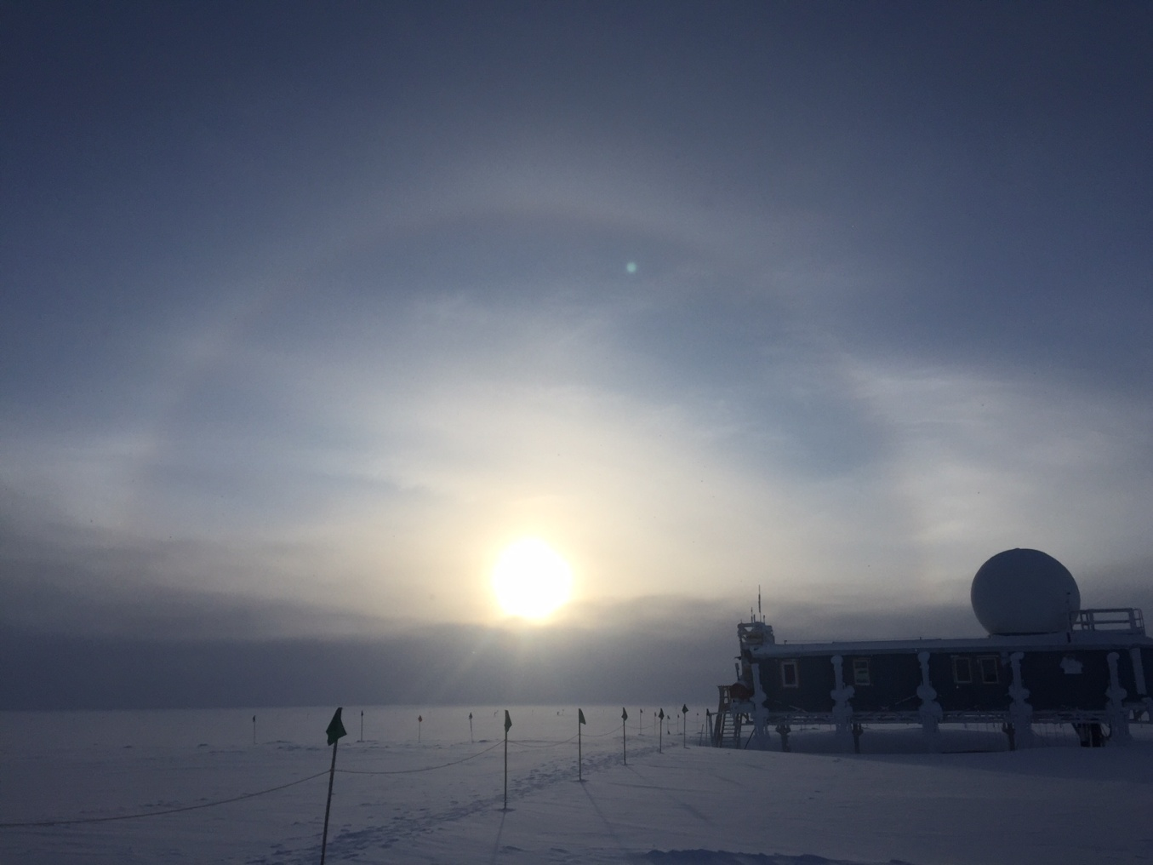

Calm winds and a halo were a welcome sight after a busy week. -HJ

**General:**

* A local MSF internet outage occurred on 2017-10-18, which caused Dataman transfers to freeze in the middle of SODAR’s transfer. SRI was contacted and internet was restored mid-afternoon Summit time.

**Significant Weather Observations:**

* 10-16: Sct stratus, bkn altocumulus, -29C, 10 kts. –Sn throughout the morning.
* 10-17: Sct cirrus. -36C, 15 kts. 11:00Z: Fatamorgana. Parhelia throughout the afternoon.
* 10-18: Sct altostratus, bkn cirrus and cirrus fibratus. Freezing fog. -32C, 17kts. Winds picked up to 20+ knots in the afternoon.
* 10-19: Bkn stratus, bkn altostratus. -22C, 24kts. Blsn.
* 10-20: Sct altostratus, sct cirrostratus. -26C, 21 kts. Blsn. Parhelia 11:30-12:30Z.
* 10-21: Bkn stratus, bkn altostratus. -24C, 13 kts. Drsn.
* 10-22: Bkn stratus, bkn cirrus. -28C, 3 kts. –Sn throughout the day.

**ICECAPS Data Management:**

* 10-16: MASC, CAPABL, and Ceilometer mounts down overnight. Remounted. Data transfer complete 09:28Z.
* 10-17: CAPABL and ceilometer mounts down overnight. Mounts report that they are connected. Data transfer complete 09:20Z.
* 10-18: CAPABL and ceilometer mounts connected and transferred previous days’ data. Lost connection mid-day during transfers, connection restored mid-afternoon by SRI. Data transfer complete 15:00Z.
* 10-19: Data transfer complete 10:33Z.
* 10-20: Data transfer complete 13:29Z. Longer period due to transfer of held MASC files since 11 Aug 2017.
* 10-21: Data transfer complete 12:11Z.
* 10-22: Data transfer complete 13:28Z.

**MWR:**

* Operating normally.

**SODAR:**

* Operating normally.

**POSS:**

* 08-14 to 10-22: The log files show ‘posaccmsod’ and truncated messages.

**MMCR:**

* Operating normally.

**CAPABL:**

* Operating normally.
* 10-16: Mount down, data not transferring.
* 10-17: Data not transferring.
* 10-18: Data from previous day successfully transferred, but a Disk Boot failure occurred. CAPABL restarted, collecting data in “FloatingRefLaser1.” Daily checks pass.

**MPL:**

* Operating normally.
* 10-19: Monthly afterpulse calibration performed 12:25-12:47Z. 12:27-12:36Z- 30m, 30s. CopolBkdAvg: 0.000244, CopolBkdStd: 0.000165. 12:37-12:45Z- 15m, 30s. CopolBkdAvg: 0.000216, CopolBkdStd: 0.000235.

**VCEIL:**

* Operating normally.
* 10-16: Mount down, no data transfer.

**Hotplate:**

* Operating normally.
* 10-16: “Visa read line” error found with Hotplate not connected. Reconnected at 13:12Z.
* 10-19: Same error as above, reconnected at 12:33Z.

**IceCAM:**

* Operating normally.

**PAERI:**

* Operating normally.

**TSI:**

* Winter storage in the MSF.

**IcePIC:**

* Images not captured.

**Radiosonde:**

* Twice daily soundings.
* After discussion of failed sondes with Matt O, it was decided that the ICECAPS iPad should be used at the SMG prior to launch to check the status of the sonde via the VNC app.
* 10-16: Evening radiosonde not launched due to 2 separate humidity failures.

**MASC:**

* Operating normally.
* 10-16: Mount down.
* 10-17/18: High temperatures reported on Apple SSD computer. John and Ralf looked into this, and it was bad data rather than high temperatures. John reset the hardware monitor to report true values.
* 10/20: MASC files dating back to 11 August 2017 successfully transferred through Dataman.