**ICECAPS Weekly Report**

October 2 – October 8, 2017

Sam Dorsi

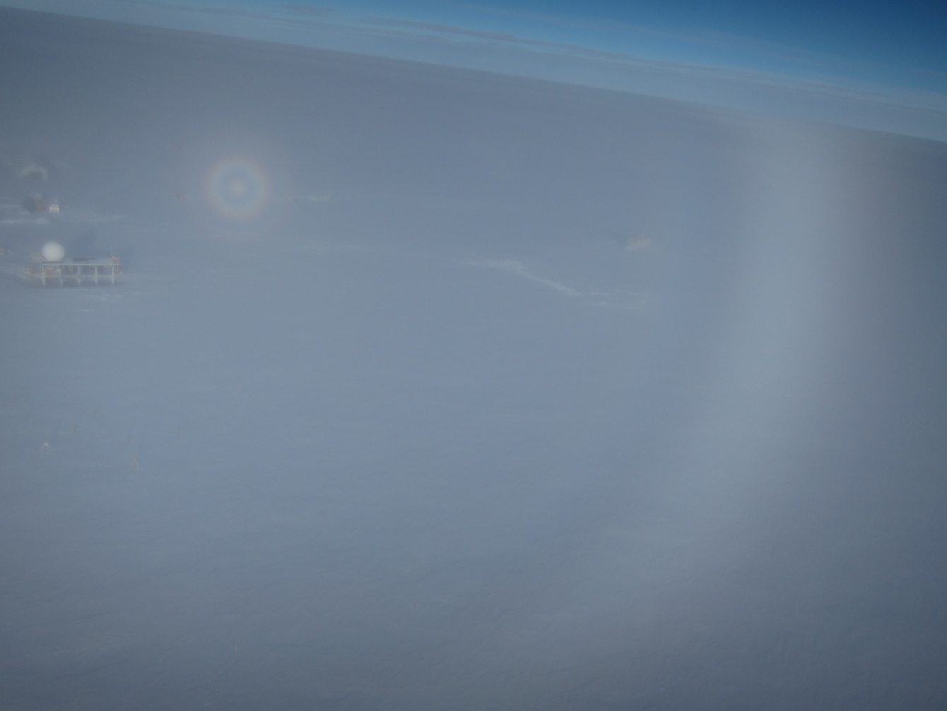

A kite-aerial perspective shows a fogbow and glory over the station. SWD

**General:**

* No ICECAPS spare monitors remain.

**Significant Weather Observations:**

* 10-02: Few altocumulus, -23C. 6 kts. Sundog 11:40 to 12:00Z.
* 10-03: Scattered altostratus, -28C, 8 kts.
* 10-04: Scattered altostratus, -29C, 7 kts. Sundog 10:20Z.
* 10-05: Broken stratus, freezing fog, -20C, 9 kts. Fogbow and glory 12:10 to 12:50Z.
* 10-06: Overcast stratus, freezing fog, -20C, 6 kts.
* 10-07: Broken altocumulus, -23C, 8 kts.
* 10-08: Broken stratus, -21C, 10kts.

**ICECAPS Data Management:**

* 10-02: Data transfer complete 12:02Z.
* 10-03: Data transfer complete 11:51Z.
* 10-04: Data transfer complete 11:09Z.
* 10-05: Data transfer complete 14:26Z.
* 10-06: Data transfer complete 12:52Z.
* 10-06: Edited /etc/fstab to remove TSI mount during the winter.
* 10-07: Data transfer complete 11:54Z.
* 10-08: Data transfer complete 11:42Z.

**MWR:**

* Operating normally.

**SODAR:**

* Operating normally.
* 10-05: SODAR dishes cleaned 18:11 to 18:15Z.

**POSS:**

* 08-14 to 10-08: The log files show ‘posaccmsod’ and truncated messages.
* 10-04: The POSS was raised by 115 cm at 13:20Z to 13:50Z.
* 10-05: The POSS was powered down, FEP box connectors reseated, and heater bulb replaced (18:05 to 18:17Z).

**MMCR:**

* Operating normally.
* 10-05: MMCR rebooted from 13:02 to 15:10Z to address calibration table errors (persisted for ~1 week).
* 10-05: MMCR monitor failed during reboot process, and was swapped out with the final ICECAPS spare.

**CAPABL:**

* Operating normally.

**MPL:**

* Operating normally.

**VCEIL:**

* Operating normally.

**Hotplate:**

* Operating normally.
* 10-05: Instrument raised 70 cm, from 14:00 to 15:25Z

**IceCAM:**

* Operating normally.

**PAERI:**

* Operating normally.
* 10-05: Shelter fan was unusually noisy due to frost accumulation and resulting unbalanced fan. Fan was brought inside to defrost; and is operating quietly upon reinstallation (18:55 to 19:06Z).

**TSI:**

* Operating normally.
* 10-04: Powered down for the winter and removed from the MSF roof at 12:25Z.
* 10-05: Data from previous day have completed transfer and laptop is powered down as well.

**IcePIC:**

* 10-04: Slides placed for collection 18:45 to 19:07Z. Particles photographed include simple stars, radiating dendrites, and stellar dendrites.
* 10-07: IcePIC stand brought inside to defrost.

**Radiosonde:**

* Twice daily soundings.
* 10-06 0Z: Sounding failed due to humidity sensor check. Freezing fog present.

**MASC:**

* Operating normally.