**ICECAPS Weekly Report**

October 30 – November 05, 2017

Hannah James

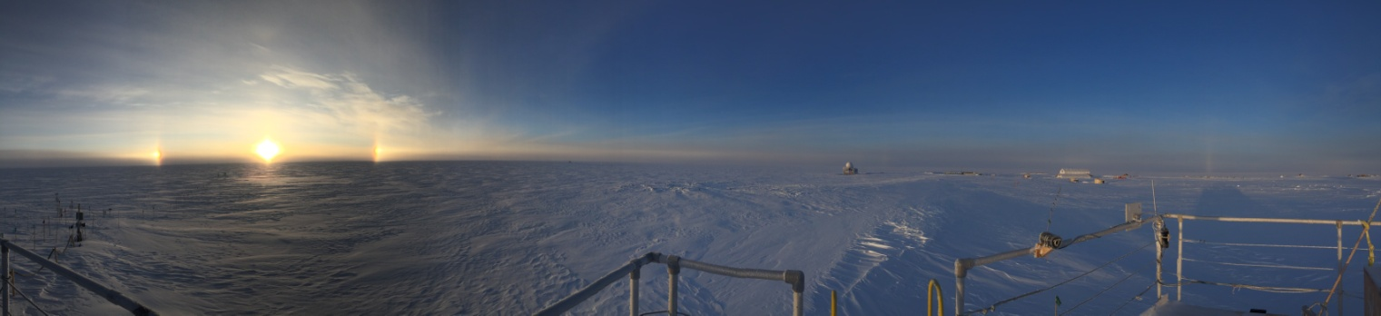

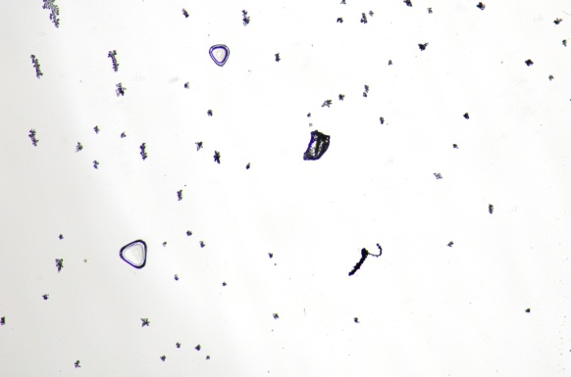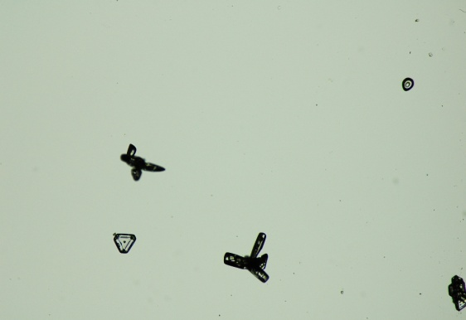 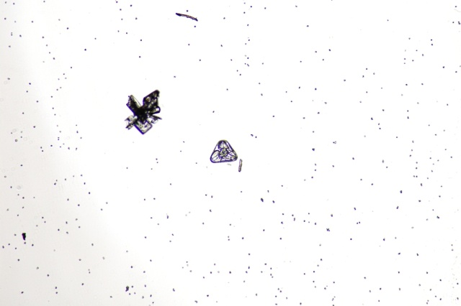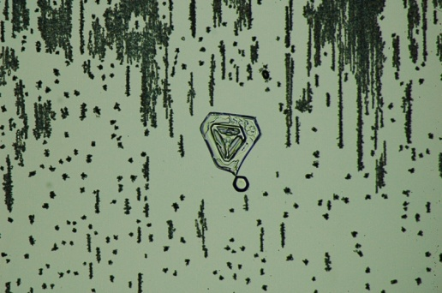 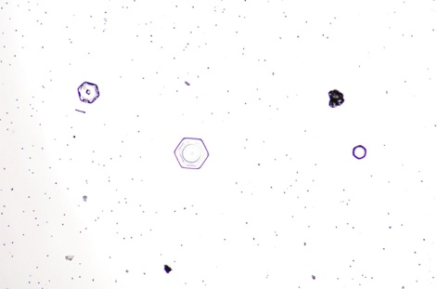

A sample of the ice crystals that provided some spectucular optics on Thursday morning. -HJ

**General:**

* Summit Station held a planned power outage on Tuesday, October 31 that lasted from 16:03-16:06UTC. A combination of high and north winds this week prevented taking the HATPRO off the MSF roof.

**Significant Weather Observations:**

* 10-30: Ovc stratus. -14C, 24 kts. Blsn.
* 10-31: Sct altostratus. -37C, 12 kts. Br, drsn.
* 11-01: Ovc stratus. -17C, 30 kts. Blsn.
* 11-02: Sct stratus, bkn altostratus, bkn cirrus. -36C, 12 kts. IC. 13:00-13:45Z- parhelia, 120 parhelia, parhelic circle, and column on opposite side of horizon (tricker and diffuse arc, perhaps?) Parhelia persisted throughout the morning.
* 11-03: Sct stratus, bkn altocumulus, bkn cirrocumulus. -42C, 8 kts. Vcfzfg.
* 11-04: Sct stratocumulus, bkn cirrocumuls. -42C, 13 kts. Br.
* 11-05: Bkn stratus, bkn altostratus. -36C, 19 kts. Drsn. Winds increased throughout the day.

**ICECAPS Data Management:**

* 10-30: Data transfer complete 11:03Z.
* 10-31: Data transfer complete 12:45Z.
* 11-01: Data transfer complete 12:02Z.
* 11-02: Data transfer complete 11-03 at 02:58Z. Server transmitted an unusual amount of data overnight- I’m looking into this with SRI.
* 11-03: Data transfer complete 11:52Z. ICECAPS reports to have transferred 2.25GB of data in past 48 hours. Ceilometer mount down overnight.
* 11-04: Data transfer complete late in the afternoon.
* 11-05: Data transfer complete late in the afternoon. Lost connection throughout early morning and did not pick up until ~07:00Z.

**MWR:**

* As of 10-28, 159-90 operating in V11_SCAN_HF.MBF, HATPRO remains on and heated until weather conditions allow it to come off the MSF roof.
* 11-02: Found 150-90 frozen at 15:38Z 11-01. Power cycled radiometers, data collection resumed 13:56Z.

**SODAR:**

* Operating normally.
* 10-31: 13:31-13:45Z- SODAR off while clearing snow and checking level.

**POSS:**

* Operating normally.

**MMCR:**

* Operating normally.

**CAPABL:**

* Operating normally.

**MPL:**

* Operating normally.

**VCEIL:**

* Operating normally.
* 11-02: Powered down 14:27-14:29Z for Hotplate troubleshooting.
* 11-03: Mount down overnight, previous day’s data did not transfer.

**Hotplate:**

* Currently offline; will continue to troubleshoot outside as winds allow.
* 11-02: Hotplate found disconnected with the error “1073807360… possible reasons: Unknown system error (miscellaneous error).” Last measurement taken 11-01, 13:48Z.
* 11-04: Hotplate resumed data collection after several software restarts, but lost connection with above error after a few minutes of data collection.

**IceCAM:**

* Operating normally.

**PAERI:**

* Operating normally.
* Red flags on 11-01 and 11-05 resolved themselves.

**TSI:**

* In the MSF for winter storage.

**IcePIC:**

* 11-02: Slides placed for collection 13:30-14:15Z during IC event creating strong optics. Images include trigonal ice, hexagonal plates, solid columns, hollow columns, bullet rosettes, simple prisms, and radiating plates.

**Radiosonde:**

* Twice daily soundings.
* 11-05: Dataman lost connection during log, quicklooks, summary, mwx, and edt files. Files not transferred until following day.

**MASC:**

* Operating normally.
* 10-31: 17:10-17:50Z- MASC reset to clear error messages from previous week.