**ICECAPS Weekly Report**

October 9 – October 15, 2017

Sam Dorsi and Hannah James

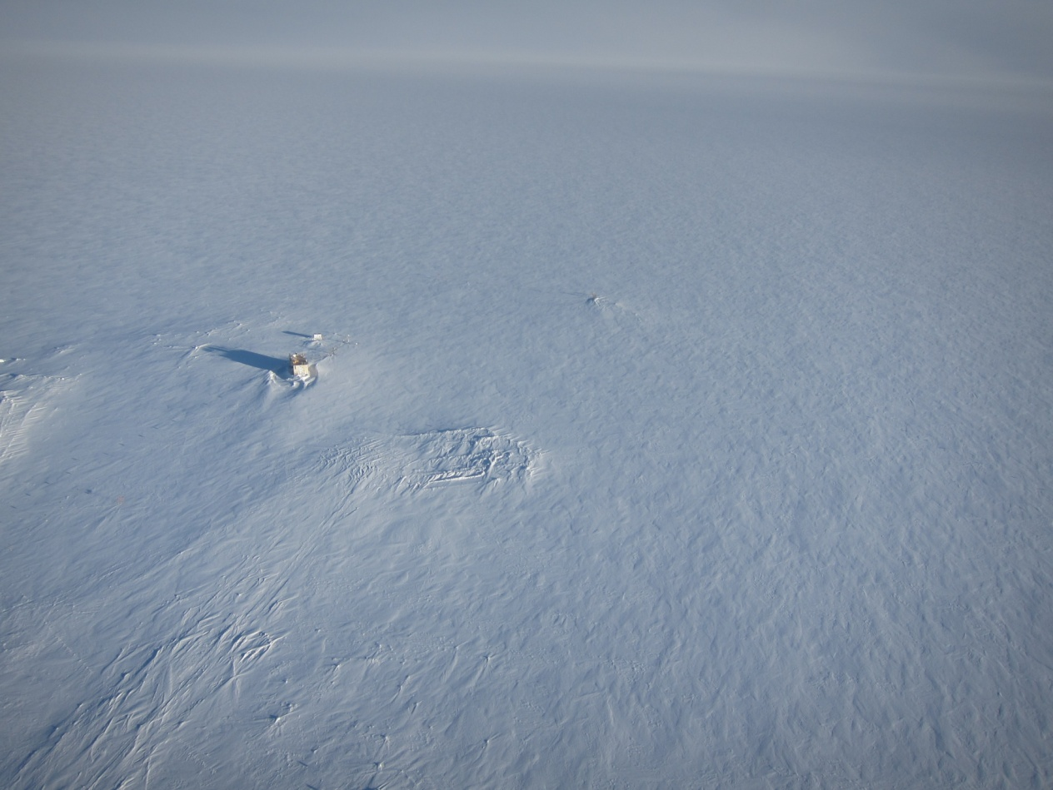

A kite-borne camera shows a sastrugi-textured surface extending in all directions from the MSF. SWD

**General:**

* Welcome to Hannah! Turnover flight arrived on 2017-10-15.
* Thank you to Sam for an easy “turnover”- the MSF and all ICECAPS spaces look great!
* A no-overlap turnover was conducted via phone, email, and document swaps.
* The POSS FEP and Telebyte arrived on station with Hannah.

**Significant Weather Observations:**

* 10-09: Broken altostratus, -26C, 7 kts.
* 10-10: Overcast stratus, -25C, 7 kts.
* 10-11: Overcast stratus, drifting snow, -24C, 20 kts.
* 10-12: Broken stratus, -35C, 14 kts. Halo at 22 degrees, sundogs at 13:10-13:30Z.
* 10-13: Overcast stratus, -34C, 7 kts.
* 10-14: Broken stratus, -23C, 6 kts.
* 10-15: Broken altocumulus, -29C, 5 kts.

**ICECAPS Data Management:**

* 10-09: Data transfer complete 11:35Z.
* 10-10: Data transfer complete 18:20Z.
* 10-11: Data transfer complete 11:46Z.
* 10-12: Data transfer complete 11:48Z.
* 10-13: Data transfer complete 12:21Z.
* 10-14: Data transfer complete 12:02Z.
* 10-15: Data transfer complete 11:41Z.

**MWR:**

* Operating normally.

**SODAR:**

* Operating normally.
* 10-12: SODAR dishes cleaned 12:16 to 12:22Z.
* 10-15: SODAR dishes cleaned 11:52 to 12:00Z.

**POSS:**

* 08-14 to 10-15: The log files show ‘posaccmsod’ and truncated messages.
* 10-12: The thermostat that regulates the POSS heater bulb is not reliably switching. To prevent the enclosure from becoming too cold, the thermostat has been bypassed, and the bulb is powered continuously. A USB temperature logger was placed inside the enclosure to determine the effect of this change. The POSS was powered down during this change.

**MMCR:**

* Operating normally.

**CAPABL:**

* Operating normally.

**MPL:**

* Operating normally.

**VCEIL:**

* Operating normally.

**Hotplate:**

* Operating normally.

**IceCAM:**

* Operating normally.

**PAERI:**

* Operating normally.

**TSI:**

* Winter storage in the MSF.

**IcePIC:**

* Images not captured.

**Radiosonde:**

* Twice daily soundings.
* 10-10 12Z: This sounding was reported as not received by GTS. The sounding was performed on schedule and without irregularities. Matt Shupe confirmed the sounding data were present and were transmitted to GTS. The cause is unknown for this ‘not received’ message.
* 10-13 12Z: Sounding was unsuccessful due to humidity check failure. Dense freezing fog present.

**MASC:**

* Operating normally.