**ICECAPS Weekly Report**

September 11 – 17, 2017

Sam Dorsi

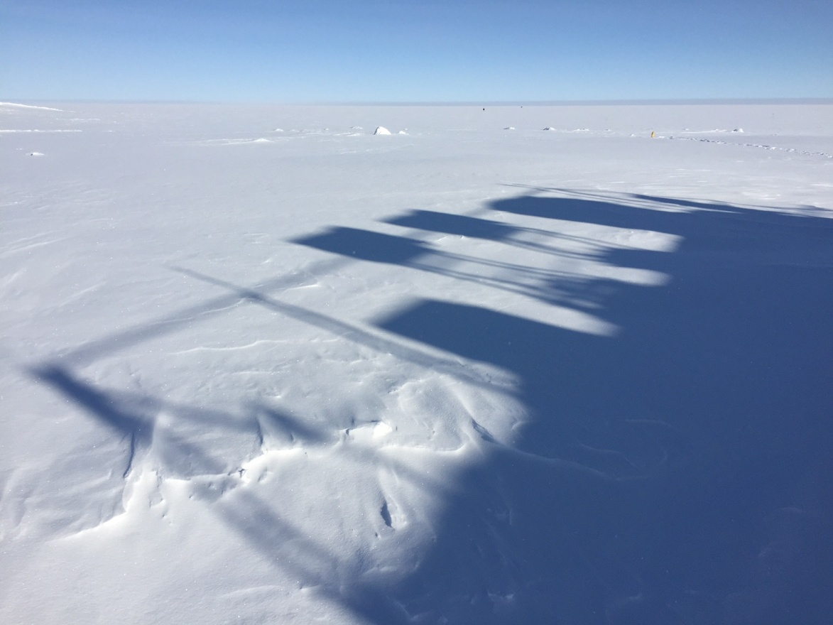

The rooftop instrument suite crowns the MSF shadow. SWD

**General:**

* None.

**Significant Weather Observations:**

* 09-11: Scattered altostratus, -21C, 7 kts.
* 09-12: Broken stratus, -18C, 8 kts.
* 09-13: Scattered altostratus, -29C, 6 kts.
* 09-14: Overcast stratus, -15C, 14 kts.
* 09-15: Overcast stratus, blowing snow, -7C, 22 kts.
* 09-16: Broken stratus, snowing, -10C, 4 kts.
* 09-17: Broken altostratus, blowing snow, -10C, 29 kts.

**ICECAPS Data Management:**

* 09-11: Data transfer complete 12:06Z.
* 09-12: Data transfer complete 16:40Z.
* 09-13: Data transfer complete 13:40Z.
* 09-14: Data transfer complete 22:38Z.
* 09-15: Data transfer complete 14:43Z.
* 09-16: Data transfer complete 13:58Z.
* 09-17: Data transfer complete 12:31Z.

**MWR:**

* Operating normally.

**SODAR:**

* Operating normally.
* 09-11: Transmitter and receiver dishes cleaned 15:27Z.

**POSS:**

* 08-14 to 09-18: The log files show ‘posaccmsod’ and truncated messages.
* 09-11: Diagnostics on communications using alternate laptop were performed. One-minute transmissions were observed, but were composed of garbage characters.
* 09-12: Successful POSS serial capture was able to confirm parameters are 1200-7E1-Hardware.
* 09-13: Extended POSS serial capture performed 12:05z. Attempting to record bad packets to assess if packets are malformed on receipt by computer, or if malformation is associated with acquisition software. However, the POSS system appears to send good packets to both the serial terminal and the POSS acquisition software when the connection was alternated between these systems during the testing period.

**MMCR:**

* Operating normally.

**CAPABL:**

* Operating normally.

**MPL:**

* Operating normally.

**VCEIL:**

* Operating normally.

**Hotplate:**

* Operating normally.

**IceCAM:**

* Operating normally.

**PAERI:**

* Operating normally.
* 09-14: Blue ‘data dropout’ flags present from 9:32 until 9:49Z.

**TSI:**

* Operating normally.

**IcePIC:**

* 09-11: Slides placed for collection 15:21 to 18:03Z. Particles photographed include isolated bullets, stellar plates, capped columns, cups, and irregulars.
* 09-14: Slides placed for collection 12:22 to 12:38Z. Particles photographed include simple stars, sectored plates, hexagonal plates, irregulars, aggregates and needles.

**Radiosonde:**

* Twice daily soundings.
* 09-13 0z: Humidity sensor error occurred amidst freezing fog conditions. Two attempts were made, but sounding was unsuccessful.

**MASC:**

* Operating normally.