**ICECAPS Weekly Report**

September 18 – 24, 2017

Sam Dorsi

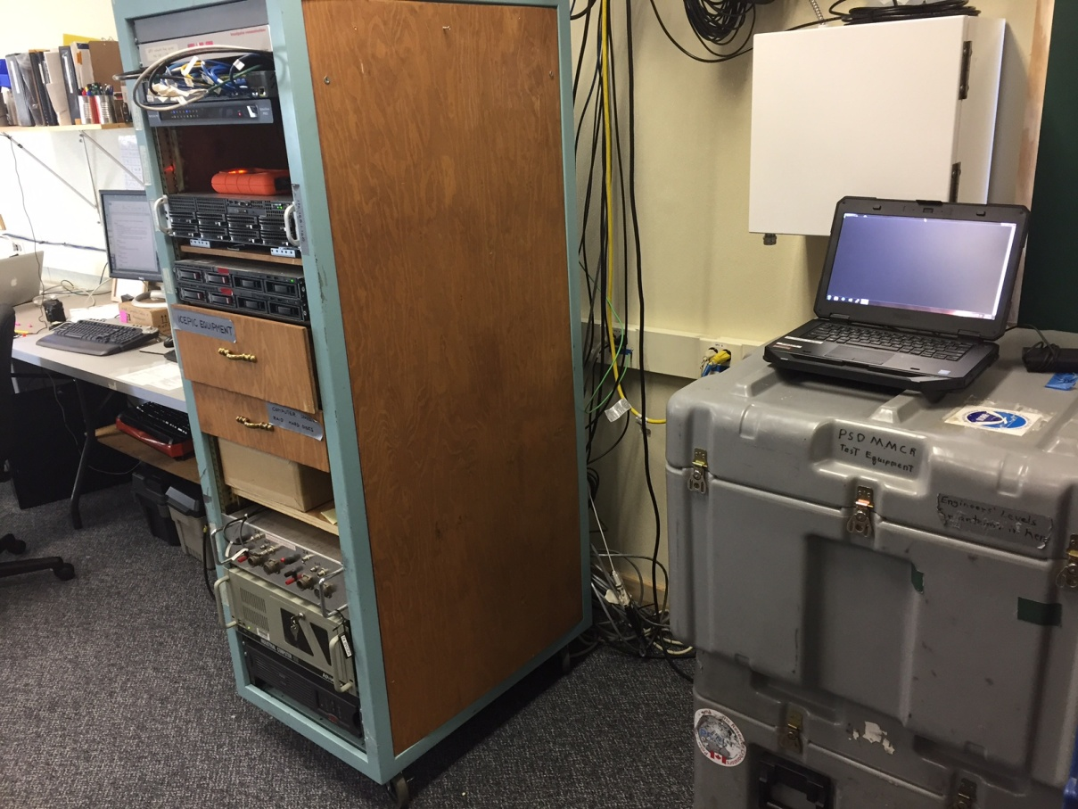

The MMCR cases provide a workstation for diagnostics on the POSS and Telebyte unit. SWD

**General:**

* 09-19: An unplanned power outage occurred 17:06:09 to 17:10:40Z.
* 09-20: A planned power outage occurred 11:30:35 to 11:30:58Z.

**Significant Weather Observations:**

* 09-18: Few stratus, -25C, 6 kts.
* 09-19: Broken stratus, -17C, 11 kts.
* 09-20: Broken stratus, -18C, 17 kts. Sundogs present from 19:50 to 20:45Z.
* 09-21: Broken altostratus, -19C, 16 kts.
* 09-22: Broken stratus, -20C, 10 kts.
* 09-23: Broken stratus, -33C. 5 kts.
* 09-24: Blowing snow, -17C, 34 kts.

**ICECAPS Data Management:**

* 09-18: Data transfer complete 12:51Z.
* 09-19: Data transfer complete 18:03Z.
* 09-19: ICECAPS computer rebooted at 18:49Z.
* 09-20: Data transfer complete 16:37Z.
* 09-21: Data transfer complete 21:35Z.
* 09-22: Data transfer complete 17:36Z.
* 09-23: Data transfer complete 13:19Z.
* 09-24: Data transfer complete 09:44Z.

**MWR:**

* Operating normally.
* 09-23: Rime accumulation photographed and removed 10:57Z.

**SODAR:**

* Operating normally.

**POSS:**

* 08-14 to 09-24: The log files show ‘posaccmsod’ and truncated messages.
* 09-19: The ICECAPS computer was rebooted (18:49Z) to test if this would improve communications over the serial port (recommended by Peter from Environment Canada). No change noted.
* 09-20: POSS communications captured using a USB-to-serial converter on multiple computers. Characters are garbled, as if port is misconfigured. The connection was then moved to the ICECAPS computer, but on the alternate front serial port. The Peter from EC reports that captured data look better, but still have some misaligned columns.
* 09-21: Investigation into faulty Windows communications continues with focus on laptop UART/Device Manager settings.

**MMCR:**

* Operating normally.
* 09-21: The MMCR displayed an ‘Error 7 occurred at Open File+.vi’ message. This was cleared at 18:31z and data collection then resumed.
* 09-23: The MMCR displayed a prompt (as of 10:35Z): ‘Replace existing "C:\mmcr\labview monitor files\XPower 1 min histories all.txt"?’ Data collection continues despite this message.
* 09-24: The MMCR is stuck in a ‘receiver cal running’ state, and data collection is not being performed.
* 09-25: At 00:04Z, the ‘XPower’ file was backed up, and the option to replace the file was selected in the radar monitor VI. Data collection resumed ~10 seconds later.

**CAPABL:**

* Operating normally.

**MPL:**

* Operating normally.
* 09-19: Afterpulse calibration performed (18:26 to 18:42Z).

**VCEIL:**

* Operating normally.

**Hotplate:**

* Operating normally.

**IceCAM:**

* Operating normally.

**PAERI:**

* Operating normally.

**TSI:**

* Operating normally.

**IcePIC:**

* No particles photographed.

**Radiosonde:**

* Twice daily soundings.
* 09-19 12Z: Radiosonde released after target window (11:52Z) due to medic duties.
* 09-23 12Z: Multiple humidity sensor failures amid freezing fog. Sounding unsuccessful. Photographed frost on sensor boom.

**MASC:**

* Operating normally.