**ICECAPS Weekly Report**

September 25 – October 1, 2017

Sam Dorsi

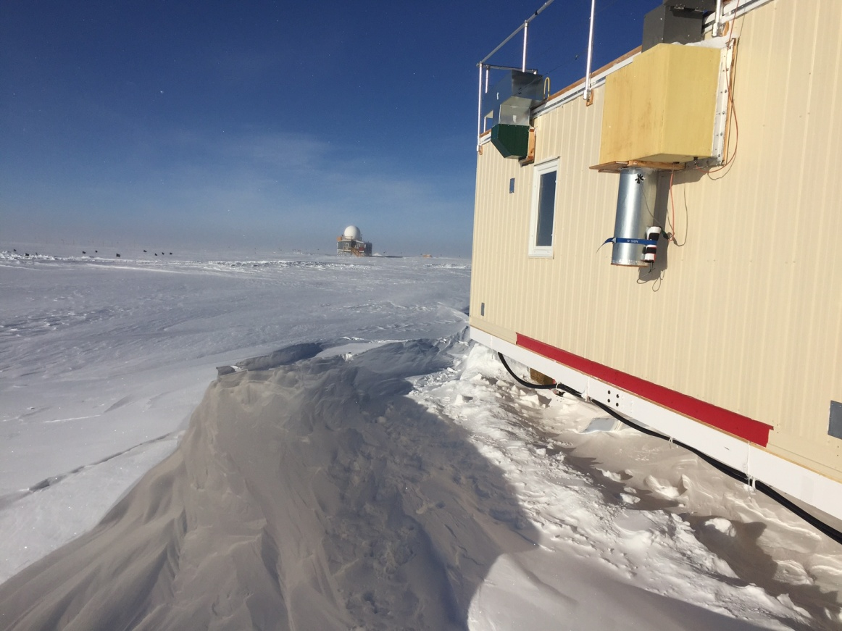

Following last week’s winds, the drift to the south of the MSF is now a meter high. SWD

**General:**

* None.

**Significant Weather Observations:**

* 09-25: Scattered altostratus, -17C, 14 kts. Sundog 11:45 to 12:15Z.
* 09-26: Few altostratus, -22C, 12 kts. Weak halo 10:50Z.
* 09-27: Blowing snow, -13C, 30 kts.
* 09-28: Scattered altocumulus, -19C, 7 kts.
* 09-29: Few stratus, -30C, 7 kts.
* 09-30: Few altostratus, -23C, 16 kts. Weak sundog 10:30Z-11:45Z.
* 10-01: Broken altostratus, -22C, 13 kts.

**ICECAPS Data Management:**

* 09-25: Data transfer complete 09:31Z.
* 09-26: Data transfer complete 13:48Z.
* 09-27: Data transfer complete 11:44Z.
* 09-28: Data transfer complete 11:24Z.
* 09-29: Data transfer complete 11:17Z.
* 09-30: Data transfer complete 11:29Z.
* 10-01: Data transfer complete 11:46Z.

**MWR:**

* 09-28: The MWR’s R2CH software reported ‘Radiometer Communication Error, Communication problem with radiometer detected! Break detected on 2017-09-28 17:00:11’. This was resolved by closing R2CH and power cycling the radiometer, then reopening R2CH and sending the batch file. Data collection resumed 18:11Z.

**SODAR:**

* Operating normally.
* 09-25: SODAR dishes cleaned 13:57 to 14:06Z.
* 09-28: SODAR dishes cleaned 17:25 to 17:32Z.

**POSS:**

* 08-14 to 10-01: The log files show ‘posaccmsod’ and truncated messages.
* 09-30: Raw serial data examined in detail. Serial cable test fixture was built (handshaking loopback and test points mid-cable) and an oscilloscope was used to inspect the data while connected to various computers. When connected to computers other than the main ICECAPS computer, the serial stream shows oscillations of 13.5V at 0.21 milliseconds. This accounts for the garbled characters received by these computers. A set of proposed actions was created in advance of Hannah’s transit to Summit. Options include further diagnostics on the alternate serial port, implementation of a new software version, and with replacement of the Telebyte Current Loop / RS-232 converter or the POSS FEP unit that originates the communications.
* 10-01: Extended POSS capture file (using alternate /dev/ttyS1 serial port on front of ICECAPS computer) was sent to Shupe and EC engineers.

**MMCR:**

* Operating normally.
* 09-28 to 10-01: MMCR reporting calibration table error.

**CAPABL:**

* Operating normally.

**MPL:**

* Operating normally.
* 09-28: Property ID tags confirmed for Von.

**VCEIL:**

* Operating normally.

**Hotplate:**

* Operating normally.

**IceCAM:**

* Operating normally.

**PAERI:**

* Operating normally.

**TSI:**

* Operating normally.

**IcePIC:**

* 09-30: Slides placed for collection 12:57 to14:11Z. Particles photographed include sheaths, needles, hexagonal plates, hollow columns, trigonal ice, and irregulars.

**Radiosonde:**

* Twice daily soundings.
* 09-29 0Z: Sounding unsuccessful due to humidity check failure. Sounding occurred during freezing fog, and fine frost was visible on sensor element.
* 09-29: Helium cylinder swap performed. Staged cylinders will provide a supply through late April.
* 09-29 12: Sounding unsuccessful due to failure to enter surface data on time.

**MASC:**

* Operating normally.