**ICECAPS Weekly Report**

September 4 – 10, 2017

Sam Dorsi

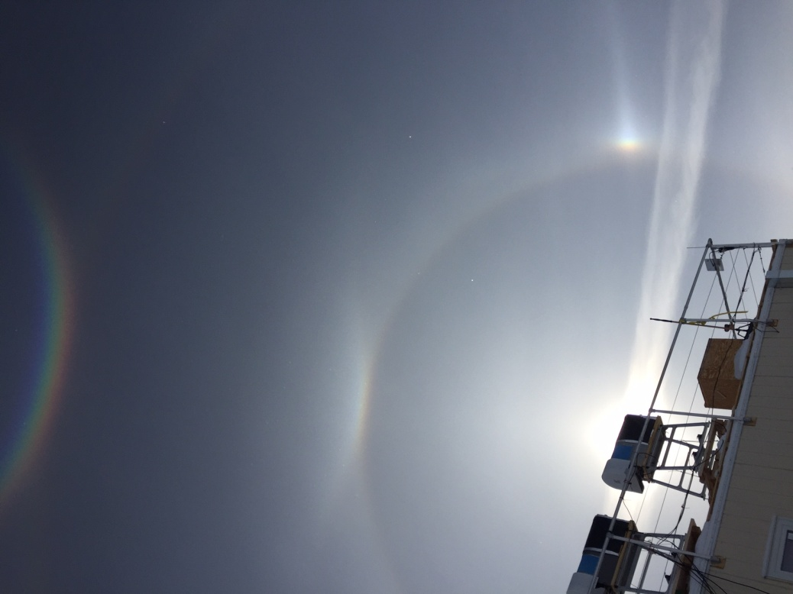

The stratus cloud deck briefly parts to reveal a grand optical display above Summit. SWD

**General:**

* None.

**Significant Weather Observations:**

* 09-04: Overcast stratus, -18C, 13 kts. At 16:55 to 17:15Z, observed 22-degree and 46-degree halos, sundogs, Parry arc, strong circumzenith arc, parhelic circle and 120-degree parahelia.
* 09-05: Overcast stratus, snowing, -12C, 16 kts.
* 09-06: Overcast stratus, -15C, 9 kts.
* 09-07: Scattered altostratus, -23C, 3 kts.
* 09-08: Scattered altostratus, -26C, 10 kts.
* 09-09: Few altostratus, -24C, 13 kts. At 10:24 to 10:29, observed 22-degree and 46-degree halos, sundogs, strong Parry arc, strong parhelic circle, 120-degree parahelia, and unusual ‘Tricker’ and ‘Diffuse’ arcs, along with a circular ‘antisolar’ arc and ‘heliac’ not visible in photo. In addition, symmetric arcs extended from the intersection of the 46-degree halo and parhelic circle rising at ~30 degrees away from the sun.
* 09-10: Overcast stratus, -23C. 10 kts.

**ICECAPS Data Management:**

* 09-04: Data transfer complete 05:42Z.
* 09-05: Data transfer complete 06:09Z.
* 09-06: Data transfer complete 05:51Z.
* 09-07: Data transfer complete 06:09Z.
* 09-08: Data transfer complete 06:40Z.
* 09-09: Data transfer complete 12:09Z.
* 09-10: Data transfer complete 13:56Z.

**MWR:**

* Operating normally.

**SODAR:**

* Operating normally.

**POSS:**

* 08-14 to 09-11: The log files show ‘posaccmsod’ and truncated messages.
* 09-05: POSS power cycled at 15:56 to 16:00Z. Telebyte communications unit observed over the course of both valid and truncated messages: no difference noted on the LCD display.

**MMCR:**

* Operating normally.

**CAPABL:**

* Operating normally.

**MPL:**

* Operating normally.
* 09-03: Disk had been at 95% utilization. Turner requested that the oldest 6 months of data be deleted. After deletion (2017-09-05 15:24Z), disk is at 62% utilization.

**VCEIL:**

* Operating normally.
* 09-04: Built new reinforced ceilometer blanket. Installed on instrument 18:10 to 18:30Z.

**Hotplate:**

* Operating normally.
* 09-10: Hotplate was encountered in an error state (10:37z), possibly relating to input parsing. On discovering the error, the error message was cleared and data collection was reinitialized. The hotplate returned to normal operation.

**IceCAM:**

* Operating normally.

**PAERI:**

* Operating normally.

**TSI:**

* Operating normally.

**IcePIC:**

* 09-04: Slides placed for collection 11:56 to 12:29Z. Particles photographed include isolated bullets, bullet rosettes, and irregulars.

**Radiosonde:**

* Twice daily soundings.

**MASC:**

* Operating normally.