**ICECAPS-ACE Weekly Report**

August 13 – August 19, 2018

Hannah James

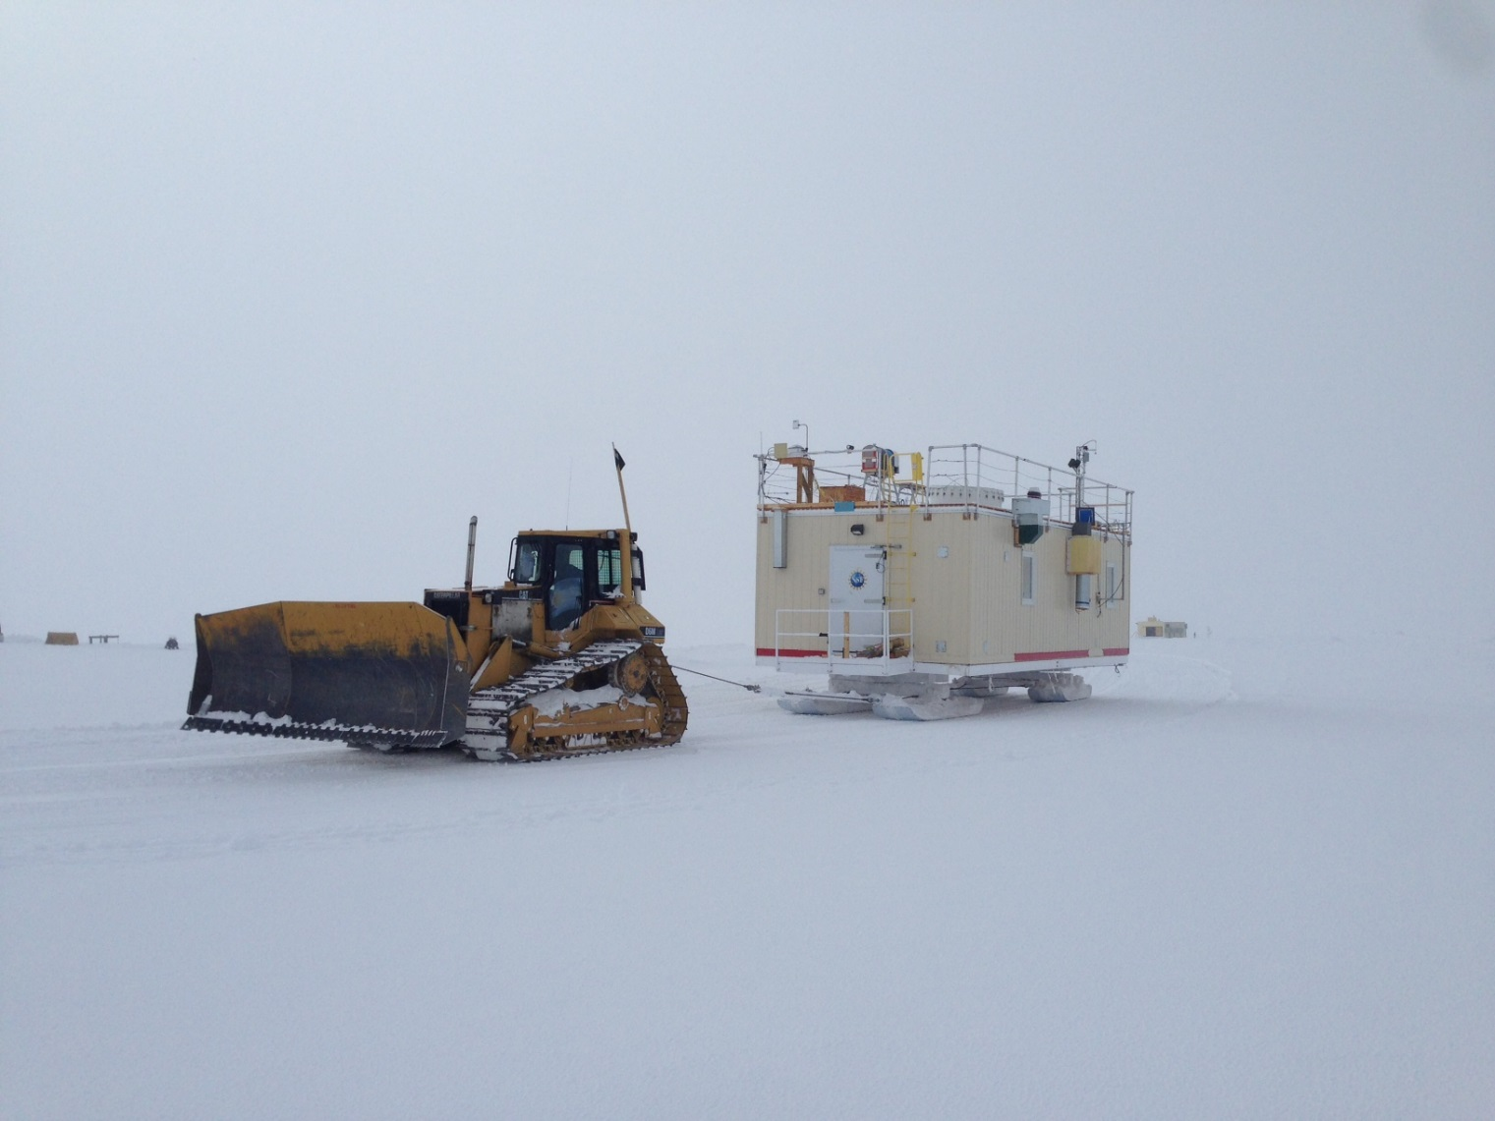

The MSF on the move to its new location Sunday afternoon. -HJ

**General:**

On Wednesday, August 15, Summit switched from the 70kW generator to the main SMG generators. The MSF was supported by the UPS from 12:16-12:17Z. Due to the sharp transition from the approach ramp to the new berm, the MSF move was delayed until Sunday, August 19th. The CLASP and CPC were successfully installed, mounts were mounted, and data started transferring to Boulder. The move to the new MSF berm went very smoothly, all individual offline times are recorded below. Due to north winds, we were not able to move the SODAR, so the POSS and SODAR remain offline until early in the coming week.

**Significant Weather Observations:**

* 08-13: Bkn fzfg in the morning. -13C, 11 kts. 10:00-13:00Z- Fogbow.
* 08-14: Ovc stratus. -10C, 2kts. Br.
* 08-15: Bkn stratus. -10C, 8 kts.
* 08-16: Ovc stratus. -15C, 10 kts.
* 08-17: Few stratus in the distance, fog overhead. -23C, 4 kts. 10:00-12:00- Fogbow.
* 08-18: VV 200m. -17C, 9 kts. Fzfg.
* 08-19: Ovc stratus.. -16C, 10 kts. Vcfzfg

**ICECAPS-ACE Data Management:**

* 08-13: Data transfer complete 05:36Z.
* 08-14: Data transfer complete 05:41Z.
* 08-15: Data transfer complete 05:31Z.
* 08-16: Data transfer complete 06:03Z.
* 08-17: Data transfer complete 05:42Z.
* 08-18: Data transfer complete 07:22Z.
* 08-19: Data transfer complete 10:22Z. Lost connection a few times during the night.

**MWR:**

* As of 10-28, 150-90 operating in V11_SCAN_HF.MBF.
* 08-19: Shut down for MSF move 13:12-17:48Z. Red flags on Receiver 1 & 2 Temp stability upon power up, but flags cleared themselves within the evening.

**SODAR:**

* Operating normally. Heavy equipment operating around the MSF throughout the week, times recorded in the SODAR log.
* 08-18: 16:22Z- Turned SODAR off for MSF move, disconnected power and data cables. Remains powered down until heavy equipment is able to place it in its new location behind the MSF.

**POSS:**

* Operating normally in old software.
* 08-16: Dug up guy lines and center pole in preparation of the MSF move. Temporarily shut down to move instrument out of the way of snow removal.
* 08-19: 11:22Z- POSS shut down for MSF move. Remains powered down until SODAR and power box are placed in their new locations.

**MMCR:**

* Indoor and outdoor temperature sensors reading high, level reading
* Pitch -0.10, Roll -0.11. Roll has been inconsistent, reading as high as 6, but seems to settle around -0.11 most of the time. A reboot of the system will most likely occur Monday afternoon if temperature and level sensors continue to be inconsistent.
* 08-16: Roll shifted to 7.24 degrees. HEO moving snow around the MSF at the time, but did not report any contact with the building, skis, tongue, or porch.
* 08-17: Roll back to 0.00 in afternoon. No building leveling done, so potentially a sensor issue with the radar?
* 08-19: Roll at 6.24. Instrument shut down 13:47-17:06Z. Radar interface software froze upon reboot, and TWTA panel needed to be manually switched, but daily checks passed and data collection started soon afterwards.

**CAPABL:**

* Operating normally in Floating Ref Laser 1. Neely and Heather on station for annual visit. Co-alignment attempted, but not achieved due to overcast conditions throughout the week.
* 08-15: Replaced Laser 1’s filter on coolant hose.
* 08-17: Laser 1 aligned, Floating Ref Laser 1 config file loaded. Alignment scans performed in the morning. 13:00- Flashlamp in Laser 2 replaced.
* 08-19: Instrument shut down 13:20-18:20Z for MSF move. Instrument shut down 19:18-20:09Z for roof cable work near laser output.

**MPL:**

* Operating normally.
* 08-15: 12:28Z- Updated computer time. 17 seconds ahead of GPS server.
* 08-19: Instrument shut down 13:20-18:21Z for MSF move.

**VCEIL:**

* Operating normally.
* 08-19: Instrument shut down 13:34-18:10 for MSF move.

**IceCAM:**

* Operating normally.
* 08-19: Camera offline 13:16-18:05 for MSF move.

**PAERI:**

* Operating normally.
* 08-13: Blue flags found, things returned to normal during the day (i.e. not before the 00:00Z reboot).
* 08-15: Blue flags on and off throughout the day. Sometimes wave number graphs were blank during the blue flags, sometimes data appeared. Time and date both read 0 during the blue flags. At points, up to 80 bad readings were reported per scan.
* 08-19: Computer, enclosure fan, and interferometer shut down for MSF move 14:27-17:15Z. Upon restart, data plots were not updating. I realized that I accidentally renamed the previous file’s day with the “_01” extension, and not the current day’s data. The following day, plots were updating normally.

**TSI:**

* Operating normally.
* 08-19: Instrument shut down 14:04-17:39Z during MSF move.

**IcePIC:**

* 08-13: Slides placed for collection 15:55-16:04Z and 19:04-20:01Z. Images captured include split stars, simple stars, sectored plates, hexagonal plates, radiating dendrites, rimed radiating dendrites, and broken branches of dendrites.
* 08-16: Slides placed for collection 15:10-15:50. Images captured include plates, sector plates, and stellar plates.

**Radiosonde:**

* Twice daily soundings.
* 08-20: Mount down overnight, Sunday’s data not transferred.

**MASC:**

* Instrument offsite for repair, will not return until summer 2019.

**OPC:**

* Plots not updating Monday morning, but instrument working normally.
* 08-16: Installed and began collecting data.
* 08-19: Instrument offline 13:13-17:45Z for MSF move.

**CLASP:**

* Instrument not working early Monday morning, but after a reboot is operating normally. Plots not updating, but currently being troubleshot.
* 08-15: Installed and began collecting data.
* 08-18: Data transfer to Boulder began.
* 08-19: Instrument offline 13:15-17:30Z for MSF move.

**CPC:**

* Operating normally.
* 08-15: Installed and began collecting data.
* 08-18: Data transfer to Boulder began.
* 08-19: Instrument offline 13:13-17:34Z for MSF move.