**ICECAPS-ACE Weekly Report**

August 20 – August 26, 2018

Hannah James

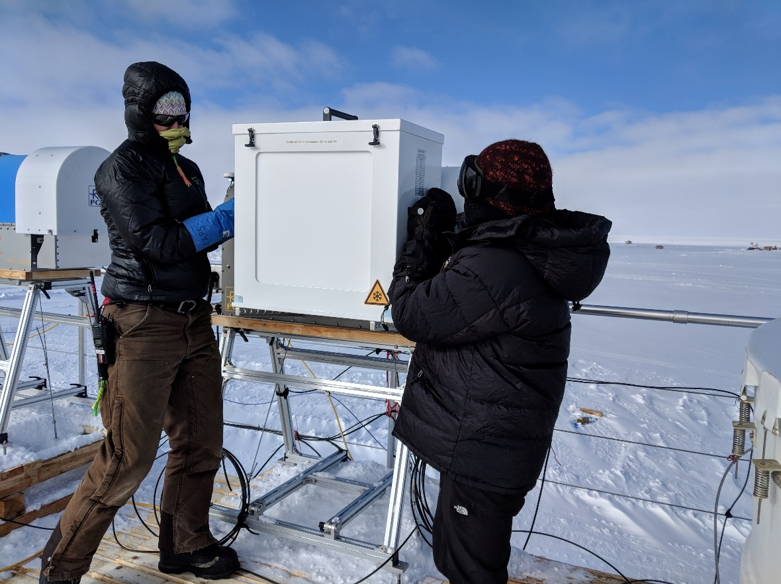

With Neely’s help, the new liquid nitrogen target was lifted up to the HATPRO for calibration. -Heather Guy

**General:**

A busy week for the ICECAPS-ACE team! Von Walden, Tom Ayers, and Sarah Murphy all arrived on the 24th for annual check-ups on their systems- see details below. An unexpected power outage occurred on Thursday, August 23 from 21:57- 22:01Z. One of our main generators shut itself down for unknown reasons. The mechanics are looking into this. The HATPRO returned to station after being offsite since February. It was reinstalled, but has some new communication issues so is not running. See below for more information. Von and Sarah were able to make a few successful drone flights, final cleanups after the MSF move were completed.

**Significant Weather Observations:**

* 08-20: Ovc stratus. -18C, 6 kts. Vcfzfg.
* 08-21: Ovc stratus. -17C, 8 kts.
* 08-22: Ovc stratus. -18C, 9 kts. Br.
* 08-23: Sct cumulus. -18C, 9 kts.
* 08-24: Sct stratocumulus, bkn altocumulus, bkn cirrostratus. -18C, 2 kts.
* 08-25: Ovc stratus. -20C, 17 kts. Drsn.
* 08-26: Bkn stratocumulus, bkn cirrus. -17C, 14kts. Blsn. 13:25- circumzenial arc, start of parahelic circle, parhelia.

**ICECAPS-ACE Data Management:**

* 08-20: Data transfer complete 04:08Z. Radiosonde mount down overnight.
* 08-21: Data transfer complete 04:40Z.
* 08-22: Data transfer complete 04:36Z.
* 08-23: Data transfer complete 05:10Z.
* 08-24: Data transfer complete 04:51Z.
* 08-25: Data transfer complete 04:30Z.
* 08-26: Data transfer complete 06:26Z.

**MWR:**

* Neither radiometer collecting data.
* HATPRO returned to station on Friday, and was placed on the roof. Lots of troubleshooting occurred in order to use the new software on the radiometer PC with the new software on the computer. The fiber optics cable was installed and the HATPRO ran overnight on Saturday.
* Sunday, we perform liquid nitrogen calibrations with the new target. This target provides some issues with its weight combined with the height of the lift necessary. A set of stairs or platform extension will be built for future calibrations.
* After the calibration, we sent an older version of the software to the HATPRO in hopes to continue to run both radiometers in Master/Slave format. This unfortunately did not work, and we are now unable to communicate with the HATPRO.

**SODAR:**

* Operating normally.
* 08-21: SODAR placed at new location. 14:05Z- Data collection began. The SODAR will most likely be moved again after the surface behind the MSF, where the SODAR previously was buried, is smoothed out.
* 08-26: At some point the amplifier was unplugged, and data collection stopped. This issue was resolved Monday morning.

**POSS:**

* Operating normally.
* 08-21: POSS restarted at 13:38Z. New location will be set after snow movement occurs to fill in old SODAR hole.
* 08-25: DC offset error at 09:37Z.

**MMCR:**

* Tom Ayers on station for annual checks. Pitch/Roll sensors as well as the 5V sensors were acting up, as well as the humidity sensors. He is looking into this.
* Pitch -0.10, Roll -0.11. Roll has been inconsistent, reading as high as 6.34, but seems to settle around -0.11 most of the time.

**CAPABL:**

* Neely and Heather on station for annual visit.

**MPL:**

* Operating normally.
* 08-20: Afterpulse calibration performed 16:16-16:37Z. 30m, 30s 16:18-16:26Z. CopolBkdAvg: 0.000248, CopolBkdStd: 0.000185. 15m, 30s: 16:27-16:35Z. CopolBkdAvg: 0.000269, CopolBkdStd: 0.000268.

**VCEIL:**

* Operating normally.

**IceCAM:**

* Operating normally.

**PAERI:**

* Operating normally.

**TSI:**

* Operating normally.

**IcePIC:**

* A few collections happened over the week, but have not been transferred. Information will be on the following week’s report.

**Radiosonde:**

* Twice daily soundings.
* 08-20: Mount down overnight, Sunday’s data not transferred. Replaced plastic on balloon table.

**MASC:**

* Instrument offsite for repair, will not return until summer 2019.

**OPC:**

* Plots not updating Monday morning, but instrument working normally.
* 08-26: No data transfer overnight.

**CLASP:**

* Instrument not working early Monday morning, but after a reboot is operating normally. Plots not updating, but currently being troubleshot.

**CPC:**

* Operating normally.
* 08-26: No data transfer overnight.