**ICECAPS-ACE Weekly Report**

August 27 – September 3, 2018

Hannah James

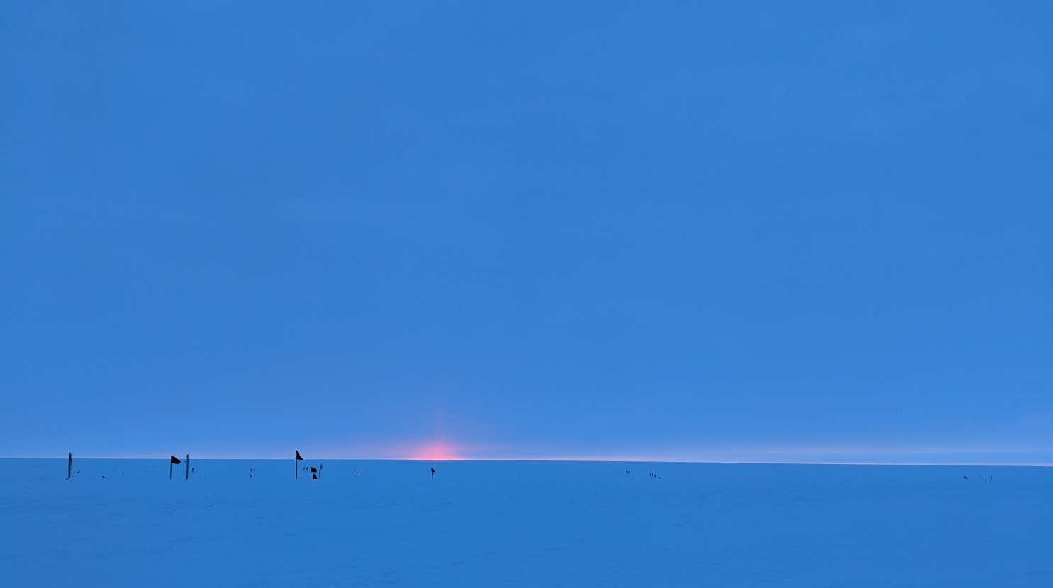

A faint colum at sunset- with daylight decreasing and temperatures dropping,

we can certainly feel winter quickly approaching! -HJ

**General:**

Von Walden, Ryan Neely, Tom Ayers, Heather Guy, and Sarah Murphy departed station on Tuesday, August 28. A huge thanks to all of you who were on station for the incredibly productive end of the summer season! On Tuesday, Jack Dibb and Sam Dorsi gave a tour to a DV group, which included Carla Sands, the US ambassador to Denmark. Neely and Von were in the MSF when this occurred. On September 1, our bandwidth decreased to winter speeds. ICECAPS-ACE data transfers are still going out in a timely manner.

**Significant Weather Observations:**

* 08-27: Few cirrus. -30C, 5 kts.
* 08-28: Few stratus, sct cirrus. -25C, 5 kts. Br, IC.
* 08-29: Sct cirrocumulus. -24C, 8 kts. Br.
* 08-30: Bkn stratocumulus, ovc cirrostratus. -18C, 13 kts. Br, drsn.
* 08-31: Ovc stratus. -16C, 10 kts. -Sn throughout the day. 22 degree halo, circumzenial arc throughout the afternoon (approximately 16:00-19:00Z)
* 09-01: Sct altocumulus, sct cirrus uncinus. 11:15Z: Parhelia, 22 degree halo, circumzenial arc.
* 09-02: Ovc stratus. -18C, 5 kts.

**ICECAPS-ACE Data Management:**

* 08-27: Data transfer complete 04:29Z.
* 08-28: Data transfer complete 05:59Z.
* 08-29: Data transfer complete 05:30Z.
* 08-30: Data transfer complete 05:29Z.
* 08-31: Data transfer complete 05:50Z.
* 09-01: Data transfer complete 06:09Z.
* 09-02: Data transfer complete 05:38Z.

**MWR:**

* Neither instrument collecting data.
* 09-01: Attempted to connect to the 90-150 in R2CH Version 8.11 but “baudrate programming failed message” persisted. Serial ports swapped, both the computer and radiometer were power cycled, but no connection was made.

**SODAR:**

* Operating normally.
* 08-29: Computer interface not running properly- unable to open JPG files. Restarted computer, computer offline 13:18-13:22Z.

**POSS:**

* Operating normally.

**MMCR:**

* Operating normally.
* Pitch -0.20, Roll -0.32. MSF leveling will likely occur in the coming week.

**CAPABL:**

* Operating normally in Configure Ops Laser 2.

**MPL:**

* Operating normally.

**VCEIL:**

* Operating normally.

**IceCAM:**

* Operating normally.

**PAERI:**

* Operating normally.

**TSI:**

* Operating normally.
* 08-29: 13:29Z- removed small icicle that was dragging along the table, not allowing the sun band to be totally aligned. After cleaning, instrument resumed self-alignment.

**IcePIC:**

* 08-31: Slides placed for collection 12:09-12:14Z. Images captured include Hexagonal plates, broken stellar plate arms, split plates, triganol ice, split plates of triganol ice, solid columns, hollow columns and simple needles. Slides placed again 18:58-19:04Z during 22 degree halo, sub-horizon halo, parhelia, upper tangent arc, and circumzenithal arc optical event. Images captured include bullet rosettes, capped bullets, hollow columns, isolated bullets, broken branches of sectored plates, and hexagonal plates. Slides placed again a third time (during same optical event) from 19:27-19:36Z. Images captured include bullet rosettes, solid columns, hollow column, hexagonal plates, triganol ice, capped columns, broken sectored plates, simple prisms, and capped bullets. Station manager Rachel Murray took great interest in this project, so will likely help me collect samples and photographs for the remainder of our season.

**Radiosonde:**

* Twice daily soundings.

**MASC:**

* Instrument offsite for repair, will not return until summer 2019.

**OPC:**

* Operating normally.

**CLASP:**

* Operating normally.

**CPC:**

* Operating normally.