**ICECAPS Weekly Report**

August 6 – August 12, 2018

Hannah James

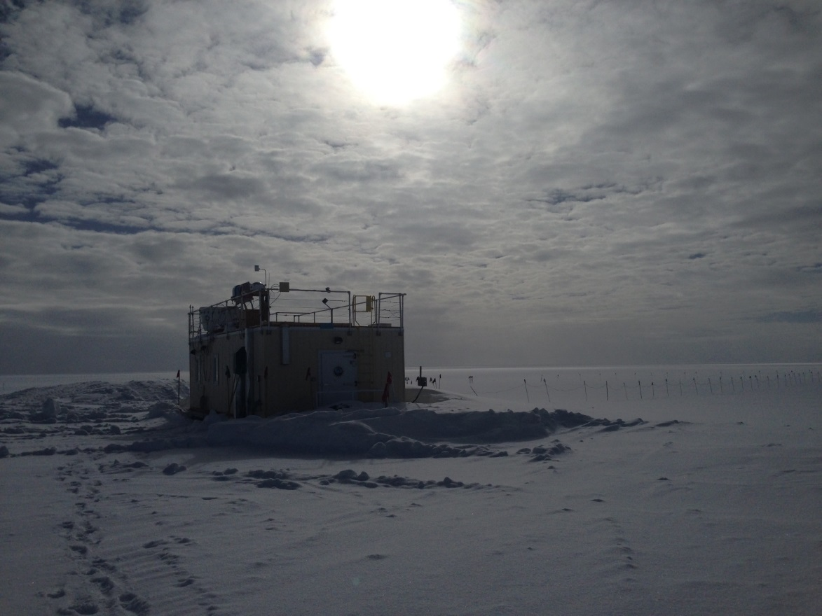

The new MSF pad behind the building has slowly grown over the last few weeks,

and later in the coming week the building will be relocated to sit 2 meters above grade. -HJ

**General:**

Ryan Neely and Heather Guy arrived on station for annual CAPABL checkups and to install the ACE instrumentation. On Saturday, the tower and mast were installed, and a hole was drilled in the south side of the MSF for the ACE instrumentation.

**Significant Weather Observations:**

* 08-06: Sct cirrus spissatus. -16C, 5 kts. 10:00Z- Fogbow.
* 08-07: Few altocumulus, sct cirrocumulus, know cirrostratus. -10C, 5 kts.
* 08-08: Ovc stratus. -5C, 8 kts. Heavy freezing fog in the morning, visibility as low as 200m.
* 08-09: Bkn stratus. -6C, 6 kts. Thick fzfg early in morning.
* 08-10: Bkn stratocumulus, bkn altocumulus. -6C, 2 kts. 12:00Z- very low, transparent cloud deck.
* 08-11: Fzfg, no clouds visible in the morning. -10C, 10 kts.
* 08-12: Ovc stratus. -7C, 2 kts.

**ICECAPS Data Management:**

* 08-06: Data transfer complete 07:08Z.
* 08-07: Data transfer complete 05:29Z.
* 08-08: Data transfer complete 05:27Z.
* 08-09: Data transfer complete 05:30Z.
* 08-10: Data transfer complete 05:30Z.
* 08-11: Data transfer complete 05:33Z.
* 08-12: Data transfer complete 05:33Z.

**MWR:**

* As of 10-28, 150-90 operating in V11_SCAN_HF.MBF.

**SODAR:**

* Operating normally. Heavy equipment operating around the MSF throughout the week, times recorded in the SODAR log.

**POSS:**

* Operating normally in old software.

**MMCR:**

* Operating normally.
* Pitch 0.00, Roll 0.00.

**CAPABL:**

* Operating normally in Floating Ref Laser 2. Neely and Heather on station for annual visit.
* 8-10: 10:44-10:51Z- CAPABL not collecting data during window cleaning. Replaced filter on Laser 1, previous faults disappeared. Neely checked power on Laser 1, which is twice as strong as Laser 2. An alignment will be performed at the next clear-sky opportunity.

**MPL:**

* Operating normally.

**VCEIL:**

* Operating normally.
* 08-03: 13:05Z- Updated time, computer 18 seconds ahead of GPS server.

**IceCAM:**

* Operating normally.

**PAERI:**

* Operating normally.

**TSI:**

* Operating normally.

**IcePIC:**

* No images captured this week.

**Radiosonde:**

* Twice daily soundings.
* 08-08: Satellites not located by SPS311, GPS unable to track sonde. After about 2 hours of troubleshooting, the satellites were picked up again. Erik suggested repositioning the antennas on the Greenhouse tower to face southeast, since all of our satellites are located south of the station. This will be done later this week when time allows.

**MASC:**

* Instrument offsite for repair, will not return until summer 2019.