**ICECAPS-ACE Weekly Report**

December 10 – December16, 2018

Gus Allen

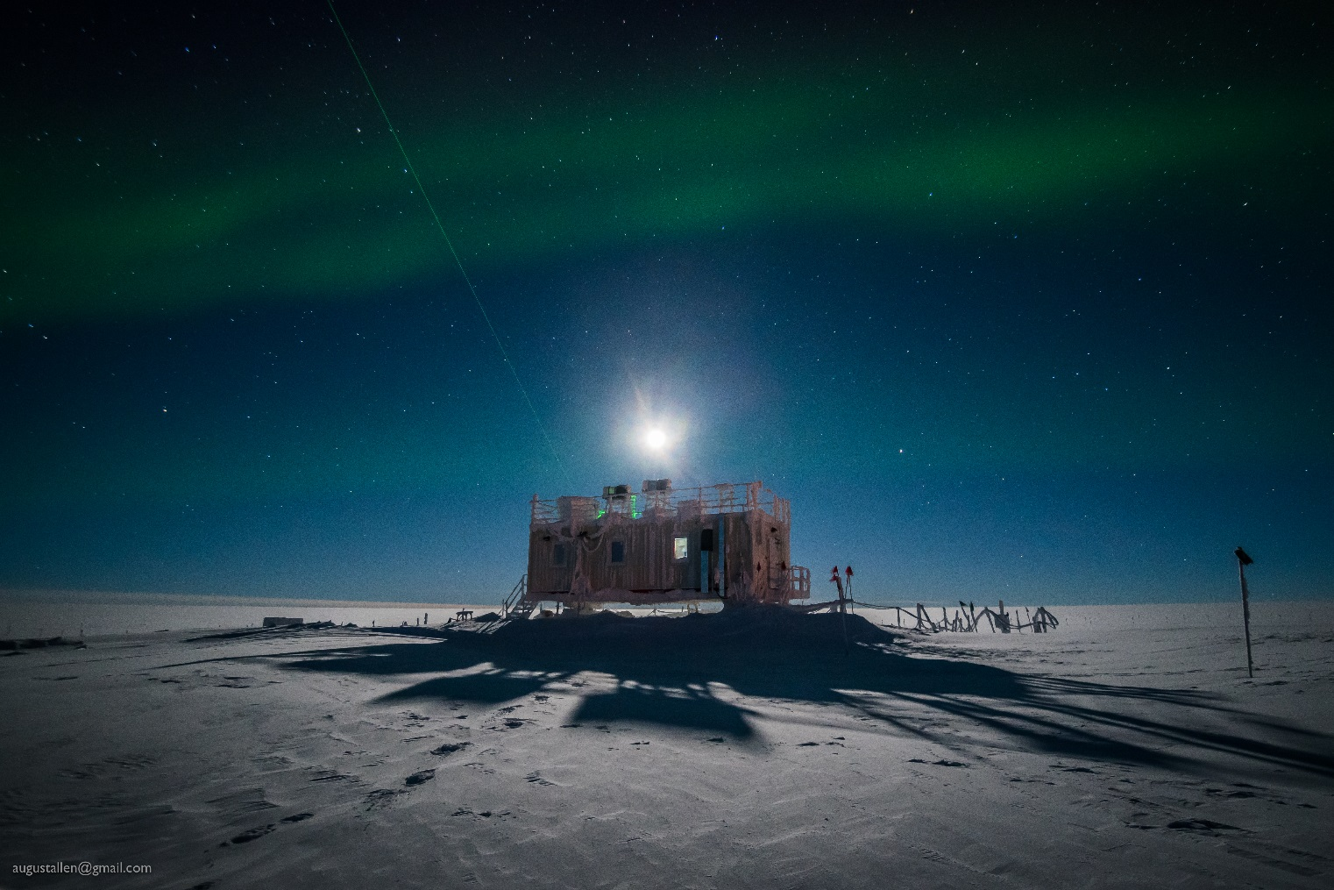

*\*

*Even the blockiest of buildings can manage a cool look in dramatic Summit winter lighting conditions.*

**General:**

Only minor issues were encountered with a couple ICECAPS systems this week.

**Significant Weather Observations:**

|  |  |  |  |  |  |  |  |
| --- | --- | --- | --- | --- | --- | --- | --- |
| **Date** | **Time (Z)** | **Wind** | **Weather** | **Visibility** | **Sky** | **Temp** | **Notes** |
| 12-10 | 12Z | 12kt from 200 | BR | 1000 | FEW100 | -46 |  |
| 12-11 | 12Z | 18kt from 100 |  | 9999 | SCT210 | -41 |  |
| 12-12 | 12Z | 13kt from 160 | -SN BR | 1000 | FEW000 FEW100 | -34 |  |
| 12-13 | 12Z | 10kt from 150 | FZFG | 0600 | SCT000 BKN018 | -34 |  |
| 12-14 | 12Z | 11kt from 190 | BR | 1000 | FEW000 BKN020 | -28 | BLSN and wind at 18Z |
| 12-15 | 12Z | 12kt from 170 | BR | 1600 | FEW000 FEW100 | -46 | Very clear following ob |
| 12-16 | 12Z | 08kt from 090 |  | 9999 | SKC | -44 | Wind to 18kts after 16Z |

**ICECAPS-ACE Data Management:**

* 12-10: Data transfer complete at 1453Z
* 12-11: Data transfer complete at 1422Z
* 12-12: Data transfer complete at 1455Z
* 12-13: Data transfer complete at 1345Z
* 12-14: Data transfer complete at 1426Z
* 12-15: Data transfer complete at 1313Z
* 12-16: Data transfer complete at 1354Z

**MWR:**

* Operating normally.

**SODAR:**

* 12-13 1755 to 1915Z: Amp powered off while I removed snow from the dishes.
* Operating normally.

**POSS:**

* Operating normally.

**MMCR:**

* Operating normally.

**CAPABL:**

* Instrument currently operating normally using laser 2

**MPL:**

* 12-12: ICECAPS showing MPL mount at 97% capacity. I notified Matt Shupe.
* 12-13: At Shupe’s direction, I deleted all archived data files from 2018-02 to clear disk space.
* Operating normally.

**VCEIL:**

* Operating normally.

**IceCAM:**

* Operating normally.

**PAERI:**

* 12-11: The PAERI briefly showed red LWresponsivity and SWresponsivity flags at 18Z and 19Z, but the flags cleared on their own without any need to clean the scene mirror of snow.
* 12-12: At daily check, I noted that the ampmeter on PAERI enclosure fan was reading 0 and the fan wasn’t turning. Assessing, I discovered the plug on the power line had become partially disconnected in the socket, probably in 30-kt wind the night before. Performing the simplest fix ever, I reseated the plug and the fan resumed turning.
* Operating normally.

**TSI:**

* Offline for winter season.

**IcePIC:**

* No images captured this week.

**Radiosonde:**

* Twice daily launches.

**MASC:**

* Instrument offsite for repair, will not return until summer 2019.

**OPC:**

* 12-13: At daily check at 1610, I noted the instrument fan was not turning and appeared to be blocked by snow. I powered down the raspberrypi and removed the OPC from the roof to dry out and assess.
* 12-15 2010Z: OPC replaced on roof and data collection restarted. Instrument mounted horizontally with intake down to assess whether this orientation might rime less.
* Operating Normally

**CLASP:**

* Instrument off site.

**CPC:**

* Instrument off site.