**ICECAPS-ACE Weekly Report**

December 17 – December 23, 2018

Gus Allen

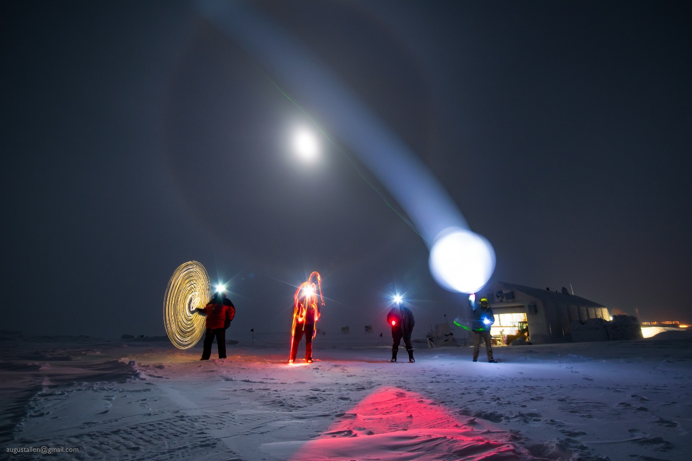

*Happy Winter Solstice from the Summit winter crew!*

**General:**

We were able to swap out about 50 empty helium tanks for full ones in the SMG, which should make balloon launches for the remainder of the winter season slightly more efficient. The ACE laptop appears to have an issue which is undiagnosed as of this writing.

**Significant Weather Observations:**

|  |  |  |  |  |  |  |  |
| --- | --- | --- | --- | --- | --- | --- | --- |
| **Date** | **Time (Z)** | **Wind** | **Weather** | **Visibility** | **Sky** | **Temp** | **Notes** |
| 12-17 | 13Z | 24kt from 100 | FZFG BLSN | 0400 | BKN000 BKN060 | -30 |  |
| 12-18 | 12 | 14kt from 150 | FZFG BLSN | 0600 | BKN000 | -34 |  |
| 12-19 | 12 | 20kt from 150 | BLSN | 0400 | BKN000 | -22 |  |
| 12-20 | 12 | 14kt from 185 | BLSN | 0400 | BKN000 BKN080 | -27 |  |
| 12-21 | 12 | 14kt from 230 | BLSN | 400 | VV000 | -25 |  |
| 12-22 | 12 | 9kt from 230 | -SN BLSN IC | 800 | SCT000 BKN100 | -34 |  |
| 12-23 | 12 | 16kt from 200 | SN BLSN | 0400 | VV006 | -26 |  |

**ICECAPS-ACE Data Management:**

* 12-17: Data transfer complete at 1410Z
* 12-18: Data transfer complete at 1451Z
* 12-19: Data transfer complete at 1520Z
* 12-20: Data transfer complete at 1419Z
* 12-21: Data transfer complete at 1650Z
* 12-22: Data transfer complete at 1416Z
* 12-23: Data transfer complete at 1443Z

**MWR:**

* Operating normally.

**SODAR:**

* 12-23 1505–1518Z: Amp powered off to allow snow removal from dishes.
* Operating normally.

**POSS:**

* Operating normally.

**MMCR:**

* Operating normally.

**CAPABL:**

* Instrument currently operating normally using laser 2

**MPL:**

* 12-20 1406Z – 1436Z: Afterpulse Calibration performed.
  + 30m, 30s: 1416Z-1424Z
    - CoPol Background Avg .000341
    - CoPol Std. Dev. .000203
    - File: 201812201416.mpl
  + 15m, 30s: 1426Z-1434Z
    - CoPol Background Avg .000314
    - CoPol Std. Dev. .000286
    - File: 201812201426.mpl
* Operating normally.

**VCEIL:**

* Operating normally.

**IceCAM:**

* Operating normally.

**PAERI:**

* Operating normally.

**TSI:**

* Offline for winter season.

**IcePIC:**

* No images captured this week.

**Radiosonde:**

* Twice daily launches.

**MASC:**

* Instrument offsite for repair, will not return until summer 2019.

**OPC:**

* 12-20: OPC removed from the roof because the intake appeared blocked by rime.
* 12-21: ACE laptop found unresponsive. ACE mount on ICECAPS system also appears to not be present. I contacted Neely and Heather.
* 12-22: At Neely’s direction, I performed a hard reboot on the ACE laptop.
* 12-22 1915Z: OPC remounted and data collection started.
* 12-23: ACE laptop unresponsive.

**CLASP:**

* Instrument off site.

**CPC:**

* Instrument off site.