**ICECAPS-ACE Weekly Report**

December 24 – December 30, 2018

Gus Allen

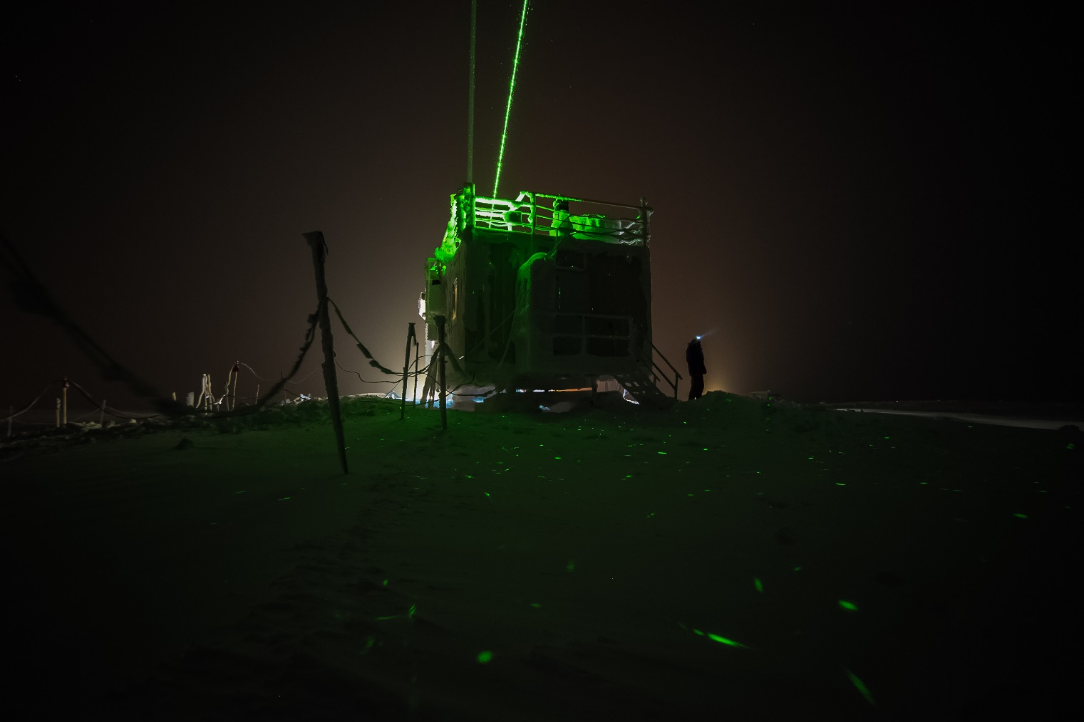

*Imageable rave ice has been relatively rare so far this season, but that hasn’t stopped me from trying.*

*This 45-image stack was taken on Thursday,*

**General:**

I have been slowly recovering some semi-buried cables around the MSF leading to the POSS and the SODAR. I believe I have successfully avoided damaging anything or otherwise interfering with operations so far. This (slow) operation will continue into next week.

**Significant Weather Observations:**

|  |  |  |  |  |  |  |  |
| --- | --- | --- | --- | --- | --- | --- | --- |
| **Date** | **Time (Z)** | **Wind** | **Weather** | **Visibility** | **Sky** | **Temp** | **Notes** |
| 12-24 | 12Z | 17kt from 255 | BLSN BR | 0800 | BKN000 BKN050 | -30 | Wind dropped to 5kts at 14Z |
| 12-25 | 12 | 11kt from 220 | BLSN BR | 0800 | SCT000 SCT004 | -20 |  |
| **12-25** | **16Z** | **12kt from 251** | **BLSN BR** | **0600** | **BKN000 OVC010** | **-19** | Warmest temp so far this season |
| 12-26 | 12 | 05kt from 160 | BR | 3200 | FEW000 SCT100 | -35 |  |
| 12-27 | 12 | 09kt from 210 | BR | 3200 | OVC006 | -27 | 1cm rime |
| 12-28 | 12 | 11kt from 200 | BR IC | 1600 | FEW000 SCT030 | -36 | Moon dogs around 12Z |
| 12-29 | 12 | 10kt from 210 |  | 9999 | FEW030 FEW100 | -46 |  |
| 12-30 | 12 | 09 from 208 | VCFG IC | 6000 | FEW000 FEW100 | -45 |  |

**ICECAPS-ACE Data Management:**

* 12-24: Data transfer complete at 1623Z
* 12-25: Data transfer complete at 1543Z
* 12-26: Data transfer complete at 1329Z
* 12-27: Data transfer complete at 1217Z
* 12-28: Data transfer complete at 1135Z
* 12-29: Data transfer complete at 1305Z
* 12-30: Data transfer complete at 1427Z

**MWR:**

* Operating normally.

**SODAR:**

* 12-25: At daily check I found the SODAR JPGs had not been written. I closed the SODAR software, reopened it. It appears to be operating correctly now.
* Operating normally.

**POSS:**

* Operating normally.

**MMCR:**

* Operating normally.

**CAPABL:**

* 12-24: Snow removed from CAPABL window at 1415Z.
* Instrument currently operating normally using laser 2

**MPL:**

* Operating normally.

**VCEIL:**

* Operating normally.

**IceCAM:**

* Operating normally.

**PAERI:**

* 12-24: Red flags on LWresponsivity and SWresponsivity. Mirror cleaned at 1420Z.
* Operating normally.

**TSI:**

* Offline for winter season.

**IcePIC:**

* Attempted to capture some images on Thursday but had focus issues.
* No images captured this week.

**Radiosonde:**

* Twice daily launches.

**MASC:**

* Instrument offsite for repair, will not return until summer 2019.

**OPC:**

* ACE laptop unresponsive. There is reportedly a spare here, but so far I have been unable to locate it.
* OPC appears functional, but I cannot conclusively determine this.

**CLASP:**

* Instrument off site.

**CPC:**

* Instrument off site.