**ICECAPS-ACE Weekly Report**

December 3 – December 9, 2018

Gus Allen

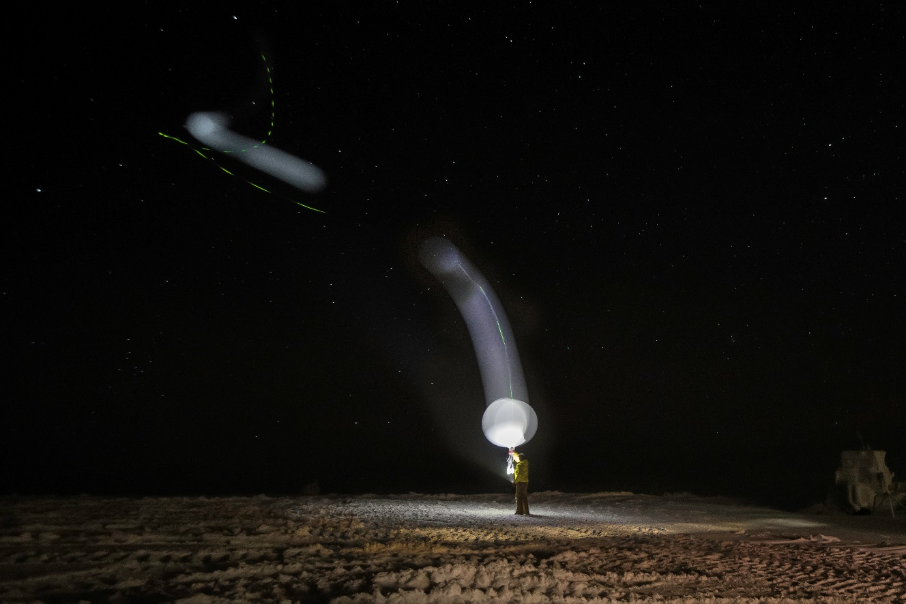

*A merge of two 5-second exposures shows the first moments of a radiosonde balloon launch in 10 knots of south wind.*

**General:**

No major issues were encountered with any ICECAPS system this week. The trend appears to be mostly smooth operations with only minor glitches every so often.

**Significant Weather Observations:**

|  |  |  |  |  |  |  |  |
| --- | --- | --- | --- | --- | --- | --- | --- |
| **Date** | **Time (Z)** | **Wind** | **Weather** | **Visibility** | **Sky** | **Temp (C)** | **Notes** |
| 12-03 | 1200 | 9kts from 250 |  | 9999 | FEW100 | -50 |  |
| 12-04 | 1200 | 11kts from 180 |  | 9999 | FEW100 | -48 |  |
| 12-05 | 1200 | 12kts from 190 | BLSN BR | 0800 | BKN000 BKN080 | -44 |  |
| 12-06 | 1200 | 06kts from 210 | FZFG | 0200 | VV002 | -33 | Sky clearing at 1500 |
| 12-07 | 1200 | 11kts from 190 |  | 9999 | FEW100 | -44 | FZFG at 1600 |
| 12-08 | 1200 | 14kts from 140 | BR | 1600 | SCT100 | -43 | BR cleared at 1400 |
| 12-09 | 1200 | 15kts from 180 | BR | 1600 | FEW100 | -40 |  |

**ICECAPS-ACE Data Management:**

* 12-03: Data transfer complete at 1335Z.
* 12-04: Data transfer complete at 1352Z.
* 12-05: Data transfer complete at 1553Z
* 12-06: Data transfer complete at 1737Z
* 12-07: ICECAPS server had an error prior to initiating data transfer at 00Z. I found the system unresponsive at 1445Z. After communicating with Matt Shupe, I performed a hard reboot at 1716Z. He reinitiated data transfer around 18Z.
* 12-08: Backlog resulting from 12-07 error transfering over entire period.
* 12-09: Data Transfer complete at 1905Z.

**MWR:**

* Operating normally.

**SODAR:**

* Operating normally.

**POSS:**

* 12-07: Stopped recording because ICECAPS linux system locked up. Precise time unclear. Restarted at 1726Z.
* Operating normally.

**MMCR:**

* Operating normally.

**CAPABL:**

* 12-03: At daily check around 13Z, I found the CAPABL terminal showing disk boot error. I restarted it using the procedure provided by Robert Stillwell on 11-22. It came back up with no issues at 14Z.
* Instrument currently operating normally using laser 2

**MPL:**

* Operating normally.

**VCEIL:**

* Operating normally.

**IceCAM:**

* Operating normally.

**PAERI:**

* Operating normally.

**TSI:**

* Offline for winter season.

**IcePIC:**

* No images captured this week.

**Radiosonde:**

* Twice daily launches.

**MASC:**

* Instrument offsite for repair, will not return until summer 2019.

**OPC:**

* Foam filter appears to keeping intake free of rime, but it isn’t clear (to me) if it’s affecting the measurement.
* Operating Normally

**CLASP:**

* Instrument off site.

**CPC:**

* Instrument off site.