**ICECAPS Weekly Report**

July 16 – July 22, 2018

Hannah James

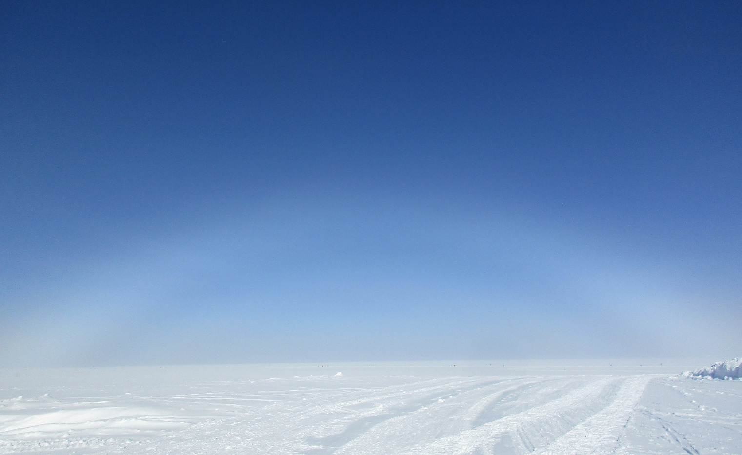

A morning fogbow. -HJ

**General:**

Preparation for electrical work in the Distribution Shack began at the end of the week. This work will require a blackout to station on Monday evening, so the 70kW generator was placed beside the MSF to ensure continuous power during the hour-long power outage. Testing of the system occurred on Saturday. It was discovered that the incorrect plug was placed on the generator power cable, so the MSF went on UPS a number of times on Saturday afternoon, 2018-07-21. Fortunately, there was a plug that allows a quick power transfer from station power to the generator, allowing quick transition times which means continuous data collection. The MSF was on UPS during the following time intervals: 15:16-15:19, 16:05-16:07, 16:44-16:51, 17:06-17:08, 17:10-17:14, 17:38-17:39, 17:54-17:56, and 18:28-18:29Z. All instruments remained powered on, and continuous data collection was achieved. The generator was on from 14:52-15:20Z, 16:42-16:51Z, and 17:53-18:38Z. Initial startup issues were found on the generator, but once the mechanic was able to diagnose and resolve the issue, it ran smoothly and continuously. Since we were in north winds during this testing period, the exhaust was blowing over the MSF and may have altered some of the instrument’s readings.

**Significant Weather Observations:**

* 07-16: VV 400 meters. -4C, 24 kts. Blsn, sn.
* 07-17: Bkn altocumulus. -5C, 22 kts. Blsn, calming in afternoon and clearing to bkn altocumulus and -sn. 22:00- 23:00Z: Large dendritic snowflakes.
* 07-18: Bkn altocumulus, bkn cirrus. -10C, 11 kts. -Sn 22:00Z.
* 07-19: Few altocumulus. -13C, 7kts. -Sn 12:00Z.
* 07-20: Sct fzfg. Sky clear through fog. -19C, 7 kts. 09:30Z- Fogbow
* 07-21: Few stratus, few cirrus in the distance. Clear overhead. -22C, 7 kts.
* 07-22: Few altostratus, few cirrocumulus, few cirrus spissatus. Vcfzfg, -13C, 7 kts.

**ICECAPS Data Management:**

* 07-16: Data transfer complete 18:02Z.
* 07-17: Data transfer complete 16:15Z.
* 07-18: Data transfer complete 16:33Z.
* 07-19: Data transfer complete 15:54Z.
* 07-20: Data transfer complete 14:37Z.
* 07-21: Data transfer complete 17:52Z.
* 07-22: Data transfer complete 19:42Z.

**MWR:**

* As of 10-28, 150-90 operating in V11_SCAN_HF.MBF.

**SODAR:**

* Operating normally.

**POSS:**

* Operating normally in old software.

**MMCR:**

* Operating normally.
* Pitch 0.00, Roll 0.00.

**CAPABL:**

* Operating in Laser 2, alignment peaked.
* 07-16: CAPABL laser off 13:26-13:36Z to clean water droplets off the window.
* 07-19: Clear skies allowed alignment of Laser 1. With Robert on the phone, signal peak was attempted but not achieved. I swapped the flash lamp, but we could not obtain signal over 2.5 km. We temporarily swapped coolant lines and peaked Laser 2’s signal, which went up to 4 km. We swapped coolant lines back and swapped to Laser 1. Neely requested that we run on Laser 2 since it has higher signal, and we can diagnose when he arrives next month. Laser 2 was peaked, normal operations resumed around 19:30Z.

**MPL:**

* Operating normally.
* 07-18: Afterpulse calibration performed 13:06-13:27Z. 30m, 30s 13:08-13:17Z. CopolBkdAvg: 0.000291, CopolBkdStd Dev: 0.000181. 15m, 30s 13:17-13:26Z. CopolBkdAvg: 0.000234, CopolBkdStd Dev: 0.000249.

**VCEIL:**

* Operating normally.

**IceCAM:**

* Operating normally.

**PAERI:**

* Operating normally.
* 07-21: 11:50Z- Cleaned heavy frost from fan blades.

**TSI:**

* Operating normally.
* 07-22: Faulty images of green screen and grey distorted image appearing throughout the day. Power cycled computer and instrument, normal operations resumed 14:12Z.

**IcePIC:**

* No images captured this week.

**Radiosonde:**

* Twice daily soundings.
* 07-17: Strange coms errors with SPS311 and ground check device. Morning launch delayed until 12:05Z, evening launch not successful. When a sonde was placed on the ground check device, it would not register. Some damage was found on the antenna cable on the GH roof, and was repaired with electrical tape. Similar errors occurred in the evening, but a connection was not successful. We will continue to email PIs with errors we come across and troubleshoot to the best of our ability.

**MASC:**

* Instrument offsite for repair, will not return until summer 2019.