**ICECAPS Weekly Report**

July 2 – July 8, 2018

Hannah James

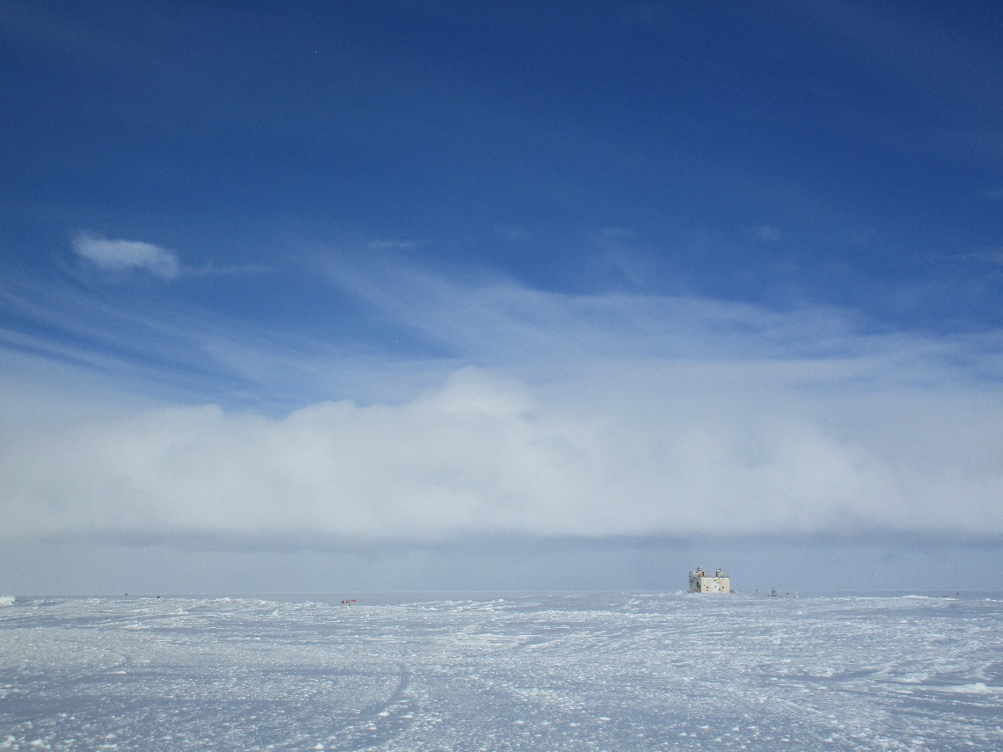

A combination of low and high clouds made for a beautiful sky on Sunday. -HJ

**General:**

None to report

**Significant Weather Observations:**

* 07-02: Sct stratus, bkn altocumulus. Blsn, -sn. -8C, 19 kts. 12:00Z- parhelia.
* 07-03: Bkn stratocumulus, bkn altostratus. -9C, 10 kts.
* 07-04: Bkn altocumulus becoming altostratus later in the morning. -11C, 5 kts.
* 07-05: Few stratocumulus, bkn altocumulus, bkn cirrus. -Sn, drsn. -10C, 16kts.
* 07-06: Sct altocumulus, sct cirrocumulus. IC. -10C, 9 kts.
* 07-07: Bkn altocumulus. Br, IC. -11C, 10 kts.
* 07-08: Bkn stratocumulus, ovc altostratus. Drsn, -sn. -8C, 20 kts.

**ICECAPS Data Management:**

* 07-02: Data transfer complete 17:50Z.
* 07-03: Data transfer complete 17:19Z.
* 07-04: Data transfer complete 13:09Z.
* 07-05: Data transfer complete 17:15Z.
* 07-06: Data transfer did not complete. Dataman computer crashed at some point in the afternoon, but I did not know about this until the following morning.
* 07-07: Data transfer did not complete. Dataman computer found with black screen and mouse. Hard reboot performed at 09:42Z. Manual data push ran, previous day’s data transferred at 10:13Z. GetData script ran at 11:28Z, LinkData script and manual transfer started at 11:50Z, but broken links reported. After seeing the script was re-written by Matt S, ./IcecapsManual.bash script started at 21:09Z.
* 07-08: Data transfer complete following morning at 01:36Z due to two days’ worth of data.

**MWR:**

* As of 10-28, 150-90 operating in V11_SCAN_HF.MBF.

**SODAR:**

* Operating normally.
* 07-02: 17:27Z- cleared snow from receiver dish.

**POSS:**

* Operating normally in old software.
* 07-07: Datama crashed previous day, restarted POSS at 09:54Z.

**MMCR:**

* Operating normally.
* Pitch 0.00, Roll 0.00.

**CAPABL:**

* Operating in Laser 2, alignment to be performed with first clear sky opportunity.
* 07-08: Laser 1 found not firing. Computer not frozen, so a closeout of LabView and full shutdown of laser was performed. Upon bringing things back up, bubbles were found in the Laser 1 line. After 30 minutes they did not disappear, so the pumps were turned off and on again. LabView was started but Laser 1 still would not fire. The Fault light on the front panel of Laser 1 was lit. It is suspected that the pump that circulates the coolant water has failed, since the vibrations coming out of Laser 1’s power supply are not as strong as Laser 2’s. Laser 2 was powered up, and although it was quite cloudy an alignment was performed. Slight improvements were gained in visibility, but a good alignment will take place the next time skies are clear. Neely is in contact with the manufacturer in order to find out what the next step should be with this unit.

**MPL:**

* Operating normally.

**VCEIL:**

* Operating normally.

**Hotplate:**

* Offline since 2018-01-11.
* Instrument has been shipped out for repair, and likely will not return to Summit Station.

**IceCAM:**

* Operating normally.

**PAERI:**

* Operating normally.

**TSI:**

* Operating normally.

**IcePIC:**

* 07-03: 16:05-16:25Z: Slides placed for collection. Particles photographed include rimed dendrites, rimed broken arms of stellar dendrites, broken arms of stellar dendrites.

**Radiosonde:**

* Twice daily soundings.

**MASC:**

* Instrument has been shipped out for repair.