**ICECAPS Weekly Report**

July 30 – August 5, 2018

Hannah James

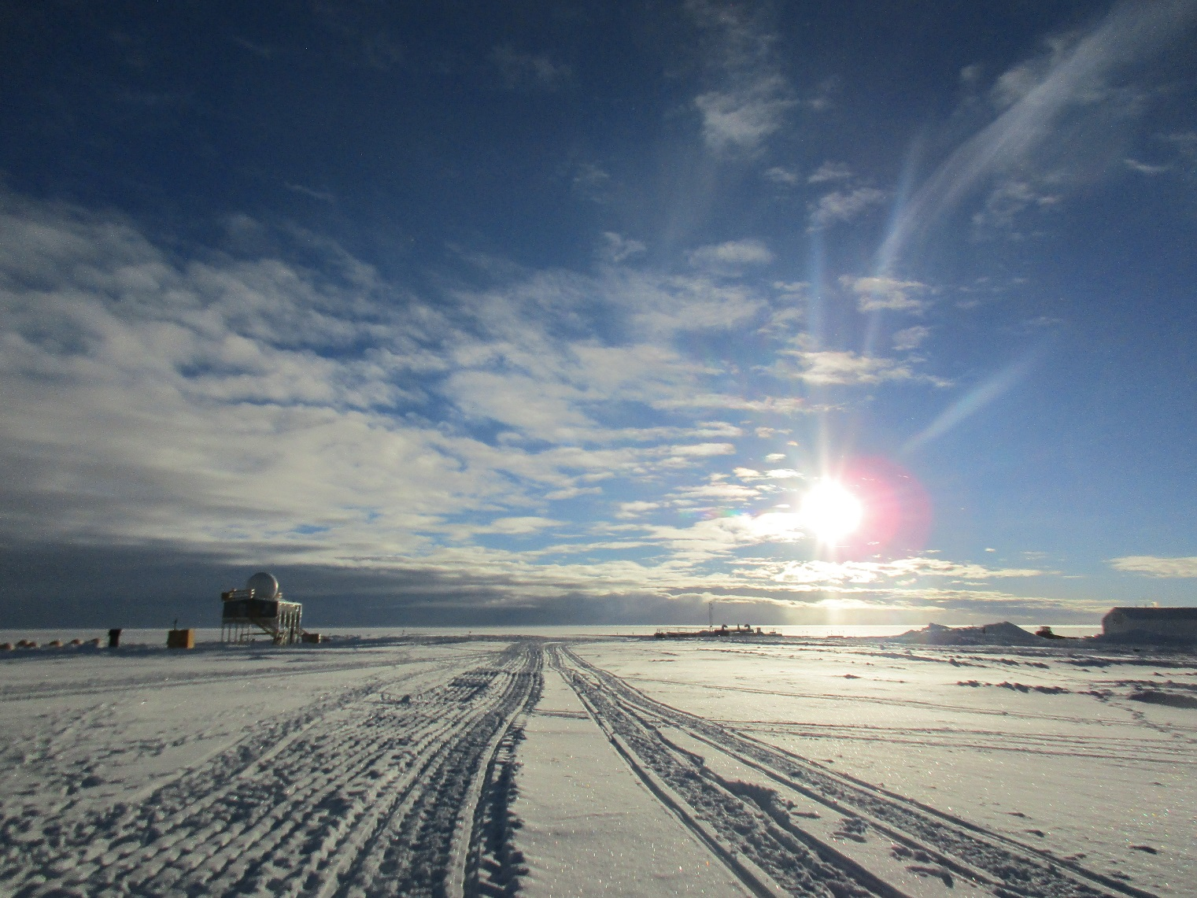Lower lighting in the evenings provides spectacular lighting. The sun will set later this week! -HJ

**General:**

On Monday, July 30, Summit switched to the Emergency Generator so vault work could continue in the garage area. The MSF ran on UPS power from 11:34-11:36Z. On Thursday, August 2, the MSF was powered by the 70kW generator while the remainder of station was offline during the D-Shack lift preparation. The generator ran on the north side of the MSF from 13:32-17:00Z. While switching on and off the generator, the MSF ran on UPS from 13:42-13:44Z and 16:49-16:51Z. During the D-Shack lift on Friday, August 3, the generator ran from 13:26- 19:55Z. The MSF was on UPS during these transfers from 13:36-13:37Z and 19:40-19:41Z. On Saturday, August 4, the generator ran from 10:02-14:18Z. The MSF was on UPS from 10:08-10:09Z and 14:06-14:07Z.

**Significant Weather Observations:**

* 07-30: Ovc stratus. -2C, 5 kts.
* 07-31: Bkn stratocumulus, bkn altocumulus, bkn cirrostratus. -4C, 12 kts.
* 08-01: Bkn stratus. -8C, 16 kts.
* 08-02: Few stratus, few altocumulus, bkn cirrostratus, bkn cirrus uncinus. -11C, 5 kts. IC.
* 08-03: Few stratus, sct cirrocumulus. -13C, 17 kts. IC.
* 08-04: Bkn stratus. -6C, 7 kts. Heavy fzfg in the morning.
* 08-05: Sct altocumulus, sct cirrus. -13C, 7 kts.

**ICECAPS Data Management:**

* 07-30: Data transfer complete 04:46Z.
* 07-31: Data transfer complete 04:43Z.
* 08-01: Data transfer complete 04:41Z.
* 08-02: Data transfer complete 04:40Z.
* 08-03: Data transfer complete 04:38Z.
* 08-04: Data transfer complete 05:57Z.
* 08-05: Data transfer complete 05:29Z.

**MWR:**

* As of 10-28, 150-90 operating in V11_SCAN_HF.MBF.

**SODAR:**

* Operating normally.

**POSS:**

* Operating normally in old software.

**MMCR:**

* Operating normally.
* Pitch 0.00, Roll 0.00.

**CAPABL:**

* Operating normally in Floating Ref Laser 2.

**MPL:**

* Operating normally.

**VCEIL:**

* Operating normally.
* 08-03: 13:05Z- Updated time, computer 18 seconds ahead of GPS server.

**IceCAM:**

* Operating normally.

**PAERI:**

* Operating normally.

**TSI:**

* Operating normally.
* 08-01: 12:37-16:45Z- TSI off during relocation to the North side of the MSF. New location allows room for incoming ACE experiments.

**IcePIC:**

* No images captured this week.

**Radiosonde:**

* 08-04: Morning balloon did not complete due to the UPS running out of power during the prolonged power outage.
* Twice daily soundings.

**MASC:**

* Instrument offsite for repair, will not return until summer 2019.