**ICECAPS Weekly Report**

July 9 – July 15, 2018

Hannah James

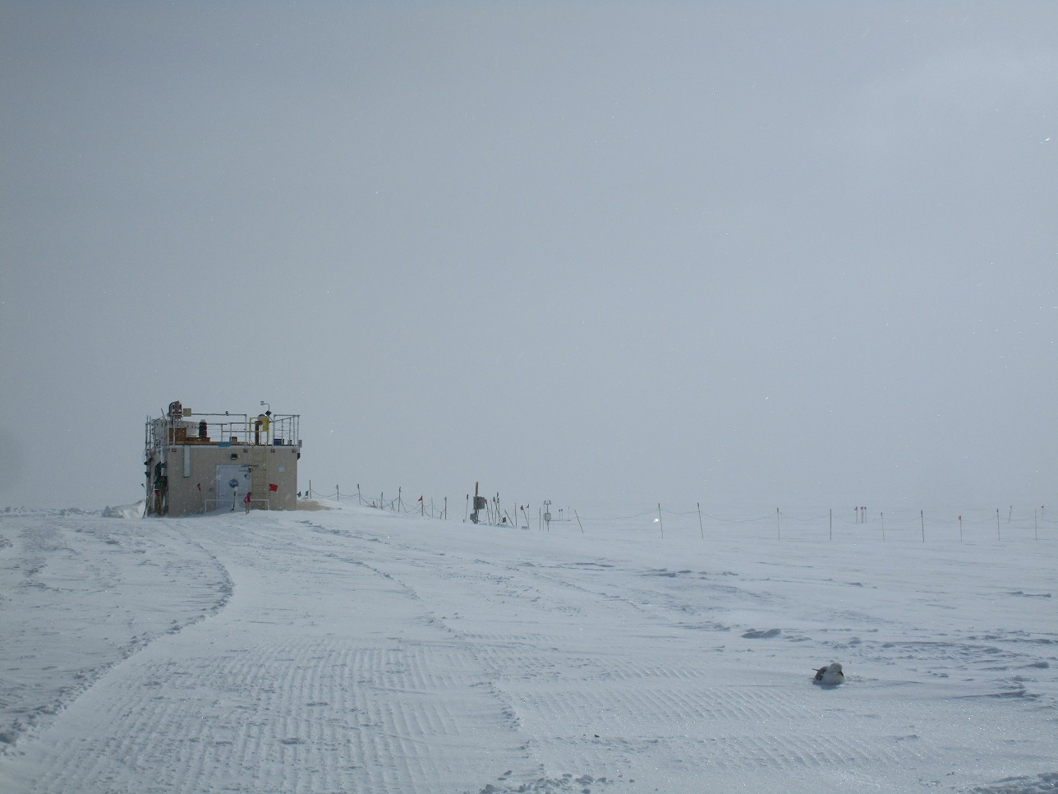

My fearless guard-bird for the week. -HJ

**General:**

Due to the decision that the Hotplate will not return to Summit, it has been removed from this weekly report. The NOAA met tower lacked data from 12:57Z on 2018-07-13 through 01:47 on 2018-07-15 in order to raise tower instrumentation and power boxes. Kristen Pope, a freelance writer for environmental magazines and websites, toured the MSF on Sunday while the Herc was on the ground.

**Significant Weather Observations:**

* 07-09: Few altocumulus, sct cirrus uncinus, sct cirrus spissatus. -11C, 5 kts.
* 07-10: Bkn altocumulus. -11C, 12 kts.
* 07-11: Few altostratus, becoming bkn cumulus by mid-afternoon. IC throughout the day. -10C, 17kts.
* 07-12: Ovc stratus. -11C, 10 kts, rising to 20kts in the afternoon.
* 07-13: Sct stratus, bkn cirrus. -11C, 15 kts. Br, -sg, drsn.
* 07-14: Ovc stratus. -9C, 26 kts. Blsn.
* 07-15: Few stratus, bkn altocumulus. -14C, 8 kts. Br.

**ICECAPS Data Management:**

* 07-09: Data transfer complete 11:18Z.
* 07-10: Data transfer complete 23:09Z.
* 07-11: Data transfer complete 18:47Z. 1 PAERI file not transferred, manual transfer started at 18:50Z, complete at 19:26Z.
* 07-12: Dataman found down with black screen. A hard reboot was performed, no errors appeared on the screen during this process. A manual data transfer was started, and data transfer was complete at 22:28Z.
* 07-13: Data transfer complete 13:50Z.
* 07-14: Data transfer complete 14:34Z
* 07-15: Data transfer complete 14:35Z.

**MWR:**

* As of 10-28, 150-90 operating in V11_SCAN_HF.MBF.

**SODAR:**

* Operating normally.
* 07-10: 12:05-12:13Z- Amplifier off while cleaning snow from dishes.
* 07-12: 14:00-14:15Z- HEO working around MSF.

**POSS:**

* Operating normally in old software.

**MMCR:**

* Operating normally.
* Pitch 0.00, Roll 0.00.
* 07-10: 11:53Z- Adjusted Radar computer clock as it was 10 seconds ahead of GPS time.

**CAPABL:**

* Operating in Laser 1, but alignment not peaked.
* 07-09: Upon chatting with Robert, we properly aligned Laser 2. During my initial realignment on Sunday, I did not realize that the motors were moving the mirrors in the alignment config file. With Robert’s help, the mirrors were zeroed and then alignment of the first and second mirrors were made. We peaked the signal, and left Laser 2 recording data. Daily checks passed afterwards.
* 07-11: Thanks to Robert’s investigation, it was discovered that the errors discovered last week are due to a low flow of the coolant in Laser 1. I swapped coolant lines so that we could switch back to Laser 1. Alignment began but was stopped when some lower level clouds rolled over camp. When the next clear sky opportunity arrives, I will notify both Neely and Robert so we can peak Laser 1’s signal.

**MPL:**

* Operating normally.
* 07-10: 11:46Z- Adjusted computer clock as it was running 20 seconds ahead of GPS time.

**VCEIL:**

* Operating normally.

**IceCAM:**

* Operating normally.

**PAERI:**

* Operating normally.

**TSI:**

* Operating normally.

**IcePIC:**

* No images captured this week.

**Radiosonde:**

* Twice daily soundings.
* Greenhouse met data used for surface obs the evening of 07-13 and morning of 07-14 due to the NOAA met station being down for maintenance.

**MASC:**

* Instrument offsite for repair, will not return until summer 2019.