**ICECAPS Weekly Report**

June 11 – 17, 2018

Marci Beitch

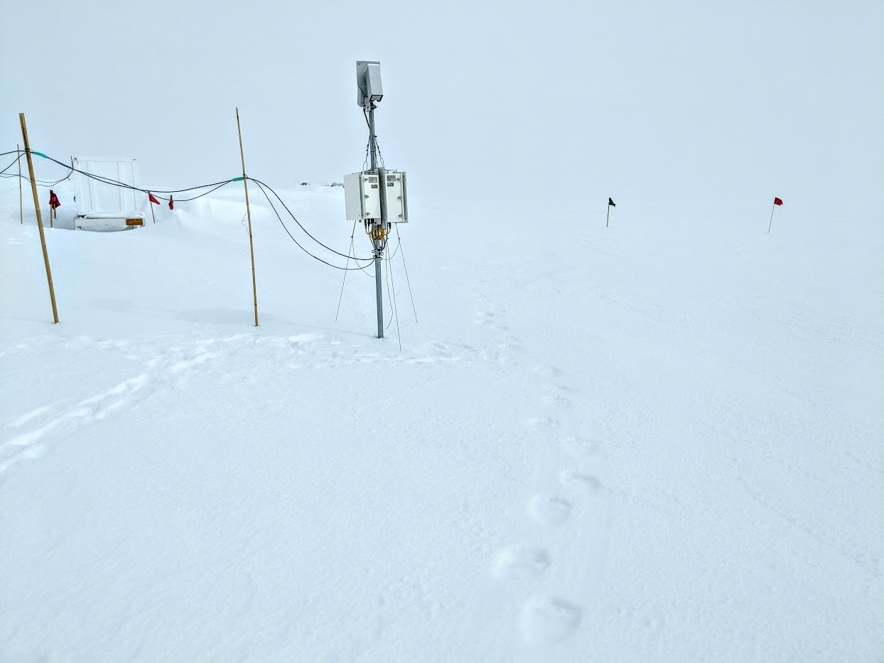

Polar bear footprints near the POSS. (Photo: Marci Beitch, 2018-06-15)

**General:**

A monumental yet unfortunate event defined our week: a female polar bear followed her nose to our far inland and upland camp. During her 36-hour stay all camp staff were hunkered down in the Big House and Green House while equipment operators took shifts in heavy equipment to provide around the clock watch. The NSF hired hunters to kill the bear because she would not leave camp and posed a risk to personnel. Radiosonde launches and visits to the MSF were not performed on 06-13 and 06-14.

**Significant Weather Observations:**

* 06-11: Few stratocirrus. Br in early morning. -14 C, 6 kts.
* 06-12: Few stratocirrus becoming Few to Sct cirrus and cirrocumulus. Fzfg in morning. -15 C, 7 kts.
* 06-13: Bkn altocumulus. -17C, 5 kts.
* 06-14: Few to Sct stratocumulus and cirrus. -17C, 12 kts.
* 06-15: Few to Bkn cirrus and cirrocumulus becoming Bkn to Ovc stratus. -Sn. -18C, 12 kts. 22-degree halo present between approximately 10:00 and 16:00Z. Significant weather pictures uploaded.
* 06-16: Few to Sct cirrus. Ic, Br. -19C, 11 kts. 22-degree halo, parhelia, parhelic circle, and upper tangent arc present between approximately 10:50 and 14:00Z. Significant weather pictures uploaded.
* 06-17: Few to Bkn stratocumulus. Ic, Sg, Drsn. -17C, 15 kts. 22-degree halo, parhelia, and parhelic circle present between approximately 07:30 and 11:30Z.

**ICECAPS Data Management:**

* 06-11: Data transfer complete 06:03Z.
* 06-12: Data transfer complete 06:09Z.
* 06-13: Unknown.
* 06-14: Unknown.
* 06-15: Data transfer complete 05:23Z.
* 06-16: Data transfer complete 07:21Z. Partway through MMCR data pull “no space left on device” errors for each subsequent data pull entry. However, Archive to Boulder log appeared normal. 06-15 data remained in many instrument data folders. Matt Shupe remotely ran daily data management program to process and archive the remaining data. Matt also started a manual data transfer of remaining data to Boulder.
* 06-17: Data transfer complete 06:19Z.

**MWR:**

* As of 10-28, 150-90 operating in V11_SCAN_HF.MBF.

**SODAR:**

* Operating normally.

**POSS:**

* Operating normally in old software.
* 06-11: Numerous “Gunn current low” errors.
* 06-12: Numerous “Gunn current low” errors. 12:33-12:47Z: Stopped acquisition software, powered instrument off. Re-powered and restarted acquisition software. “Gunn current low” errors persisted. Peter Rodriguez from Environment Canada followed up with Matt and let us know that the error was coded incorrectly and meant to say “FEP too warm.” 15:55Z light bulb in the enclosure was unscrewed and the errors discontinued.

**MMCR:**

* Operating normally.
* 06-11 13:00Z: NetCDF errors occurred and were cleared at 13:53Z. Reboot not performed.
* 06-11 14:00Z: NetCDF errors occurred and were cleared at 14:01Z. Reboot not performed.
* 06-11 15:00Z: NetCDF errors occurred and were cleared on 06-12 at 13:16Z. Reboot not performed.
* 06-12 14:00Z: NetCDF errors occurred and were cleared at 14:01Z. Reboot not performed.
* 06-12 15:00Z: NetCDF errors occurred and were cleared at 16:08Z. 16:11, 16:24, and 16:37Z: reboots performed. 16:50Z: Instrument operational.
* 06-15: MMCR found to be not mounted on dataman and MMCR internet connectivity absent. MMCR D-Link router power-cycled. Internet connectivity and dataman mount restored.
* Pitch 0.00 flashing to 0.11, Roll 0.00 flashing to 0.11 as of 06-17.

**CAPABL:**

* Operating normally.

**MPL:**

* Operating normally.
* 06-17 13:09-13:34Z: Afterpulse calibration performed.
  + 30m, 30s: CoPol BkdAvg 0.000296, CoPol BkdStdDev 0.000179.
  + 15m, 30s: CoPol BkdAvg 0.000241, CoPol BkdStdDev 0.000264.

**VCEIL:**

* Operating normally.

**Hotplate:**

* Offline since 2018-01-11.
* Instrument has been shipped out for repair.

**IceCAM:**

* Operating normally.
* 06-16 01:15Z: photograph corrupt.

**PAERI:**

* Operating normally.
* 06-11 12:01-12:47Z: Removed fan to defrost due to divergent outside air and air near BB temps.
* 06-12 12:24-13:29Z: Removed fan to defrost due to divergent outside air and air near BB temps.

**TSI:**

* Operating normally.

**IcePIC:**

* 06-15 12:15-12:30Z: Slides placed for collection. Particles photographed include bullets, sheaths, bullet rosettes, triangular forms, graupel, and irregulars.

**Radiosonde:**

* Twice daily soundings.
* 06-13: 12Z sonde not released due to polar bear.
* 06-14: 0Z and 12Z sondes not released due to polar bear.

**MASC:**

* Instrument has been shipped out for repair.