**ICECAPS Weekly Report**

June 18 – 24, 2018

Marci Beitch

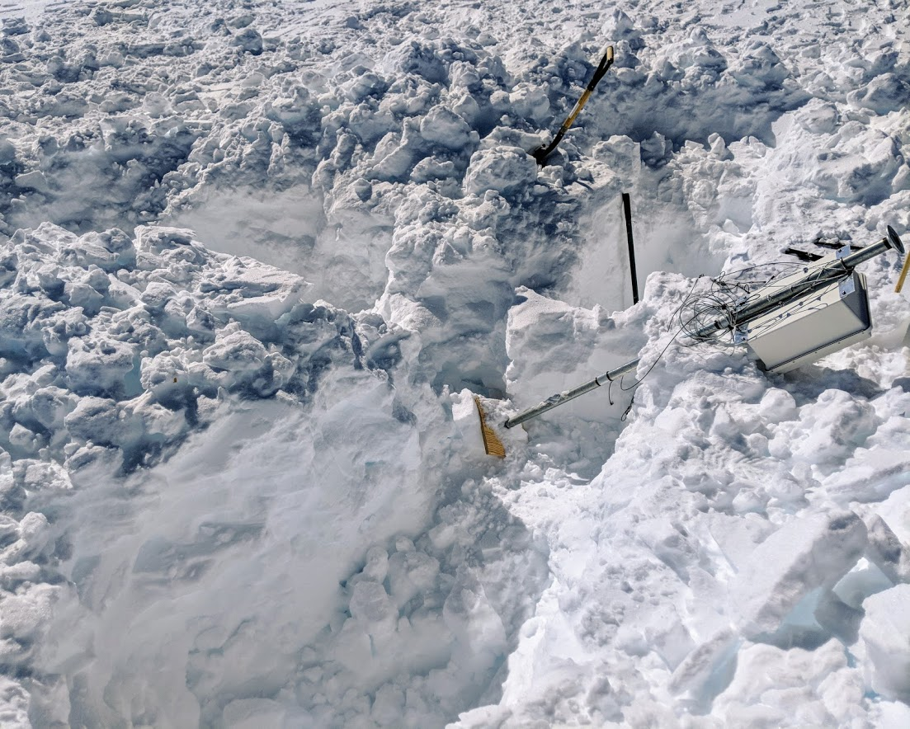

Three large holes dug to remove the Hotplate stand and anchors. (Photo: Marci Beitch, 2018-06-20)

**General:**

Two short station power outages were performed in order to transfer power to and from the emergency generator for testing on 06-18 between 01:21 and 01:29Z and between 06:47 and 06:48Z. Associated with these outages was a Big House power outage in order to repair and extend its power cable at the primary power distribution building, which meant a multi-hour internet outage on 06-18 between 01:21 and 07:06Z. The time server GPS antenna was reinstalled on the MSF roof on 06-19. Preparations for the MSF move began by digging up MASC anchors and the Hotplate stand and anchors, feeding the Hotplate and MASC network cables inside the MSF, and uncovering drifted over electrical and instrument cables.

**Significant Weather Observations:**

* 06-18: Bkn stratocumulus. Sg, Drsn. Becoming Few cirrus. Ic, Drsn. -16 C, 14 kts. 22-degree halo, parhelia, and parhelic circle present from approximately 11:54 to 15:30Z. 22-degree halo continued to be present until approximately 18:50Z. Significant weather pictures uploaded.
* 06-19: Bkn stratocumulus becoming Few cirrus. -13 C, 3 kts.
* 06-20: Few to Bkn cirrus. -14 C, 12 kts. 22-degree halo from approximately 09:50 to 15:30Z.
* 06-21: Sct cirrocumulus. -14 C, 7 kts. 22-degree halo present from approximately 13:20 to 15:00Z.
* 06-22: Few to Sct stratus and Sct to Bkn altocumulus. -Sn. -11 C, 16 kts.
* 06-23: Sct stratus and Bkn altocumulus becoming Few to Bkn cirrus. Sg, Ic. -13 C, 8 kts.
* 06-24: Vv becoming Sct to Bkn altocumulus and cirrus. Fzfg, Sg, Ic. -16 C, 5 kts. 22-degree halo and parhelia present in evening hours. Significant weather photo uploaded.

**ICECAPS Data Management:**

* 06-18: Internet outage interrupted automatic data transfer. Data transfer manually pushed at 07:08Z. Data transfer complete 12:42Z.
* 06-19: Data transfer complete 06:10Z.
* 06-20: Data transfer complete 05:49Z.
* 06-21: Data transfer complete 07:30Z.
* 06-22: Data transfer complete 06:00Z.
* 06-23: Data transfer complete 10:17Z.
* 06-24: Data transfer of 06-23 data did not run this morning. Dataman computer unresponsive beginning 06-23 after 20:00Z. 06-24 23:25Z hard reboot performed, which brought the dataman computer back.

**MWR:**

* As of 10-28, 150-90 operating in V11_SCAN_HF.MBF.
* 06-24: Data from 06-23 not pulled by dataman.

**SODAR:**

* Operating normally.
* 06-24: Data from 06-23 not pulled by dataman.

**POSS:**

* Operating normally in old software.
* 06-18: Downloaded temp logger placed in enclosure box on 06-08. When the light bulb was turned on temperatures reached in the 40s C. Now that the light bulb is off temperatures oscillate daily centered slightly below 0 C.
* 06-24: Data from 06-23 not pulled by dataman. POSS not operational after 06-23 20:00Z. 06-24 23:35Z data acquisition restarted after dataman computer reboot.

**MMCR:**

* Operating normally.
* 06-20 15:40 and 15:41Z: Synced MMCR-RADAR and MMCR-DM computer clocks, respectively, to GPS time server.
* 06-24: Data from 06-23 not pulled by dataman.
* Pitch 0.00 flashing to 0.11, Roll 0.00 as of 06-24.

**CAPABL:**

* Operating normally.
* 06-19 15:20-15:50Z: Laser realignment performed with Neely and Robert on the phone and remotely logged in. Laser had been out of alignment since 06-09 when the MSF was re-leveled.
* 06-19 15:50Z: Synced CAPABL computer time with GPS time server.
* 06-24: Data from 06-23 not pulled by dataman.

**MPL:**

* Operating normally.
* 06:20 15:43Z: Synced MPL computer clock with GPS time server.
* 06-24: Data from 06-23 not pulled by dataman.

**VCEIL:**

* Operating normally.
* 06-24: Data from 06-23 not pulled by dataman.

**Hotplate:**

* Offline since 2018-01-11.
* Instrument has been shipped out for repair.
* 06-19 and 06-20: Removed network cable from outdoors and dug up anchors and stand.

**IceCAM:**

* Operating normally.
* 06-24: Data from 06-23 not pulled by dataman. IceCAM not operational after 06-23 20:00Z and before 06-24 23:30Z.

**PAERI:**

* Operating normally.
* 06-24 13:18-13:33Z: Fan enclosure unplugged and brought inside to defrost due to heavy frost on fan blades that could not be cleaned with long-handled paintbrush. Outside air and air near BB temps divergent by approximately 3 deg C before fan defrost and improved after.
* 06-24: Data from 06-23 not pulled by dataman.

**TSI:**

* Operating normally.
* 06-24: Data from 06-23 not pulled by dataman.

**IcePIC:**

* 06-22 10:30-11:00Z: Slides placed for collection. Particles photographed include stellar dendrites, sectored plates, hexagonal columns, triangular forms, hexagonal plates, capped columns, rimed particles, graupel, and irregulars.
* 06-22 18:40-19:10: Slides placed for collection. Particles photographed include fernlike stellar dendrites, simple stars, rimed particles, and irregulars.
* 06-22: Cleaned optics.

**Radiosonde:**

* Twice daily soundings.

**MASC:**

* Instrument has been shipped out for repair.
* 06-19: Dug up anchors.
* 06-21: Removed network cable from outdoors.