**ICECAPS Weekly Report**

June 25 – July 1, 2018

Marci Beitch and Hannah James

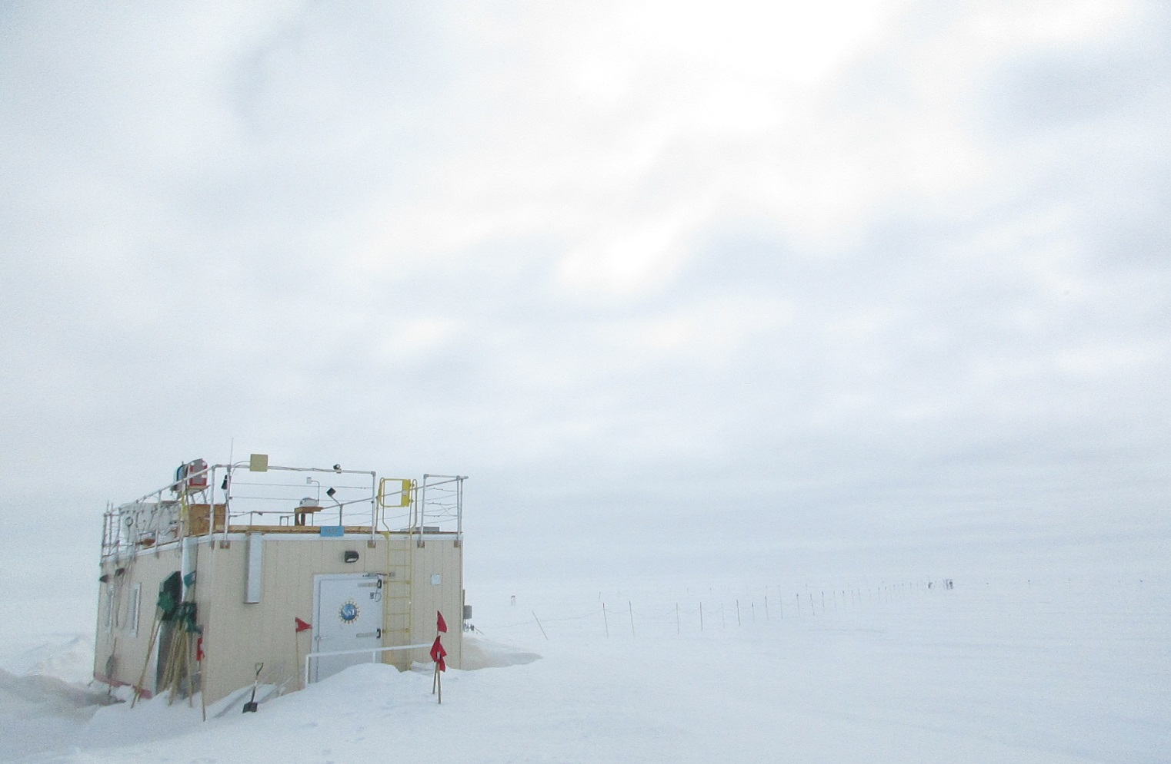

The MSF on an overcast, yet bright, morning. -HJ

**General:**

Preparations for the MSF move continued with digging snow to uncover drifted over electrical cables. The Big House lift was performed on 06-26. During the lift Summit Station experienced internet outages on 06-26 from approximately 15:15-21:36Z and overnight 23:45-02:30Z (into 06-27) while power was off to the Big House and internet technicians repositioned the satellite. Flight Period 4 came to a close on 06-29 with the arrival of returning ICECAPS technician Hannah James and the departure of Marci Beitch. Slow data transfers continued through the week. SRI has been notified, and we hope to resolve this issue early on this week.

**Significant Weather Observations:**

* 06-25: Bkn altocumulus. Sg. -13 C, 8 kts.
* 06-26: Few stratus and Bkn altocumulus. Sg. -13 C, 10 kts.
* 06-27: Vv becoming Few cirrus. Fzfg. -18 C, 9 kts.
* 06-28: Few cirrus. -14 C, 11 kts.
* 06-29: Few to Bkn stratocumulus, altocumulus, and cirrus. -Sn, Ic. -11 C, 10 kts.
* 06-30: Few stratus, few altostratus, bkn altocumulus. Ic. Late afternoon, ovc stratus, -sn. -14C, 9 kts.
* 07-01: Bkn stratus. Blsn, IC. -8C, 20 kts.

**ICECAPS Data Management:**

* 06-25: Data transfer complete 11:29Z. Two days’ worth of data to send due to dataman computer fault from 06-23 to 06-24.
* 06-26: Data transfer complete 05:46Z.
* 06-27: Automatic data transfer interrupted due to internet outage while satellite was being repositioned after Big House lift. Manual data transfer initiated: Icecaps.Manual.bash started at 09:32Z; ArchiveToBoulderManual.bash started at 09:47Z. According to SRI, due to poor alignment of internet satellite dish after Big House lift, data transfers proceeded at slow pace. 06-26 data transfer did not complete on 06-27 and remaining 06-26 data was incorporated into 06-27 data transfer on 06-28.
* 06-28: Data transfer complete 13:44Z.
* 06-29: Data transfer complete 16:22Z.
* 06-30: Data transfer complete 12:33Z.
* 07-01: Data transfer complete 12:35Z.

**MWR:**

* As of 10-28, 150-90 operating in V11_SCAN_HF.MBF.

**SODAR:**

* Operating normally.
* 06-27 13:02-13:10Z: cleaned snow from dishes.

**POSS:**

* Operating normally in old software.

**MMCR:**

* Operating normally.
* 06-28 12:22Z: “Error 8: LabVIEW file permission error” occurred and was able to be cleared without a reboot. No loss of data ensued.
* Pitch 0.00 flashing to 0.11 occasionally, Roll 0.00 flashing to 0.11 occasionally as of 07-01.

**CAPABL:**

* Operating normally.

**MPL:**

* Operating normally.

**VCEIL:**

* Operating normally.

**Hotplate:**

* Offline since 2018-01-11.
* Instrument has been shipped out for repair.

**IceCAM:**

* Operating normally.

**PAERI:**

* Operating normally.

**TSI:**

* Operating normally.

**IcePIC:**

* 06-26 12:45-12:55Z: Slides placed for collection. Particles photographed include radiating plates, hollow columns, bullet rosettes, hexagonal plates, graupel, and irregulars.

**Radiosonde:**

* Twice daily soundings.

**MASC:**

* Instrument has been shipped out for repair.