**ICECAPS Weekly Report**

Jun 4 – Jun 10, 2018

Rex Nelson and Marci Beitch

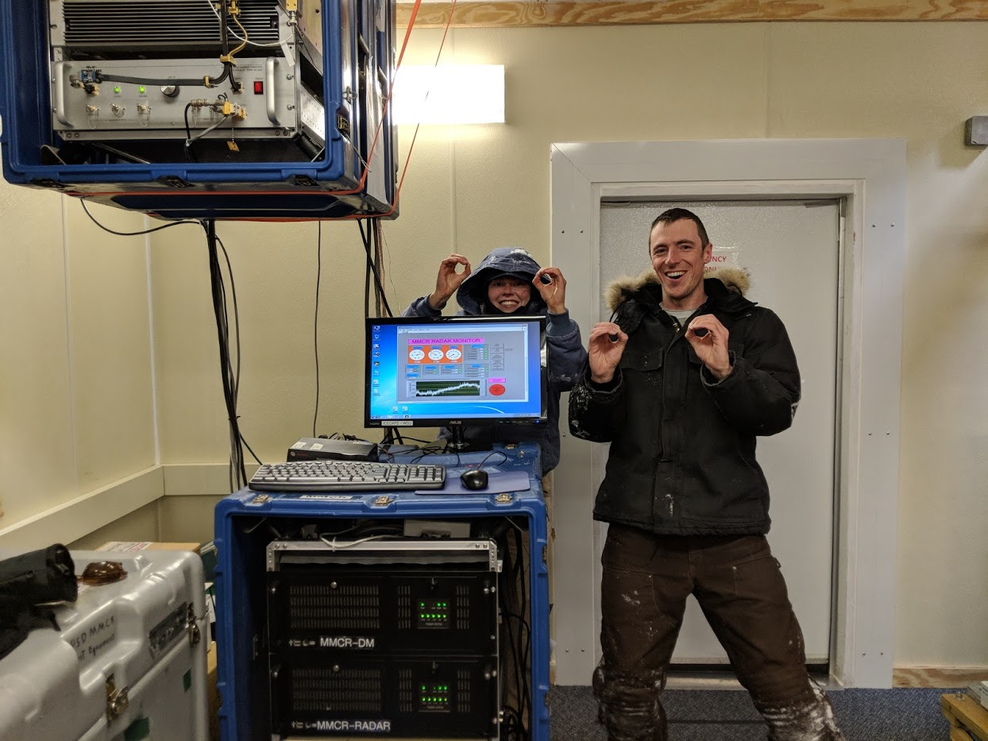

Incoming PFS technician Mara Menahan and Science Project Manager Sam Dorsi completed a leveling of the MSF structure. The MMCR pitch and roll each read 0.00. (Photo: Marci Beitch, 2018-06-09)

**General:**

A busy turnover week ensued with challenging weather conditions: high winds and warm temperatures. Near the end of the week as winds decreased many outdoor tasks were completed including a leveling of the MSF structure so that the MMCR has pitch and roll readings of 0.00 and retesting the new GPS base station antenna and cable on the Green House tower, which led to a successful connection and a switch to the tower antenna for radiosondes. Rex Nelson was scheduled to depart Summit on 2018-06-10 and Marci Beitch, a returning Summit PFS and ICECAPS technician, has taken over the ICECAPS duties.

**Significant Weather Observations:**

* 06-04: Ovc stratus. Sn. -7C, 12kts. Winds increasing to 27kts in afternoon.
* 06-05: Sct stratocumulus. Blsn. -9C, 27kts.
* 06-06: Low visibility in Blsn. -5C, 22kts. 15:39Z: 22deg halo, parhelic circle.
* 06-07: Ovc stratus. Sn. -5C, 14kts.
* 06-08: Sct status, Bkn altocumulus. Sg, Drsn. -11C, 21kts.
* 06-09: Bkn stratocumulus. -Sn. -14C, 8kts.
* 06-10: Few stratocirrus. Ic. -15C, 10kts.

**ICECAPS Data Management:**

* 06-04: Data transfer complete 07:40Z
* 06-05: Data transfer complete 06:29Z
* 06-06: Data transfer complete 07:31Z
* 06-07: Data transfer complete 06:15Z
* 06-08: Data transfer complete 06:36Z
* 06-09: Data transfer complete 06:49Z
* 06-10: Data transfer complete 06:31Z

**MWR:**

* As of 10-28, 150-90 operating in V11_SCAN_HF.MBF.

**SODAR:**

* Operating normally.
* 06-06 15:37-15:44Z: SODAR off while cleaning snow from dishes.
* 06-10 13:46-13:54Z: cleaned snow from dishes.

**POSS:**

* Operating normally in old software.
* 06-07 18:20Z: Tightened guy lines.
* 06-08 16:45Z: Temp logger placed in enclosure. 17:18Z: New bulb installed.
* 06-09: Numerous “Gunn current low” errors.
* 06-10: Numerous “Gunn current low” errors.

**MMCR:**

* Operating normally.
* 06-08 11:00Z: NetCDF errors occurred and were cleared at 12:45Z. Reboot not performed.
* 06-08 13:00Z and 19:00Z: NetCDF errors occurred and were cleared on 06-09 at 13:15Z. Reboot not performed.
* 06-09 11:30-13:05Z: MSF leveling performed.
  + MMCR parameters before level: Pitch -0.21 flashing to -0.32, Roll 0.00 flashing to 0.11.
  + MMCR parameters after level: Pitch 0.00, Roll 0.00.
* 06-09 14:00Z: NetCDF errors occurred and were cleared at 14:14Z. Reboot not performed.
* 06-09 15:00Z: NetCDF errors occurred and were cleared at 17:58Z. Reboot not performed.
* 06-09 18:00Z: NetCDF errors occurred and were cleared on 06-10 at 13:18Z. Reboot not performed.
* 06-10 14:00Z: NetCDF errors occurred and were cleared at 14:32Z. Reboot not performed.
* 06-10 15:00Z: NetCDF errors occurred and were cleared on 06-11 at 12:34Z. Reboot not performed.

**CAPABL:**

* Operating normally.

**MPL:**

* Operating normally.

**VCEIL:**

* Operating normally.

**Hotplate:**

* Offline since 2018-01-11.
* Instrument has been shipped out for repair.

**IceCAM:**

* Operating normally.

**PAERI:**

* Operating normally.
* 06-06 12:24-12:54Z: Removed fan to defrost due to divergent outside air and air near BB temps, but no frost was apparent. Temperature difference persisted.
* 06-08 12:57Z: “293 Kelvin Reference” red flag. Turned yellow then green in records immediately following. 16:40-17:00Z: Removed fan to defrost due to divergent outside air and air near BB temps, but no frost was apparent.

**TSI:**

* Operating normally.
* 06-06: Large system clock drift (20min).
* 06-07: Updated Windows to get time from the server.

**IcePIC:**

* 06-04: Slides placed for collection 11:20-11:30Z. Particles photographed include isolated bullets, bullet rosettes, capped columns, radiating plates, stellar dendrites, sectored plates, and irregulars.
* 06-07: Slides placed for collection 13:10-13:35Z. Downwind slide melted. Particles photographed include broken and rimed sectored plates and dendrites, and irregulars.
* 06-07: Slides placed for collection again at 13:45-13:55Z. Particles photographed include broken sectored plates and dendrites, and irregulars.
* 06-09: Slides placed for collection 17:40-17:50Z. Particles photographed include graupel, irregulars, sheaths, and capped bullets. Particles melting due to warm temperatures.
* 06-09: Slides placed for collection again at 18:00-18:15Z. Particles photographed include graupel, irregulars, stellar dendrites, bullets, and capped bullets. Particles melting due to warm temperatures.

**Radiosonde:**

* Twice daily soundings.
* Radiosonde GPS antenna is temporarily located on SW Green House roof railing through 06-09 12Z sonde.
* 06-09: Retested new GPS antenna and cable already installed on Green House tower and it was successful. Switched to Green House tower antenna before 06-10 0Z sonde. Updated GPS antenna height offset parameter to tower antenna height in MW41 software.

**MASC:**

* The MASC has been shipped out for repair.