**ICECAPS-ACE Weekly Report**

November 12 – November 18, 2018

Gus Allen

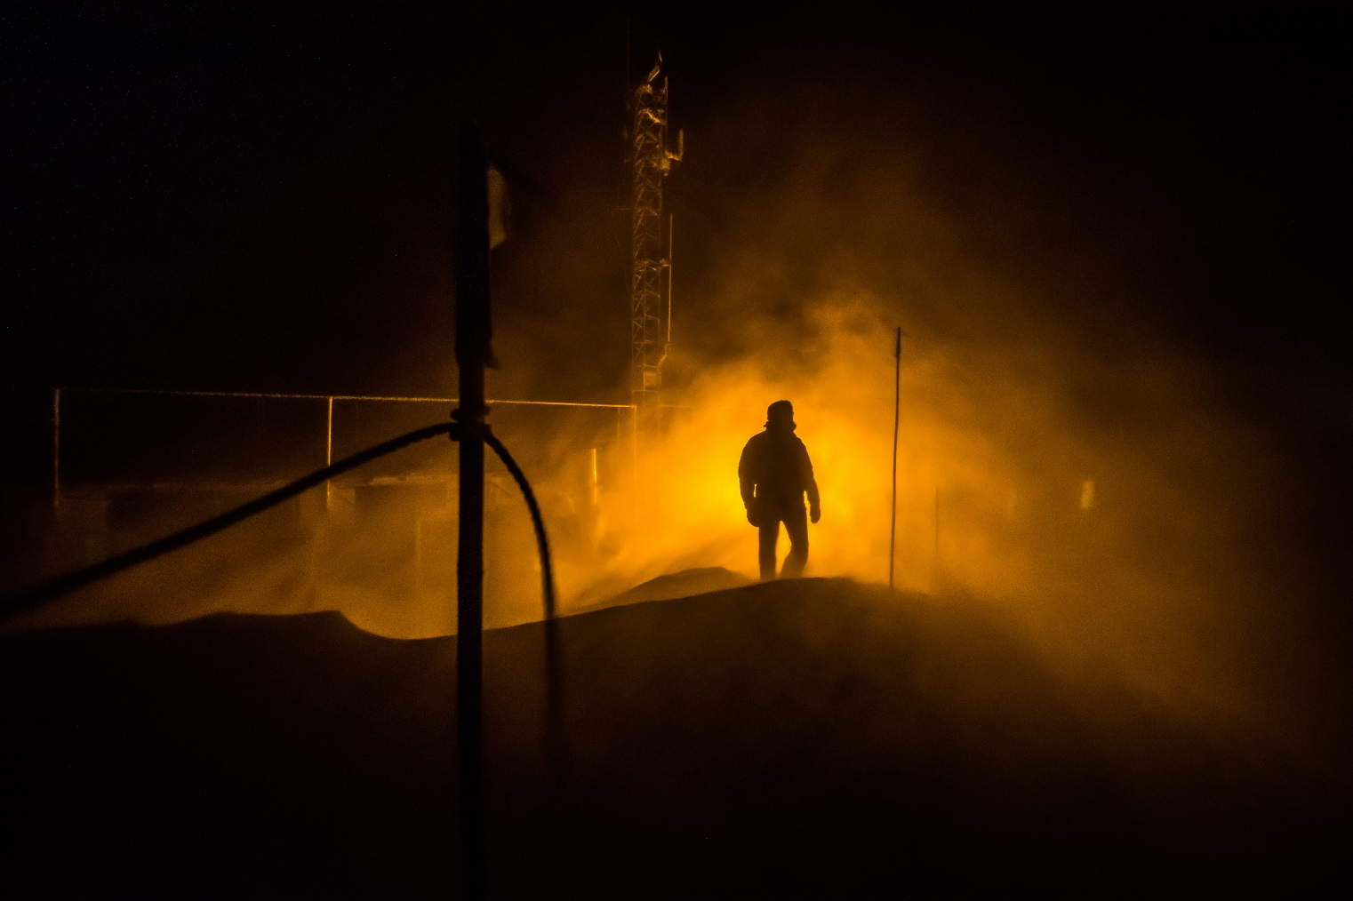

*ICECAPS operations were impacted by wind and blowing snow on 2018-11-17 only minorly.*

**General:**

Numerous small issues cropped up across a number of instruments this week, which worked in concert with some weather on Friday and Saturday to make it feel like a busy one. The dataman transfer issue described below is still unresolved as of this writing.

**Significant Weather Observations:**

|  |  |  |  |  |  |  |
| --- | --- | --- | --- | --- | --- | --- |
| **Date** | **Time (Z)** | **Wind** | **Weather** | **Sky** | **Temp(C)** | **Notes** |
| 11-12 | 1200 | 11kt from 250 | -SN | BKN000 OVC006 | -23 |  |
| 11-13 | 1210 | 11kt from 176 | -SN BR | SCT000 BKN090 | -33 | Sun pillar |
| 11-14 | 1200 | 10kt from 200 | BR -SN | SCT000 OVC012 | -29 |  |
| 11-15 | 1210 | 06kt from 200 | -SN | OVC030 | -30 | Rime Icing |
| 11-16 | 1200 | 07 from 190 | BR | FEW000 | -34 |  |
| 11-17 | 1200 | 22kt from 136 | BLSN | SCT000 OVC060 | -18 | Big blow, peak wind overnight 36kts |
| 11-18 | 1200 | 15kt from 180 | FZFG -SN | BKN000 | -12 |  |

**ICECAPS-ACE Data Management:**

* 11-12: Data transfer complete at 0944Z
* 11-13: Data transfer complete at 1006Z
* 11-14: Data transfer complete at 1027Z
* 11-15: Data transfer complete at 1005Z
* 11-16: Data transfer complete at 1247Z
* 11-17: Data transfer complete at 1016Z
* 11-18: Data transfer not complete.

Last lines from ArchiveToBoulder log are:  
Read from remote host 140.172.38.113: connection timed out; lost connection.

I notified Matt Shupe via email.

**MWR:**

* Operating normally.

**SODAR:**

* 11-14 1310-1340Z: Powered down amp and removed accumulated snow from dishes.
* Operating normally.

**POSS:**

* 11-12: Daily check revealed a number of “Gunn current low” fault codes in the logs. I notified Matt Shupe.
* 11-18: Daily check revealed many more “Gunn current low” fault codes in the logs. Shupe writes this is likely due to unusually high ambient temperatures, which is consistent with conditions at Summit the previous night.
* Operating normally.

**MMCR:**

* Operating normally.

**CAPABL:**

* 11-13 1830Z: Removed back plate of laser 1 to assess for moisture. None noted.
* 11-17 ca. 0130Z: IceCAM shows CAPABL window was possibly blocked by snow around this time.
* Instrument currently operating normally using laser 2

**MPL:**

* Operating normally.

**VCEIL:**

* Operating normally.

**IceCAM:**

* 11-14 1015Z: Aurora visible.
* Operating normally.

**PAERI:**

* 11-14 2200Z: Red LW and SWresponsivity flags; cleaned scene mirror at 2222Z.
* 11-17 0029Z – 0133Z: Red LW and SWresponsivity flags. Issue resolved on its own without cleaning. Presumably, the high winds blew only a small amount of snow onto the mirror.
* Operating normally.

**TSI:**

* Offline for winter season.

**IcePIC:**

* No images captured this week.

**Radiosonde:**

* Twice daily launches.

**MASC:**

* Instrument offsite for repair, will not return until summer 2019.

**OPC:**

* 11-15 1630Z: Removed from roof to clear rime occluding intake.
* 11-18 2055Z: Instrument remounted and data restarted using updated SOP provided by Heather. Intake has been extended 6cm and is now removable, hopefully allowing rime ot be cleared without pulling the whole instrument down.
* Operating Normally

**CLASP:**

* Instrument off site.

**CPC:**

* Instrument off site.