**ICECAPS-ACE Weekly Report**

November 19 – November 25, 2018

Gus Allen

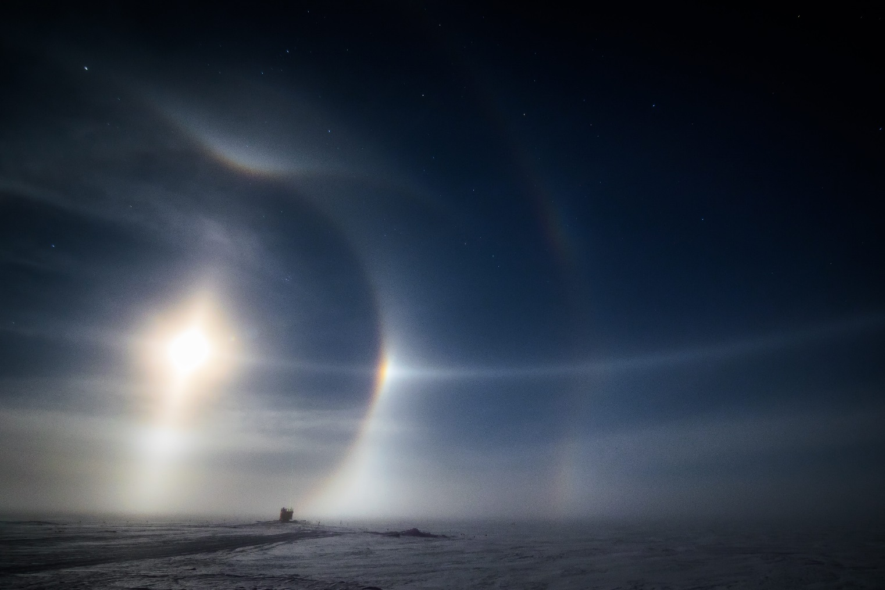

*Paraselenae (moon dogs) observed over the MSF on Friday, 11-23. The CAPABL beam is faintly visible.*

**General:**

Errors with multiple instruments are a sure sign it’s a holiday, so I’m told. An apparent drop in the data upload rate for the whole station has not been resolved as of this writing.

**Significant Weather Observations:**

|  |  |  |  |  |  |  |  |
| --- | --- | --- | --- | --- | --- | --- | --- |
| **Date** | **Time (Z)** | **Wind** | **Weather** | **Visibility** | **Sky** | **Temp(C)** | **Notes** |
| 11-19 | 1200 | 14kts from 170 | FZFG IC | 400 | SCT000 SCT100 | -33 |  |
| 11-20 | 1200 | 25kts gusting to 30kts from 170 | BLSN | 100 | BKN000 | -19 | Peak wind overnight 40kts |
| 11-21 | 1200 | 24kt from 150 | BLSN | 100 | BKN000 OVC018 | -20 |  |
| 11-22 | 1200 | 11kts from 160 |  | 9999 | SCT050 | -44 | 30kts and BLSN overnight |
| 11-23 | 1200 | 15kts from 210 | BLSN | 300 | SCT000 BKN120 | -27 | Moon dogs around 2100Z |
| 11-24 | 1200 | 9kts from 190 | IC | 9999 | BKN030 | -25 |  |
| 11-25 | 1200 | 13kts from 212 | BLSN BR | 400 | BKN000 BKN020 | -22 | IC and rave ice 1900 to 2300Z |

**ICECAPS-ACE Data Management:**

* 11-19: Data transfer continues to be unsuccessful. Contacted Shupe again.
* 11-20: Data transfer issue appears to be resolved by Kelly Healy at NOAA. Transfer ran most of the night, appears to be complete at 1404Z.
* 11-21: Data transfer complete at 1008Z.
* 11-22: Data transfer complete at 2235Z, very slow.
* 11-23: Data transfer complete at 2110Z. Again, slow.
* 11-24: Data transfer complete at 2233Z.
* 11-25: Data transfer complete at 11-26 0034Z.

**MWR:**

* 11-23: Software found showing “Communication Error”. Last data files written at 0447Z. Software not responding normally. I contacted Dave Turner and Erik Olson by email.
* 11-25: Software only communicating with HATPRO. Per Erik Olson, I cycled the power to the 150-90 and was able to bring both instruments back online at 2217Z.

**SODAR:**

* Operating normally.

**POSS:**

* Operating normally.

**MMCR:**

* 11-22: Window showing error 7. I hit continue and the instrument appeared to resume normal operations. I contacted Matt Shupe.
* 11-24: NetCDF errors noted. I cleared them and contacted Matt Shupe.
* Operating normally.

**CAPABL:**

* 11-20 1435-1445Z: Laser power set to 1 to allow safe snow removal from window on MSF roof.
* 11-22 1645Z: Terminal found showing a disk boot error. I contacted Robert Stillwell, and he sent me instructions to restart the system. I was able to complete this, but in the time I was there the CAPABL window was covered by snow in high wind. It cleared itself (I wasn’t able to safely access the the roof) and I restarted the system at 1913Z.
* 11-23 1445Z: I found the window covered with snow when I came in. I manually adjusted the laser power down to 1 then removed the snow from the window. I put it back at power 10 at 1457Z.
* Instrument currently operating normally using laser 2

**MPL:**

* 11-20: At daily check I found the MPL window blocked by snow. I cleared it while the afterpulse cal ran.
* 11-20 1426-1445Z: Afterpulse calibration performed.
  + 30m30s
    - Copol background avg: .000338
    - Copol std dev .000216
    - File: 201811201426.mpl
  + 15m30s
    - Copol background avg: .000310
    - Copol std dev .000307
    - File: 201811201436.mpl
* Operating normally.

**VCEIL:**

* Operating normally.

**IceCAM:**

* Operating normally.

**PAERI:**

* Operating normally.

**TSI:**

* Offline for winter season.

**IcePIC:**

* No images captured this week.

**Radiosonde:**

* Twice daily launches.

**MASC:**

* Instrument offsite for repair, will not return until summer 2019.

**OPC:**

* Options for filtering or otherwise preventing snow and rime buildup leading to occlusion of instrument intake remain under consideration.
* Operating Normally

**CLASP:**

* Instrument off site.

**CPC:**

* Instrument off site.