**ICECAPS-ACE Weekly Report**

November 5 – November 11, 2018

Gus Allen

*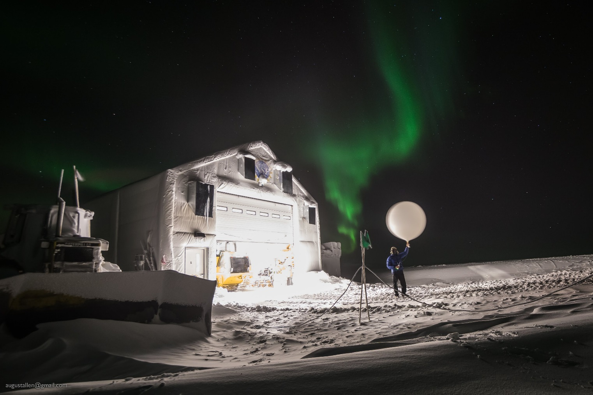Troy Nave does his best to hold a radiosonde balloon still for the camera*

**General:**

A quiet week at the MSF saw only a couple of minor maintenance issues with the PAERI and the OPC.

**Significant Weather Observations:**

|  |  |  |  |  |  |  |
| --- | --- | --- | --- | --- | --- | --- |
| **Date** | **Time (Z)** | **Wind** | **Weather** | **Sky** | **Temp(C)** | **Notes** |
| 11-05 | 1200Z | 17 from 094 | BR | SCT000 BKN045 | -24 |  |
| 11-06 | 1210 | 18 from 110 | BR | FEW000 BKN030 | -28 |  |
| 11-07 | 1210Z | 22 from 126 | DRSN FZFG | OVC005 | -30 |  |
| 11-08 | 1210 | 26 from 145 | BLSN | BKN000 BKN030 | -23 |  |
| 11-09 | 1215 | 19 from 143 | BLSN | BKN000 | -27 |  |
| 11-10 | 1210 | 7 from 212 |  | SCT 010 SCT100 | -32 |  |
| 11-11 | 1300 | 14 from 166 | FZFG | FEW000 FEW100 | -36 | Rime icing |

**ICECAPS-ACE Data Management:**

* 11-5: Data transfer complete at 1043Z.
* 11-6: Data transfer complete at 0958Z.
* 11-7: Data transfer complete at 0950Z.
* 11-8: Data transfer complete at 1003Z.
* 11-9: Data transfer complete at 1004Z.
* 11-10: Data transfer complete at 1032Z
* 11-11: Data transfer complete at 1230Z

**MWR:**

* Operating normally.

**SODAR:**

* 11-9: Data indicate possibly accumulated snow in dishes.
* Operating normally.

**POSS:**

* Operating normally.

**MMCR:**

* Operating normally.

**CAPABL:**

* Assessment of issue resulting in malformed beam image from laser 1 is ongoing.
* Instrument currently operating normally using laser 2

**MPL:**

* Operating normally.

**VCEIL:**

* Operating normally.

**IceCAM:**

* 11-6: Removed snow from lens at 1200Z
* 11-7: Removed snow from lens at 1230Z
* Operating normally.

**PAERI:**

* 11-07: Red flags thrown for LW and SW Responsivity at approximately 1600Z. I cleaned the scene mirror at 1620Z, and the flags returned to green at 1628Z.
* 11-10: Daily checks revealed enclosure fan stopped. I unmounted the enclosure, and found the fan (#4) seized. I replaced it with fan #8, replaced the blown fuse, and remounted the enclosure at 1720Z. Several hours later I found the fan stopped again. Assessing, I found the new fuse blown, but the fan free/not seized. After consulting with Von, I determined that I had used the smallest available fuse, rated at 250mA. I replaced it with a 750mA fuse, and remounted the enclosure. The incident appears to be resolved as the new fan is running as of 2018-11-12 14Z.
* Operating normally.

**TSI:**

* Offline for winter season.

**IcePIC:**

* No images captured this week.

**Radiosonde:**

* Twice daily launches.

**MASC:**

* Instrument offsite for repair, will not return until summer 2019.

**OPC:**

* 11-9: At daily check, OPC intake was found to be at least partially occluded with snow.
* 11-10 1313Z: OPC powered down per ACE protocol and removed fromtower to dry out and remove snow from intake.
* 11-10 1830Z: Instrument replaced on tower and supplied power. I was unable to complete the Power Up procedure because of ambiguity or possibly omission in the protocol. I contacted Heather for a resolution.
* 11-12 1230Z: Heather restarted data collection remotely.

**CLASP:**

* Instrument off site.

**CPC:**

* Instrument off site.