**ICECAPS-ACE Weekly Report**

November 26 – December 2, 2018

Gus Allen

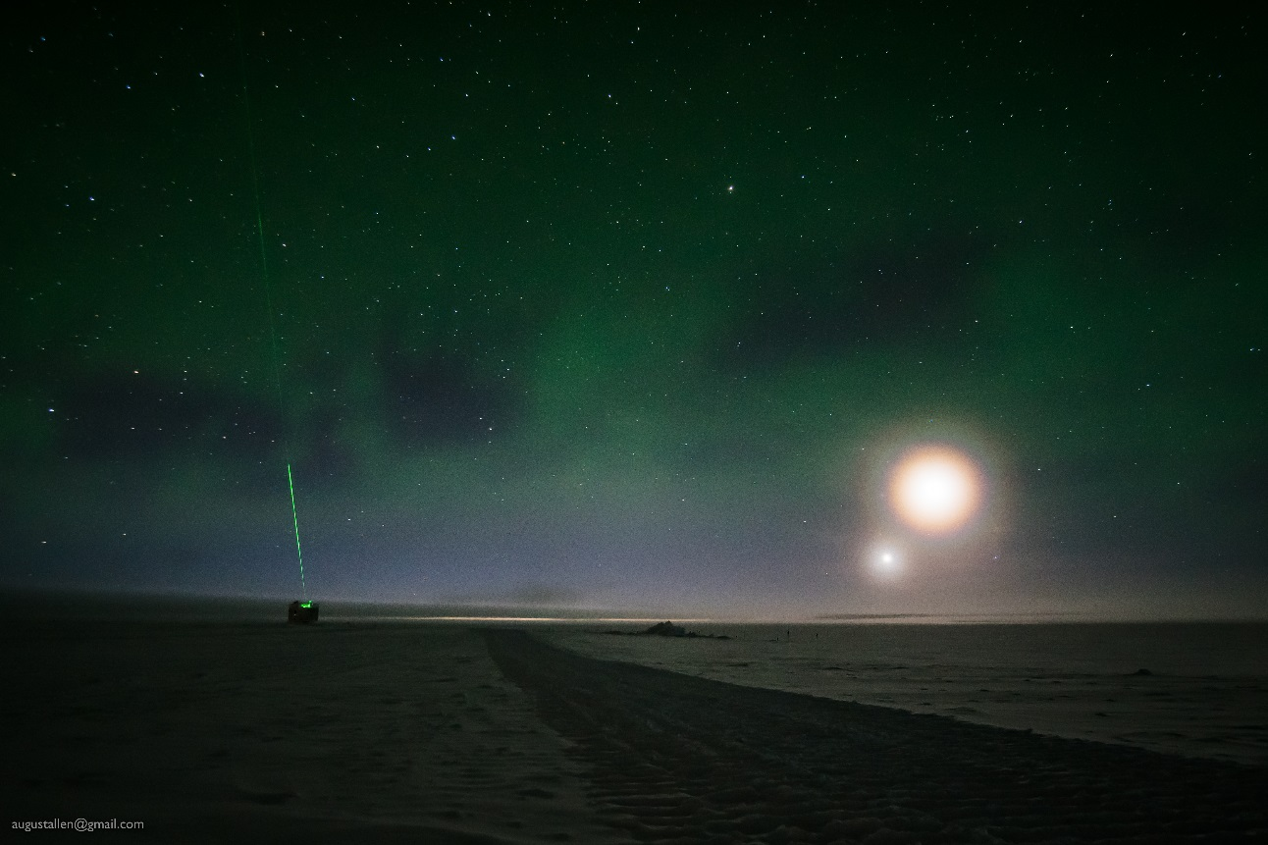

*The CAPABL beam illuminates an otherwise-invisible low fog layer, which is also causing bright rings around the Moon and Venus. Faint mottled green glow is all that remains of bright auroras all through the previous night.*

**General:**

Very cold temperatures set in at Summit this week, making any kind of outside work challenging. Several minor maintenance issues are detailed below. None are outstanding.

**Significant Weather Observations:**

|  |  |  |  |  |  |  |  |
| --- | --- | --- | --- | --- | --- | --- | --- |
| **Date** | **Time (Z)** | **Wind** | **Weather** | **Visibility** | **Sky** | **Temp(C)** | **Notes** |
| 11-26 | 1200 | 13kts from 240 | FZFG | 0400 | BKN012 | -28 |  |
| 11-27 | 1200 | 9kts from 270 |  | 9999 | SKC | -47 |  |
| 11-28 | 1200 | 9kts from 240 | IC | 9999 | FEW060 | -48 |  |
| 11-29 | 1200 | 7kts from 220 | IC BR | 6000 | SCT030 | -48 | Cold! |
| 11-30 | 1200 | 14kts from 107 | IC | 9999 | SCT100 | -49 | A little riming |
| 12-01 | 1200 | 09kts from 260 | IC | 9999 | FEW024 SCT100 | -53(!) | About 5cm of new rime on MSF roof |
| 21-02 | 1200 | 08kts from 280 |  | 9999 | FEW060 | -45 |  |

**ICECAPS-ACE Data Management:**

* 11-26: ToBoulder script stopped at 2312Z. Not complete
* 11-27: ToBoulder script stopped at 11-28 0032Z. Unclear if complete.
* 11-28: Data transfer complete at 2016Z
* 11-29: Data transfer complete at 1405Z
* 11-30: Data transfer complete at 1237Z
* 12-01: Data transfer complete at 1503Z
* 12-02: Data transfer complete at 1335Z

**MWR:**

* 11-28: With Erik Olson’s direction I mirrored the primary MWR server’s primary hard drive to its secondary hard drive, and to the backup server’s primary and secondary hard drives. We also verified the backup server was functional and keeping good time.
* Operating normally.

**SODAR:**

* Operating normally.

**POSS:**

* Operating normally.

**MMCR:**

* 11-26 1600Z: NetCDF error.
* 11-27 1400Z & 1600Z: NetCDF errors
* 11-28 1400Z, 1600Z, 2100Z: NetCDF errors
* 11-29 1330Z: Reboot initiated at Matt Shupe’s request.
  + 6 reboots performed
  + TWTA helix overcurrent fault loop
  + Powered down completely for 20 minutes prior to last reboot
  + Came up without faults at 1553Z
* Operating normally.

**CAPABL:**

* 11-29 1351 to 1405Z: Laser power set to 1 to allow snow removal from window
* 12-01 1405 to 1445Z: Laser power set to 1 to allow snow removal from window
* Instrument currently operating normally using laser 2

**MPL:**

* Operating normally.

**VCEIL:**

* Operating normally.

**IceCAM:**

* Operating normally.

**PAERI:**

* 12-01:
  + Around 1400Z: I possibly knocked some snow into the instrument because the roof was heavily rimed (~5cm pointing southeast) the night before
  + 1430-1445Z: Hatch covered to allow rime removal without additional snow entering instrument
  + 1530Z: Yellow flags for LW and SW responsivity. Looks like I got some snow in there.
  + 1540Z: Scene mirror cleaned
* Operating normally.

**TSI:**

* Offline for winter season.

**IcePIC:**

* No images captured this week.

**Radiosonde:**

* Twice daily launches.

**MASC:**

* Instrument offsite for repair, will not return until summer 2019.

**OPC:**

* 12-01 1400 – 1800Z: OPC pulled from the roof to remove rime and install foam filter.
* Operating Normally

**CLASP:**

* Instrument off site.

**CPC:**

* Instrument off site.