**ICECAPS-ACE Weekly Report**

October 1 – 7, 2018

Hannah James

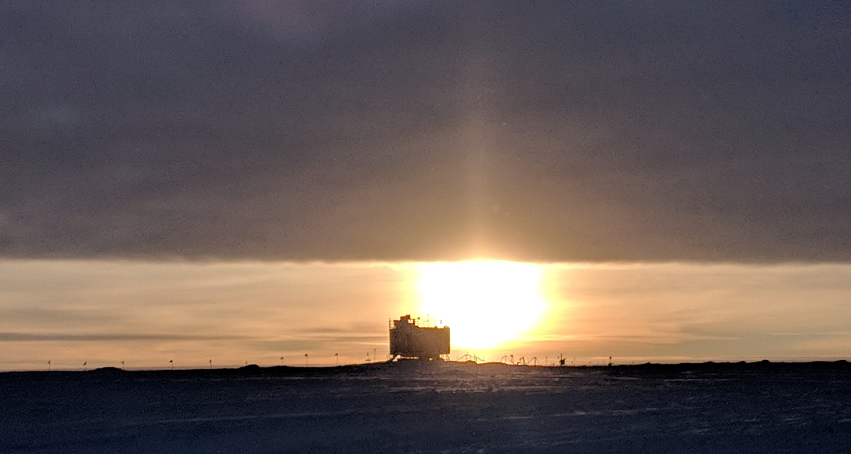A low cloud deck and the early morning sun. -HJ

**General:**

On Tuesday, 2 October bandwidth speeds decreased to 1.4 MB down, 0.3 MB up.

**Significant Weather Observations:**

* 10-01: Sct stratus, bkn altocumulus. -24C, 10 kts. Drsn, br.
* 10-02: Bkn altostratus. -32C, 14 kts. Br. 10:00Z- 22-degree halo.
* 10-03: Sct stratus, bkn cirrostratus. -36C, 12 kts. Vcfzfg.
* 10-04: Sct cirrostratus. -42C, 7 kts. Fzfg. 10:00-12:00Z faint fogbow.
* 10-05: Sky clear overhead, thick ground fog. -40C, 15 kts. Fzfg, IC. 12:00Z- 22-degree halo.
* 10-06: Bkn stratus, ovc altostratus. -27C, 8 kts. 10:00Z- parhelia.
* 10-07: Bkn cirrostratus. -26C, 12 kts.

**ICECAPS-ACE Data Management:**

* 10-01: Data transfer complete 05:30Z.
* 10-02: Data transfer complete 09:53Z. No IceCam photos sent. Matt Shupe reconnected drive remotely.
* 10-03: Data transfer complete 10:14Z. All backed up IceCam photos sent.
* 10-04: Data transfer complete 10:01Z.
* 10-05: Data transfer complete 09:52Z.
* 10-06: Data transfer complete 10:19Z.
* 10-07: Data transfer complete 10:05Z.

**MWR:**

* Operating normally.

**SODAR:**

* Operating normally.
* 10-06: Secured cables around SODAR with drill 13:20-13:45Z, SODAR picked up noise.

**POSS:**

* Operating normally.

**MMCR:**

* Operating normally.
* Pitch 0.00, Roll wavering between 0.32 and 0.43.
* 10-01: Replaced desiccant.
* 10-02: Error 7 found. “Continue” selected at 13:14Z. Daily checks passed afterwards.
* 10-04: Error 7 found. “Continue” selected at 12:27Z. Daily checks passed afterwards.

**CAPABL:**

* Operating normally in Configure Ops Laser 2.
* 10-03: 12:04Z- Adjusted CAPABL’s computer clock as it was 25 seconds behind the GPS time server.

**MPL:**

* Operating normally.
* 10-03: 12:09Z- Adjusted computer clock as it was 49 seconds ahead of the GPS time server.

**VCEIL:**

* Operating normally.

**IceCAM:**

* Operating normally.

**PAERI:**

* Operating normally.

**TSI:**

* Offline for winter season.

**IcePIC:**

* No images captured this week.

**Radiosonde:**

* Twice daily soundings.

**MASC:**

* Instrument offsite for repair, will not return until summer 2019.

**OPC:**

* Operating normally.

**CLASP:**

* Operating normally.
* 10-06: Reinstalled on ACE tower, data collection started at 13:11Z.

**CPC:**

* Temperature and status lights alternating between orange and green throughout the day since 09-28. Data plots continue to update.
* 10-01: No cpc.png files sent over Dataman.