**ICECAPS-ACE Weekly Report**

October 8 – 14, 2018

Hannah James

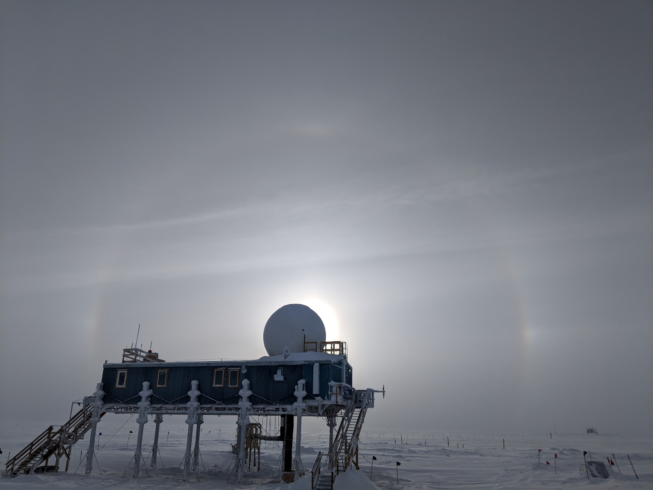

A faint 22 degree halo on Sunday afternoon. -HJ

**General:**

None to report.

**Significant Weather Observations:**

* 10-08: Sct cirrostratus. -41C, 8 kts. Fzfg. 10:30-13:30Z fogbow.
* 10-09: Bkn cirrocumulus. -42C, 11 kts. Fzfg.
* 10-10: Bkn stratus, bkn cirrostratus. -41C, 6 kts. Vcfzfg.
* 10-11: Sct cirrostratus. -46C, 14 kts. Br. 12:00Z-Fogbow.
* 10-12: Sct altostratus, bkn cirrostratus. -24C, 21 kts. Blsn. Early in morning, vis 100m due to blsn.
* 10-13: Ovc stratus. -28C, 8 kts. Fzfg.
* 10-14: Ovc stratus. -24C, 17 kts. -Sg, br, drsn.

**ICECAPS-ACE Data Management:**

* 10-08: Data transfer complete 11:23Z.
* 10-09: Data transfer complete 09:50Z. MMCR mount down overnight.
* 10-10: Data transfer complete 13:48Z. All MMCR data from previous day transferred.
* 10-11: Data transfer complete 11:08Z.
* 10-12: Data transfer complete 11:23Z.
* 10-13: Data transfer complete 14:06Z.
* 10-14: Data did not transfer overnight. Dataman did not respond to commands, POSS files wouldn’t open. Rebooted computer at 11:47Z. Shutdown or restart command would not work, a hard reboot was performed. Manual Data push started at 12:15Z. I realized I forgot to run the ArchiveData script, so some links were broken. Proper data transfer started at 12:53Z, solar outage stopped data. Restarted again at 13:48Z. Data transfer complete 18:44Z.

**MWR:**

* Operating normally.

**SODAR:**

* Operating normally.

**POSS:**

* Operating normally.
* 10-13: Many “Gunn current low” errors, continuous from 08:23-10:06Z. Warm temperatures combined with light bulb on may have caused these?
* 10-14: POSS rebooted with Dataman, offline 11:47-12:01Z.

**MMCR:**

* Operating normally.
* Pitch 0.00, Roll wavering between 0.32 and 0.43.
* 10-08: Net_CDF errors found upon morning rounds. Cleared at 11:46Z. Found again, cleared at 12:58Z. Found again in the afternoon. Began reboot process at 16:18Z. Five reboots later (due to Helix overcurrent faults), the MMCR was collecting data at 17:55Z.
* 10-09: Mount down overnight, no data transferred. Daily 12:30Z calibration failed.
* 10-10: Daily 12:30Z calibration failed.
* 10-12: Reboot requested by Matt Shupe- clouds were not being seen by the radar. MMCR offline 11:56-12:50Z, five reboots required.

**CAPABL:**

* Operating normally in Configure Ops Laser 2.

**MPL:**

* Operating normally.

**VCEIL:**

* Operating normally.

**IceCAM:**

* Operating normally.

**PAERI:**

* Operating normally.

**TSI:**

* Offline for winter season.

**IcePIC:**

* No images captured this week.

**Radiosonde:**

* 10-12: Morning sonde failed 1 minute after launch due to a reported temperature sensor failure. Since winds were 30 knots sustained, a relaunch was not attempted.

**MASC:**

* Instrument offsite for repair, will not return until summer 2019.

**OPC:**

* Operating normally.

**CLASP:**

* Operating normally.
* 10-11: Very low values plotted on the quicklooks, so Neely advised that I reboot the whole system. After reboot, data plots were not updating.
* 10-13: Realized that the script to record data had reported an error. I re-ran the script, but plots were still not updating. Raw data was coming through.
* 10-14: Plots updating, daily checks pass at 12:10Z.

**CPC:**

* Temperature and status lights alternating between orange and green throughout the day since 09-28. Data plots continue to update.
* “Error Liquid” audible alarms are temporarily present throughout the day, with status and liquid LEDs temporarily going red, and then returning to green/orange.