**ICECAPS-ACE Weekly Report**

October 15 – 21, 2018

Hannah James & Gus Allen

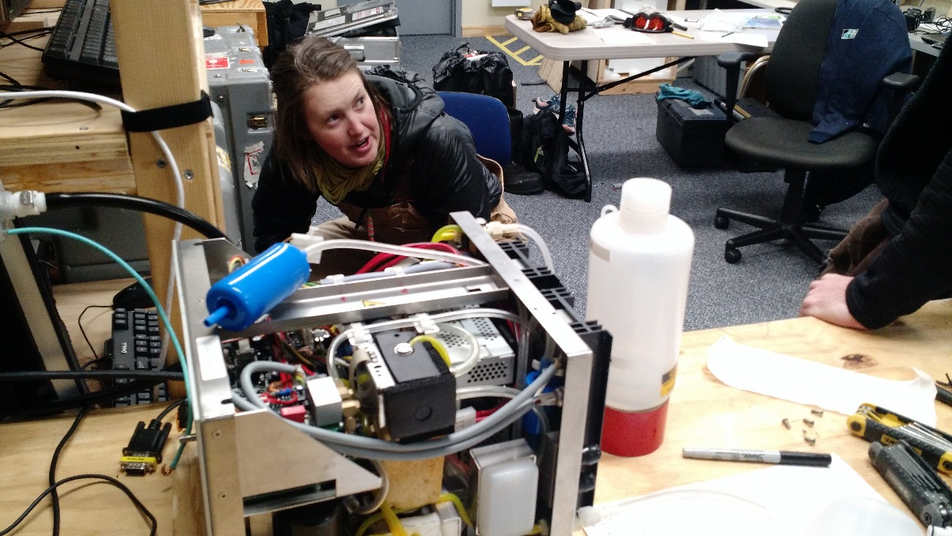

Troubleshooting the CPC, which was eventually packed up and will shortly be on its way back to Leeds. -AA

**General:**

Turnover to the new winter crew was the theme of the week. Gus Allen arrived on Monday morning, and spent the week turning over tasking with Hannah. With Grey Davis and Sam Dorsi on site, the MSF was leveled on Tuesday, Oct 16. It was brought from a pitch/roll of 0.11/0.42 to 0.00/0.00! The CPC and CLASP were troubleshot throughout the week, and finally packed up to be sent back to Leeds for maintenance and further testing in the cold lab.

**Significant Weather Observations:**

* 10-15: Ovc stratus. -25C, 11 kts. -Sg, br.
* 10-16: Sct cirrostratus, sct cirrus. -43C, 12 kts. Fzfg. 12:00-14:00Z- fogbow.
* 10-17: cirrocumulus, -31C, 14 kts, fzfg, rime icing at surface, drsn.
* 10-18: sct cirrocu, -32C, 14kts from 152, fzfg, rime icing, drsn
* 10-19: sct cirrocu, -26C, 21kts from 136, br, -sn, blsn
* 10-20: few cirrus in distance, -35C, 8kts from 191, fzfg riming
* 10-21: sct cirrocu, -46C, 14kts from 347, fzfg with riming

**ICECAPS-ACE Data Management:**

* 10-15: Data transfer complete 11:33Z.
* 10-16: Data transfer complete 12:25Z.
* 10-17: Data transfer complete 11:08Z.
* 10-18: Data transfer complete 19:24Z.
* 10-19: Data transfer complete 16:58Z.
* 10-20: Data transfer complete 15:14Z.
* 10-21: Data transfer complete 13:47Z.

**MWR:**

* Operating normally.
* 10-17: 3 channels (22.24, 25.44, 150.00) were reporting 0.00 value. Response from Dave is that this is due to the calibration file being out of date.
* 10-19: 22.24, 25.44, and 150.00 channels are now showing non-zero values.

**SODAR:**

* Operating normally.
* 10-16: 11:17Z- noise picked up from unknown source
* 10-19 1206Z – 1234Z: Powered down amplifier for snow removal

**POSS:**

* Operating normally.

**MMCR:**

* Operating normally.
* Pitch 0.00, Roll 0.00.

**CAPABL:**

* Operating normally in Configure Ops Laser 1. Alignment will occur with clear skies.
* 10-16: Laser 1 installed. CAPABL offline 13:33-18:53Z. No realignment of Laser 2 necessary.
* 10-18: 12:18Z- Stopped data collection to check alignment of Laser 1. Through firing the laser at very low power levels with the Licel off, it was discovered that Laser 1 was had a ring of light surrounding it, with the brighter ‘true’ laser beam located in the southwest side of the larger circle. We then checked Laser 2’s appearance, and noticed no larger ring around the main beam. Robert had us power on both lasers at the same time to compare locations, and we discovered that the main beam of Laser 1 was about 1 cm off where Laser 2’s beam was located, thus slightly out of alignment.
* 10-20: Alignment attempted on Laser 1 1056-1226Z. Improvements were made, but a thick fog rolled in preventing peaking the alignment.
* 10-21: Neely attempted a fine alignment, but the initial alignment was not good enough. An alignment was attempted from 13:01-13:20Z, but clouds rolled in. It seems that no improvements were made. 14:58-15:22Z- Alignment attempted, but ice crystals prevented improvements.

**MPL:**

* Operating normally.
* 10-18: 1911z to 1932z Afterpulse Calibration performed.

**VCEIL:**

* Operating normally.

**IceCAM:**

* Operating normally.

**PAERI:**

* Operating normally.
* 10-19: Noted and cleaned snow from intake enclosure during daily check. (Presumably) knocked some snow onto the scene mirror, necessitating a cleaning from the roof. Instrument showed reg flags for LW responsivity and SW responsivity from 1125Z to 1133Z.

**TSI:**

* Offline for winter season.

**IcePIC:**

* No images captured this week.

**Radiosonde:**

* Twice daily launches.

**MASC:**

* Instrument offsite for repair, will not return until summer 2019.

**OPC:**

* Operating normally.
* 10-19: During CLASP cable roof work, the USB connection was bumped out of place on the ACE tower, and data collection stopped. The OPC was not plotting data from 2018-10-19 1345Z to 2018-10-20 1328Z.

**CLASP:**

* Instrument offline and being shipped offsite for repair.
* Strange data throughout the week. On 10-15, lots of noise was present in the afternoon. On 10-16, only a straight line of particles at 3.0µm appeared from 03:30Z on.
* 10-16: 19:35Z- powered down and brought inside to thaw out.
* 10-17: Upon daily rounds, noted that CLASP appears to online and reporting data, despite the instrument being disconnected and inside thawing. Instrument hooked up to power and began data collection inside for diagnostic testing.
* 10-18: CLASP plots not updating, but raw data coming through.
* 10-19, 10-20: Diagnostic testing continued. Different cables were tested inside and outside. After looking at data, the decision was made to ship it back to Leeds where it can be repaired and tested in a cold chamber before returning in February.
* 10-21: Packed up with all three cables for shipment back to Leeds via Iceland.

**CPC:**

* Instrument offline and being shipped offsite for repair.
* Temperature and status lights alternating between orange and green throughout the day since 09-28. “Error Liquid” audible alarms were temporarily present throughout the day, with status and liquid LEDs temporarily going red, and then returning to green/orange.
* 10-16: 19:12Z- Added Butanol to the reservoir.
* 10-18: Error 3 and Error i discovered in the morning. The errors would not self-clear, so instrument was put in standby mode for most of the morning. In the afternoon, with Neely on the phone, the instrument was brought back online. After about 20 minutes of warmup, the same errors appeared. It was discovered that the fan was not spinning. Instrument was powered down to cool off.
* 10-19, 10-20: Troubleshooting continued. During initial powerups, the temperatures would not regulate and during the warmup phase the errors would return. The saturated chamber temperature was reading normal levels, but the cooled condenser would increase from 10C up to 22C in matter of seconds during these errors. The fan was running properly during the warmup phase, but did need a push to start during the initial powerup. The instrument was powered down, and a dry out cycle was attempted in preparation for shipping. However, this cycle does not work with the electrical modifications made to this unit. The Butanol was dumped out of the reservoir by tipping the instrument, and left open to dry overnight.
* 10-21: Packed up for shipment back to Leeds via Iceland.